Business Requirement:
Integration of SAP to Nittsu 3PL. Existing warehouse IDOCs to not meet the requirements of Nittsu flat files, where applicable existing document will be cloned and changes made to accommodate Nittsu files.
Functional Specification:
Outbound delivery document – Document will be used by GIS to generate the SHP file
A proforma F8 for Japan to generate all billing values
Create ZJD4 delivery output, by copying ZLD4 WHSORD (940) and make the following additions
Header
A proforma invoice will have to be created. Net value and tax value from proforma will have to be added to IDOC output in separate custom fields at the header level
Bill-to phone number added to AG segment
ship-to phone number added to WE segment
Line

The following pricing information should be added from the pro forma to the line level and summed at the header level of the IDOC.
I am not sure what segments are available and/or make sense for this.
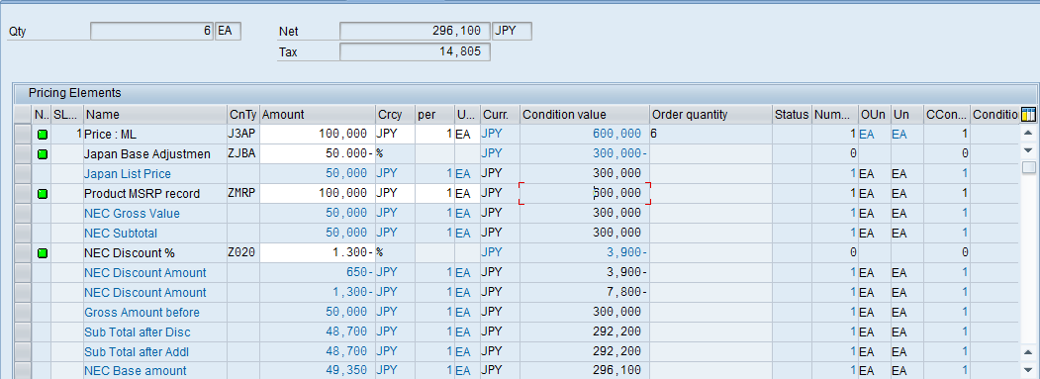  5  6  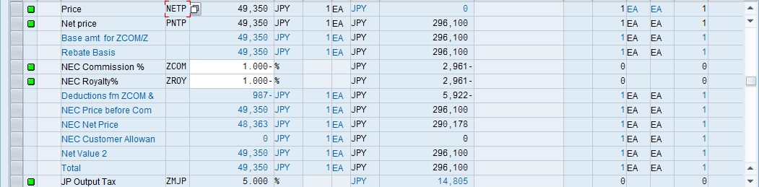  1  3  4  2 | - Sales Value (Incl. VAT)  - Total Amount (1) + ZMJP Amount (2)  - Sales Value (Excl. VAT)  - Total Amount (1)  - Total Sales Value (Incl. VAT)  - Total Cond. Val. (3) + ZMJP Cond. Val. (4)  - Total Sales Value (Excl. VAT)  -Total Cond. Val. (3)  - Retail Value (Incl. VAT)  -ZMRP Amount (5) + ZMJP Amount (2)  - Retail Value (Excl. VAT)  -ZMRP Amount (5)  - Total Retail Value (Incl. VAT)  - ZMRP Cond. Val. (6) + ZMJP Cond. Val. (4)

Outbound PO Document
This will be the outbound document
Assumptions:
- New ZJD4 output will be determined exiting key combination
- Bill-to, Ship-to phone number are populated in customer master data
- Proforma pricing date can be pulled for delivery output
- New Partner will have to be setup in WE20
Known Issues:
Currently no known issues
Technical Specification:
Technical Object | Type | Description
Delivery output | WHSORD | Delivery IDOC output

Source Control:
Change Object | Application | Developer | Description

TDMS Requirements:
Is a new TDMS client required? If yes: No

Test Scenarios:
No. | Test Scenario | Expected Results | Actual Results | Application / Environment | Tester | Creation  Date | P/F | Panaya
1 | Stock Order | Drop stock order to Nittsu which ships product |  | SAP |  |  |  | ☐
2 | Season Order | Drop season order to Nittsu which ships product |  | SAP |  |  |  | ☐
3 | Multi Line | Drop order to Nittsu which ships product |  | SAP |  |  |  | ☐
4 | Credit Card Order | ZWEB GBP |  | SAP |  |  |  | ☐
5 | Cash on Delivery Orer | ZWEB EUR |  | SAP |  |  |  | ☐
6 |  |  |  |  |  |  |  | ☐
77

Panaya Scripts:
No. | Panaya Script | Test No. | Tester | Description

uPerform / Camtasia:
No. | uPerform Script | Creation Date | Language | Description

