Issue : When a purchase Order is created in AFS 6.5 Version a Dump is caused, below is the screen shot of the Dump.

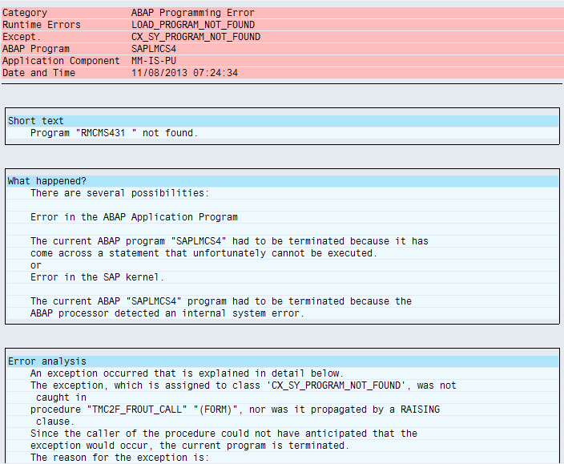

Reason :

This is because the infostructure S431 is no longer valid in the AFS 6.5
AFS Purchasing infostructure S431 is no longer used. S433 is the valid infostructure for the release AFS 5.0 and above.

Solution :

As per the OSS note 800335 there are two Manual Steps which are to be carried out in each client.

- Rebuild Infostructure.
- Carry ouy the report ZDELS431

Rebuild Infostrcture:

Transaction : OLI3

Infostructure to compile : S433
Name of the Run : Give any name to identify
Termination Date : Give some future Date (Two Days)
Check the box New Run.

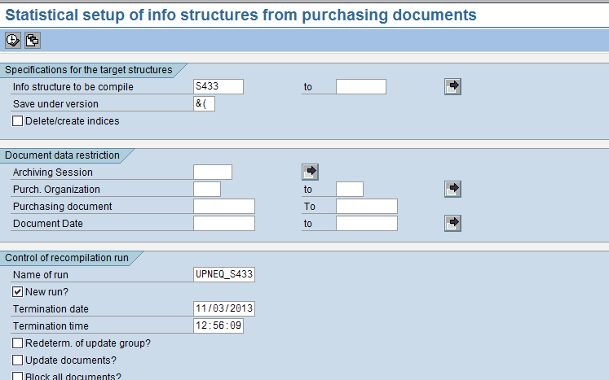

Setup a background job

We can check the log with the job name in the transaction NPRT.
After the Job is complete carry out the secound step.

Report ZDELS431

Transaction SA38
Set the background job for the program “

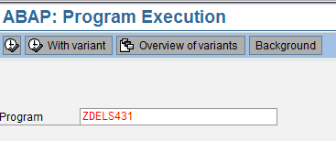

Execute.

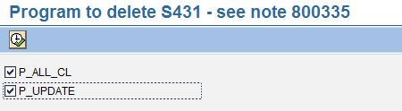

Set the background job.

These Manual steps are carried out in NECNED 100, NECNED 300, NES 100 & NECNEQ 100 Systems

In NEQ Below are the jobs carried out.

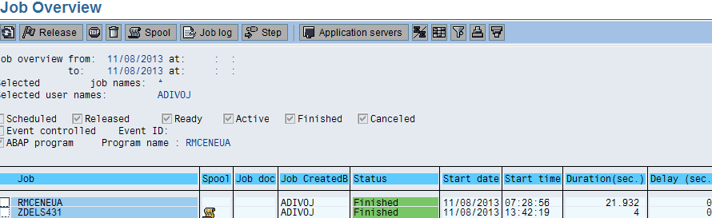

***End ***

