**One Time Vendor – Process Flow**

Step 1:- Create Vendor account group in T.code OBD3 with one time vendor checked

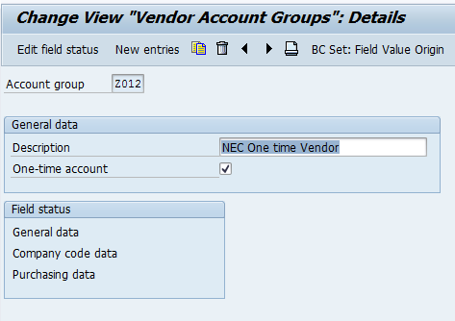

Step 2:- Assign vendor number ranges to new account group in Tcode OBAS

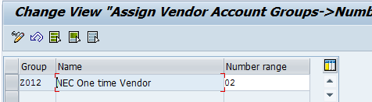

Step 3:- Create vendor in XK01 without master data

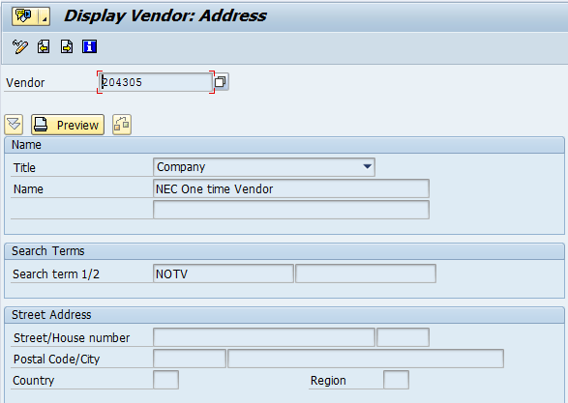

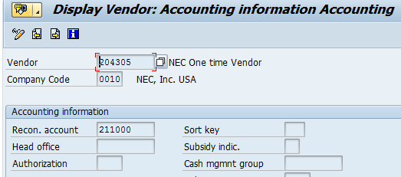

P2P Process

1) Create Purchase order in ME21N

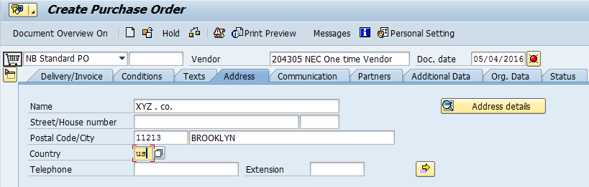

2) Then GR in MIGO

3) Invoice in MIRO

4) Run F110 – APP

Payments and remittance are done as per the vendor address.