**North America:**

Passed Parameter values are:

Display Currency: USD

Region: North America

Week From: 21/2016

Week To: 13/2019

Year: NE/2016.NE/2017,NE/2018

**From BEx query:**

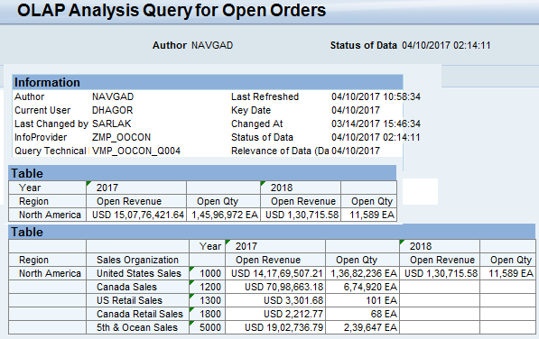

**From NA Explorer Space:**

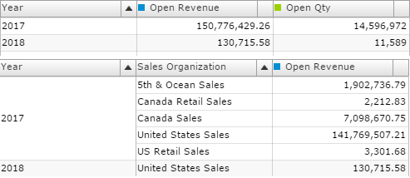

Both results are matched.

**EMEA:**

Passed Parameter values are:

Display Currency: USD

Region: EMEA

Week From: 21/2016

Week To: 13/2019

Year: NE/2016.NE/2017,NE/2018

**From BEx query:**

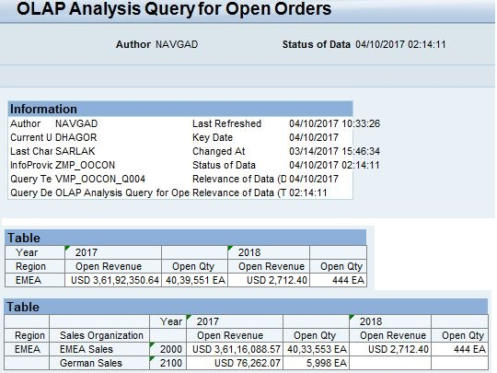

**From EMEA Explorer Space:**

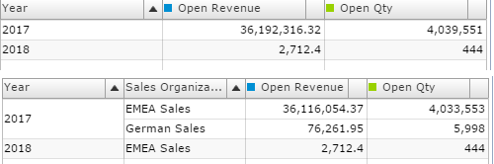

Both results are matched.

**Emerging Markets:**

Passed Parameter values are:

Display Currency: USD

Region: Emerging Markets

Week From: 21/2016

Week To: 13/2019

Year: NE/2016.NE/2017,NE/2018

**From BEx query:**

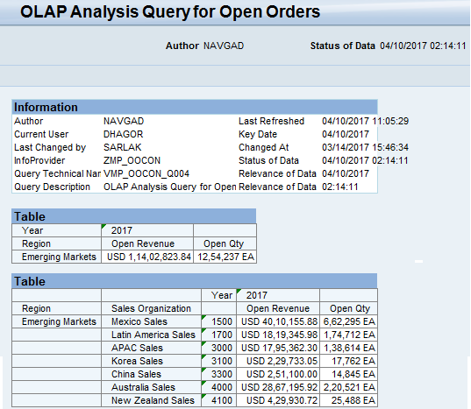

**From Emerging Markets Explorer Space:**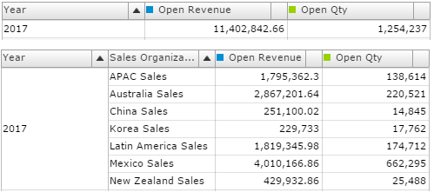

Both results are matched.

**Japan:**

Passed Parameter values are:

Display Currency: Yen

Region: Japan

Week From: 21/2016

Week To: 13/2019

Year: NE/2016.NE/2017,NE/2018

**From BEx query:**

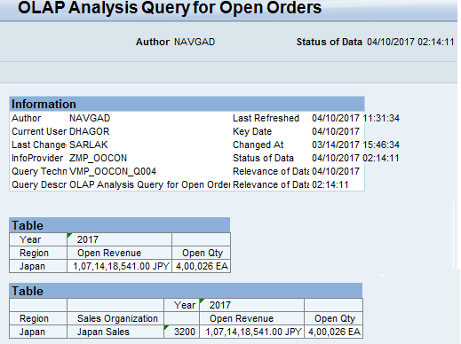

**From Japan Explorer Space:**

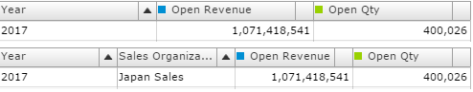

Both results are matched.

---------------------------------------------Thank You------------------------------------------------------