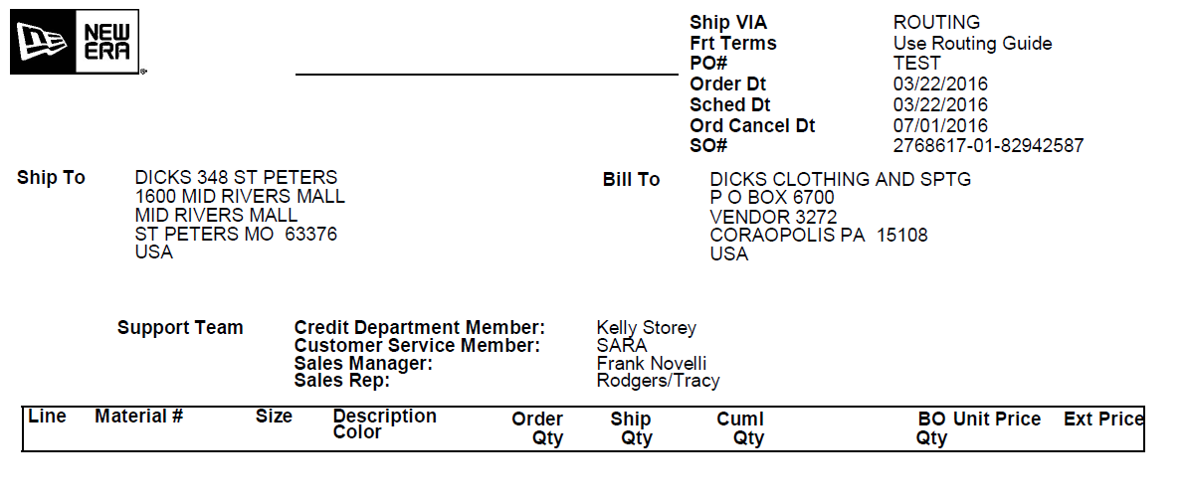

SKU/UPC

**Material List**

10 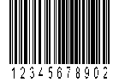 638 JR THE LEAGUE DETTIG HM    
 Black 10 10 0

 638 JR THE LEAGUE DETTIG HM    
 Black 10 10 0

 638 JR THE LEAGUE DETTIG HM    
 Black 10 10 0

20  638 JR THE LEAGUE DETTIG HM    
 Black 10 10 0

 638 JR THE LEAGUE DETTIG HM    
 Black 10 10 0

 638 JR THE LEAGUE DETTIG HM    
 Black 10 10 0

Page 1/2 Box 1/2



**Material List**

30  638 JR THE LEAGUE DETTIG HM    
 Black 10 10 0

40  638 JR THE LEAGUE DETTIG HM    
 Black 10 10 0



Page 2/2 Box 2/2