**Parallel A-RUN**

1. Steps to execute online parallel A-RUN (/AFS/ARUN_PARALLEL) in NEQ:
2. Transaction : J4AE
3. Select variant: SET 70

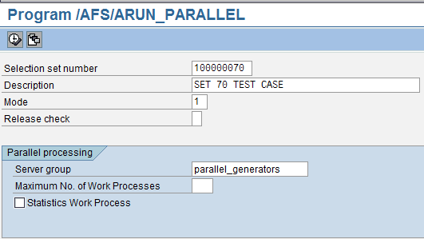

1. Execute

The following dump results:

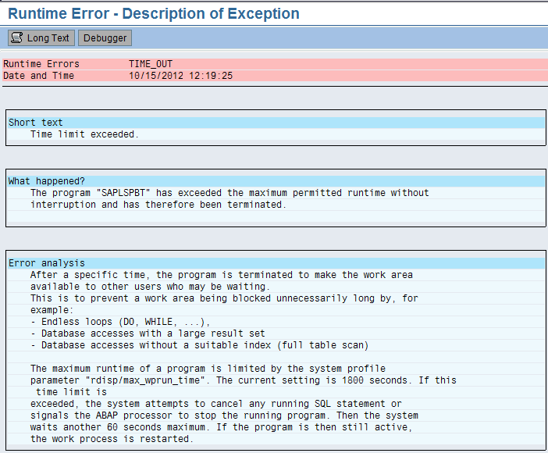

[Info: The transaction was also tried in simulation mode (3) resulting in the same dump error]

1. Steps to execute parallel A-RUN in background.
2. Transaction: SM37
3. Selection set used in the variant: 100000070 & 100000010 respectively

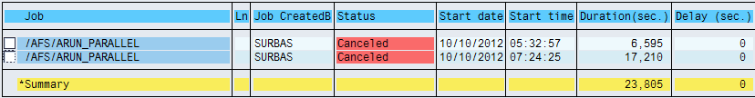

Job log for selection set 100000070

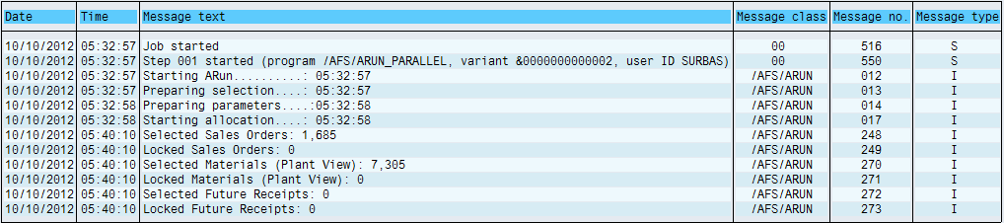

Job log for selection set 100000010

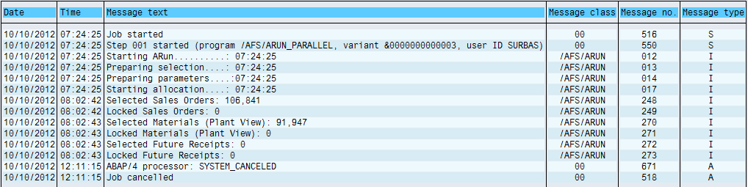

Info: The two jobs were required to be cancelled as the log was not updated after the initial few minutes and in debug mode, the program was stuck at this point.



NB: The following performance improvement related notes have been implemented in NEQ-

1. 1442963
2. 1618658