1. REQUIREMENT:

Analysis to find the behavior of PIRs consumption by stock/ receipts.

2. ANALYSIS:

3.1 Consumption periods defined for PRGM MRP group

In the MRP group PRGM consumption periods are maintained as below
- Backward consumption period – 7 days
- Forward consumption period – 20 days

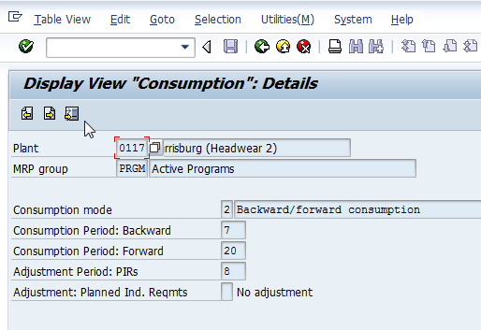

3.2 PIR Consumption when stock is available

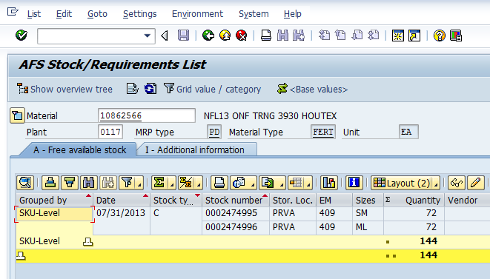

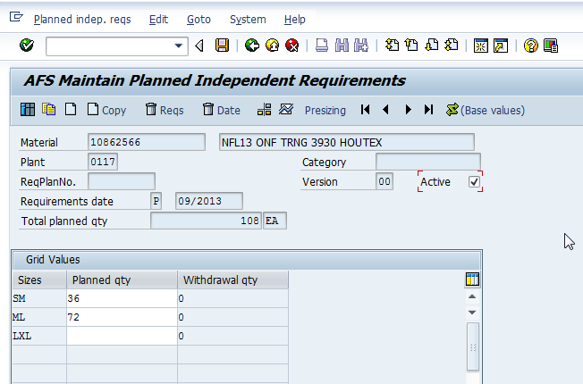

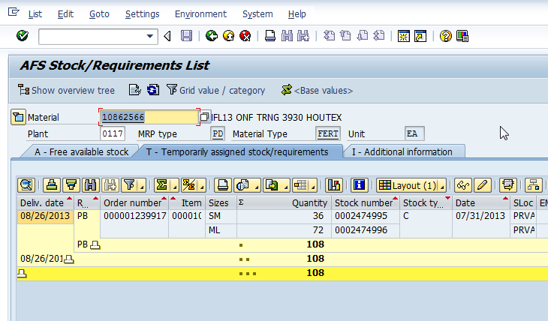

From the above we can understand that if the stock is available, then PIR will be assigned to that stock and proposal will be generated for PIR balance quantity if any.

3.3 PIR Consumption when sales orders are exists

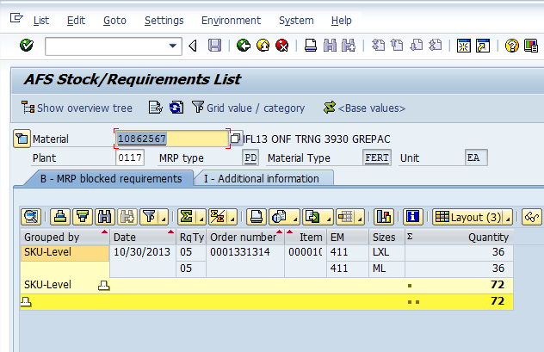

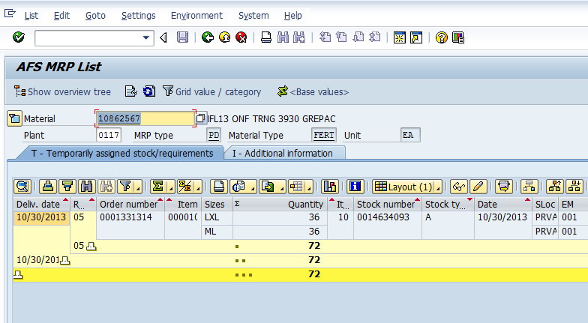

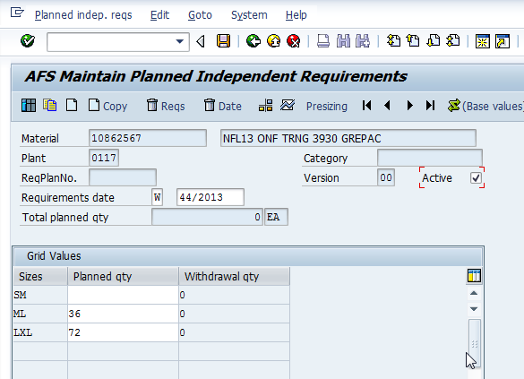

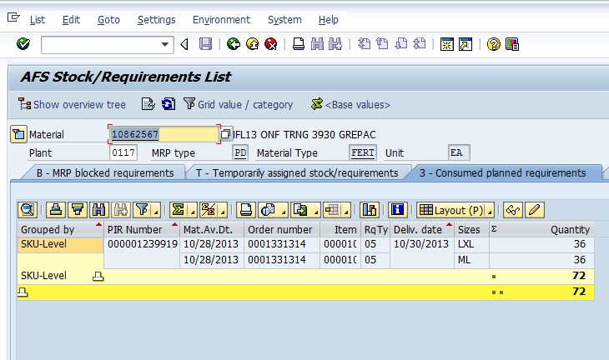

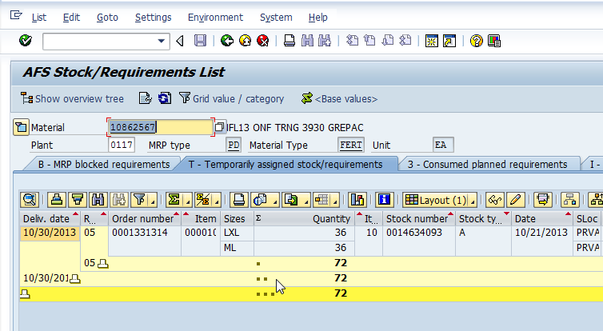

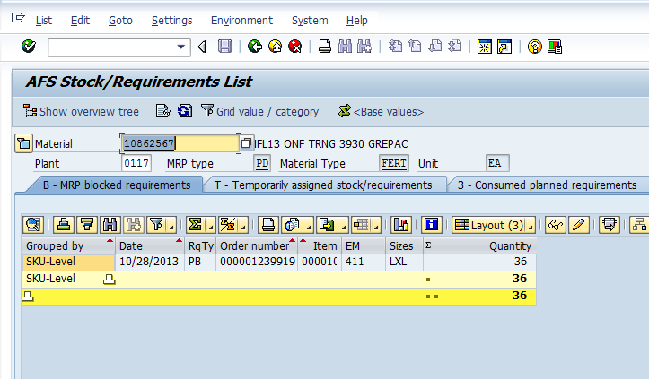

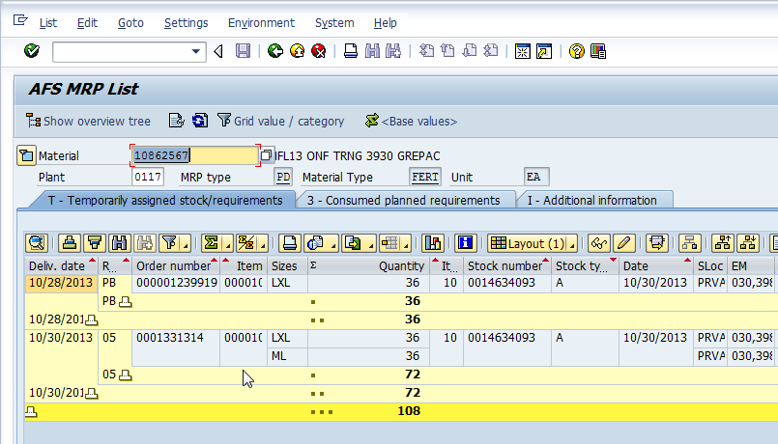

From the above we can understand that if PIR is created even though after the sales order creation that is consumed. For this criteria is requirement date for both sales order and PIR will be within the consumption period.

3.4 PIR Consumption if receipts are exists

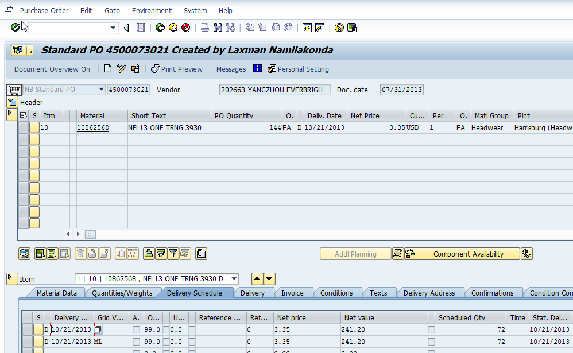
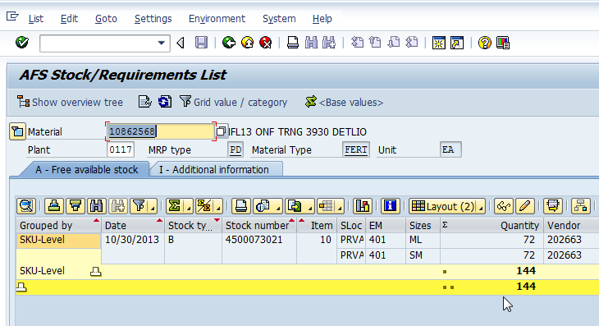

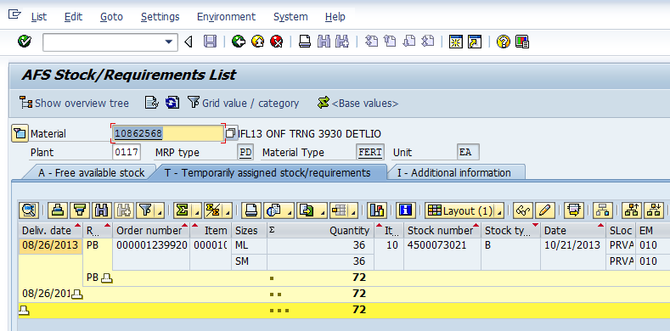

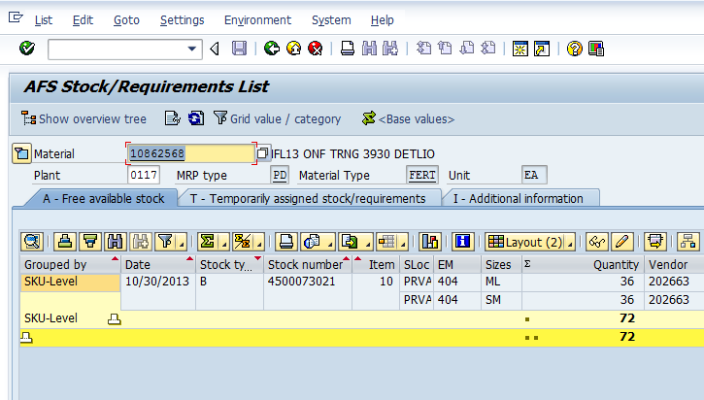
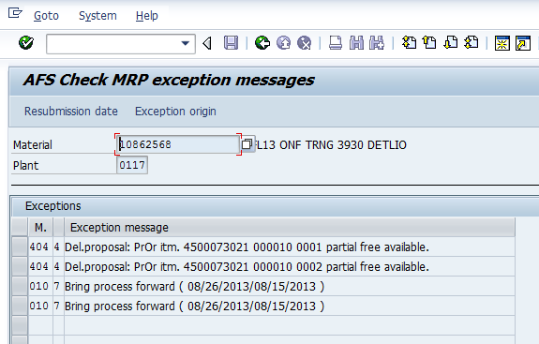
From the above we can understand that if any freely available incoming receipts (Purchase orders) are there those will be assigned to PIR and system will propose to bring the process forward or postpone as shown above.

*End of Document*

