1. REQUIREMENT:

Analysis to find the behavior of PIRs consumption based on consumption periods.

2. ANALYSIS:

3.1 No consumption periods in the material master

As we are aware that if the consumption parameters are not maintained in the material master then these will be considered from MRP group.

In the MRP group PRGM consumption periods are maintained as below
- Backward consumption period – 7 days
- Forward consumption period – 20 days

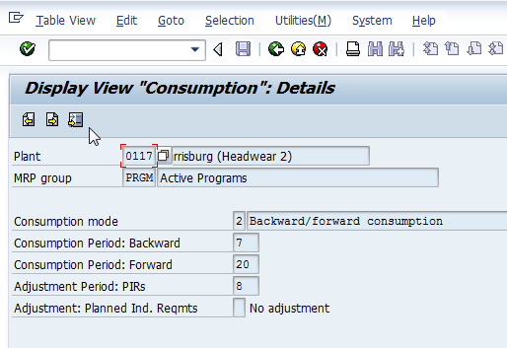

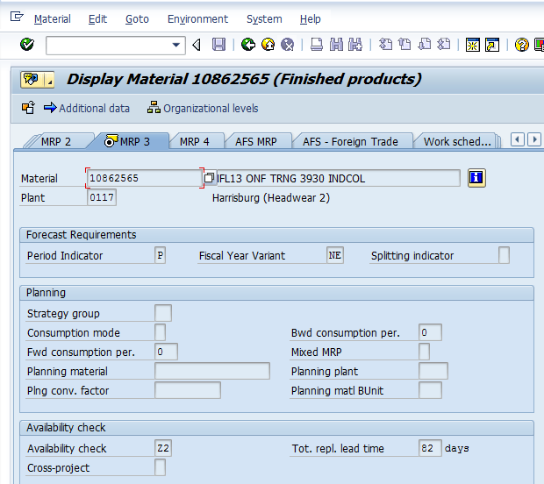

From the above we can understand that in the material master consumption mode and corresponding periods are not maintained.

Delivery date of sales order: 10/17/2013
PIR Requirement date: 10/14/2013

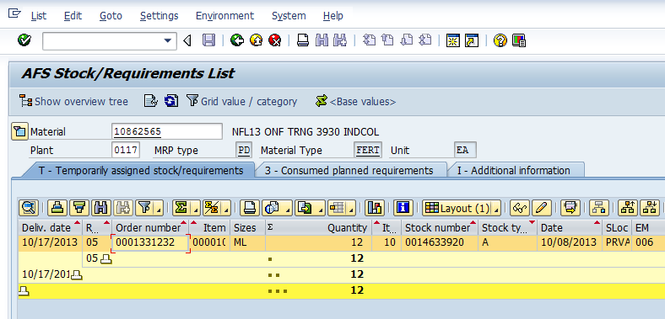

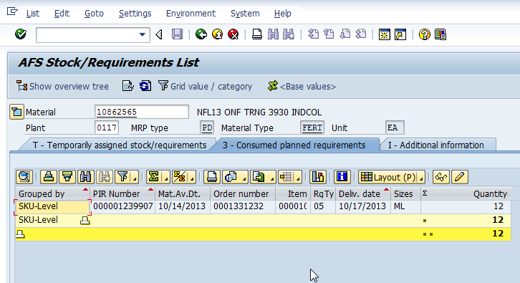

Since backward consumption period is 7days PIR is consumed by sales order.

3.2 Consumption periods from material master

In the material master consumption periods are maintained as below
- Backward consumption period – 1 day
- Forward consumption period – 2 days

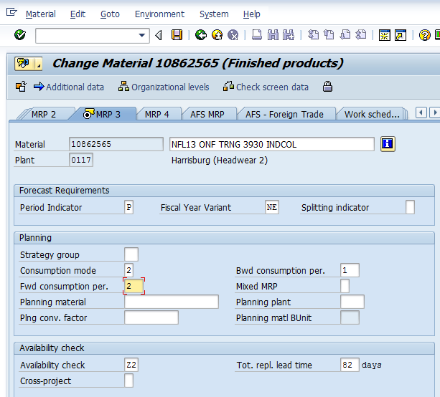

Delivery date of sales order: 10/17/2013
PIR Requirement date: 10/14/2013

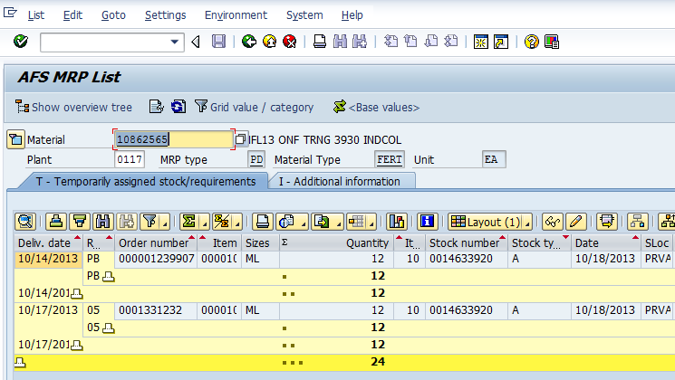

Since backward consumption period is only one day PIR is not consumed by sales order. From the above we can understand that separate purchase reqs are created (Requirement PB for PIRs and requirement 05 is for sales order).

3.3 Consumption periods as ZERO in the material master

In the material master consumption periods are maintained as below
- Backward consumption period – Zero days
- Forward consumption period – Zero days

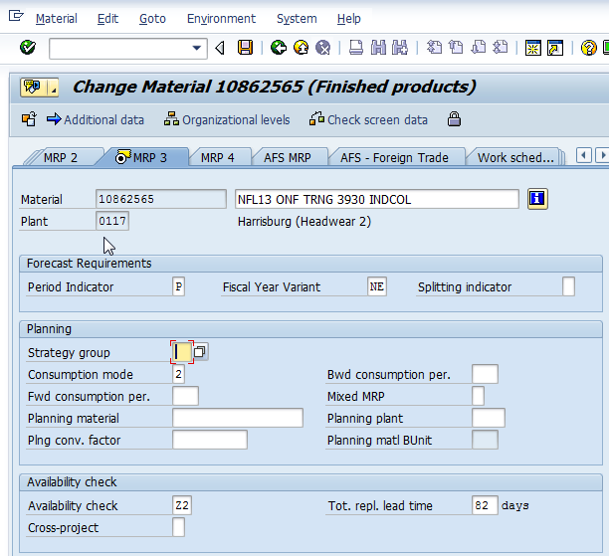

From the above we can observe that only consumption mode is maintained and consumption periods are not maintained. So in this case consumption periods are ZERO.

Delivery date of sales order: 10/17/2013
PIR Requirement date: 10/16/2013

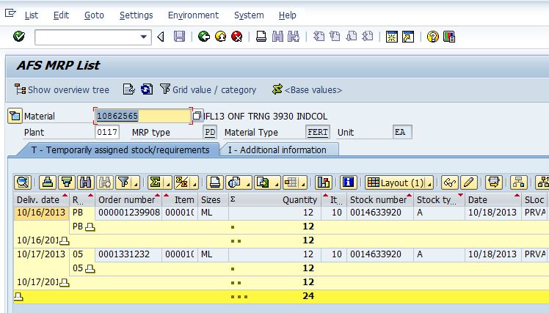

Since backward consumption period is Zero and delivery date and PIR requirement date are on different dates PIR is not consumed by sales order. From the above we can understand that separate purchase reqs are created.

3.4 Consumption periods as ZERO in the material master (Both delivery date and PIR requirement date are same)

In the material master consumption periods are maintained as below
- Backward consumption period – Zero days
- Forward consumption period – Zero days

From the above we can observe that only consumption mode is maintained and consumption periods are not maintained. So in this case consumption periods are ZERO.

Delivery date of sales order: 10/17/2013
PIR Requirement date: 10/17/2013

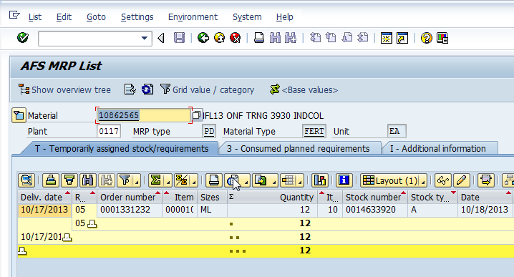

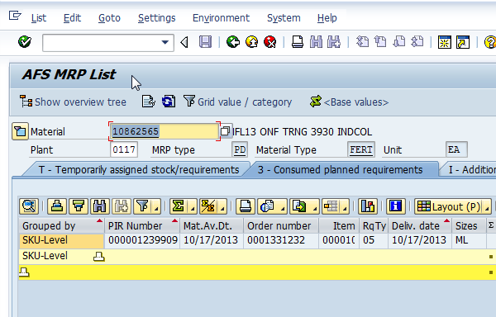

Even though consumption periods are Zero since delivery date and PIR requirement date are on same day PIR is consumed by sales order

3.5 Consumption periods as ZERO in the material master (With multiple sales orders)

In the material master consumption periods are maintained as below
- Backward consumption period – Zero days
- Forward consumption period – Zero days

From the above we can observe that only consumption mode is maintained and consumption periods are not maintained. So in this case consumption periods are ZERO.

Delivery date of sales order 1331232: 10/17/2013
Delivery date of sales order 1331237: 10/21/2013
PIR Requirement date: 10/18/2013

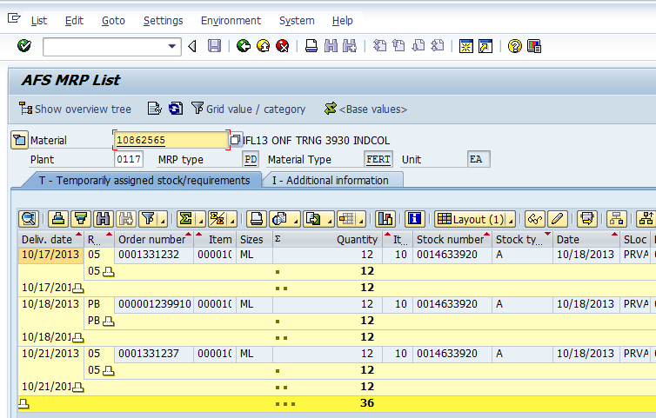

Since requirement date are different for sales orders and PIR separate proposals are generated as shown above.

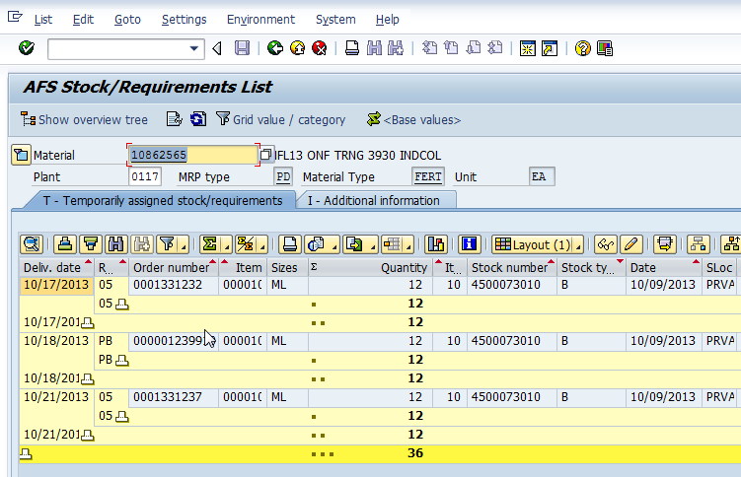

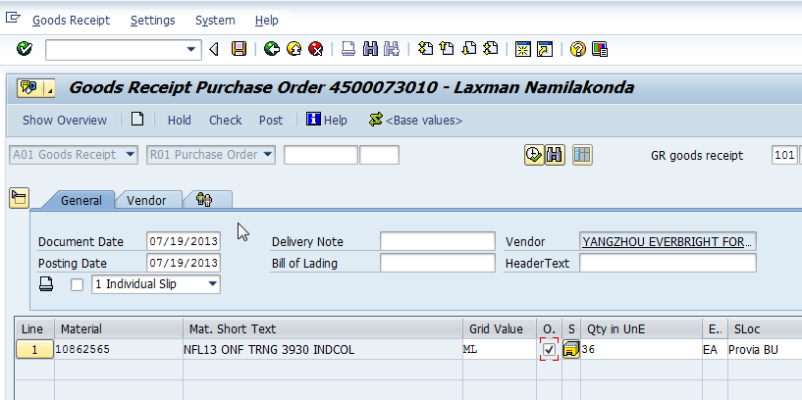

Then converted that purchase requisitions in to purchase order and did the goods receipt.
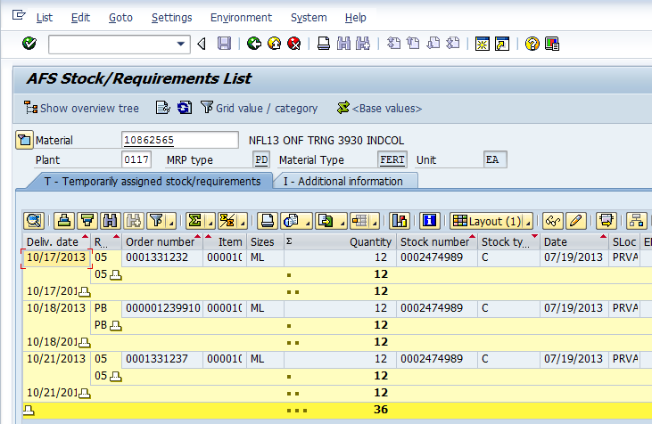

From the above we can understand that stock is assigned to sales orders and PIR.

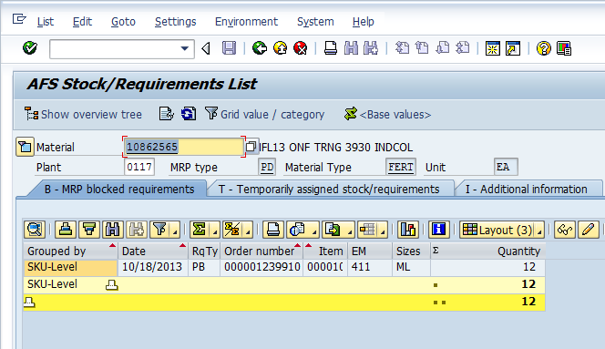

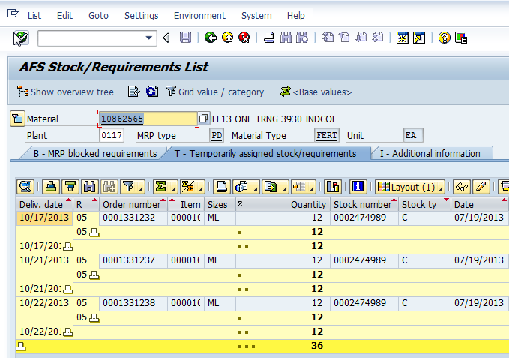

Then we got a new sales order 1331238 with a delivery date of 10/22/2013. So since this is a confirmed requirement stock is assigned to this sales order and PIR is moved to blocked stock.
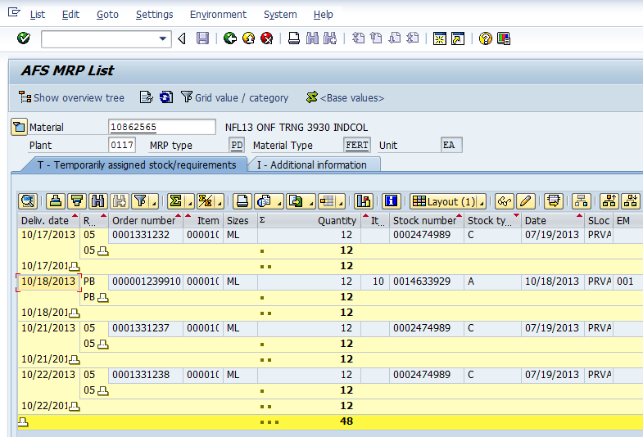

Once the MRP is ran a new proposal is generated against that PIR. From the above we can understand that a new purchase req is generated. Then that purchase req is converted to purchase order.

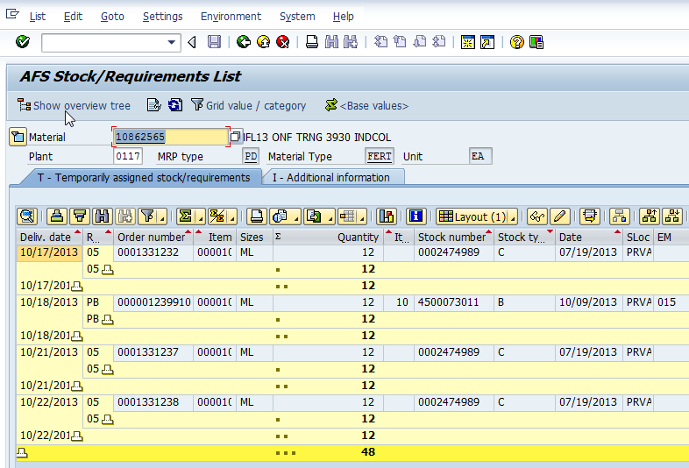

*End of Document*

