1. REQUIREMENT:

9207.100 - Investigate the purchase requisition release process by cost center. The process should also investigate the workflow process to evaluate how release notifications can be sent over to the approver.

2. TRANSACTION FLOW:

2.1 Create purchase requisition (me51n)

Since release procedure for purchase requisition is configured based on only material group ‘06’ (MRO), If we want release strategy need to specify the material group ‘06’ during creation of purchase requisition.

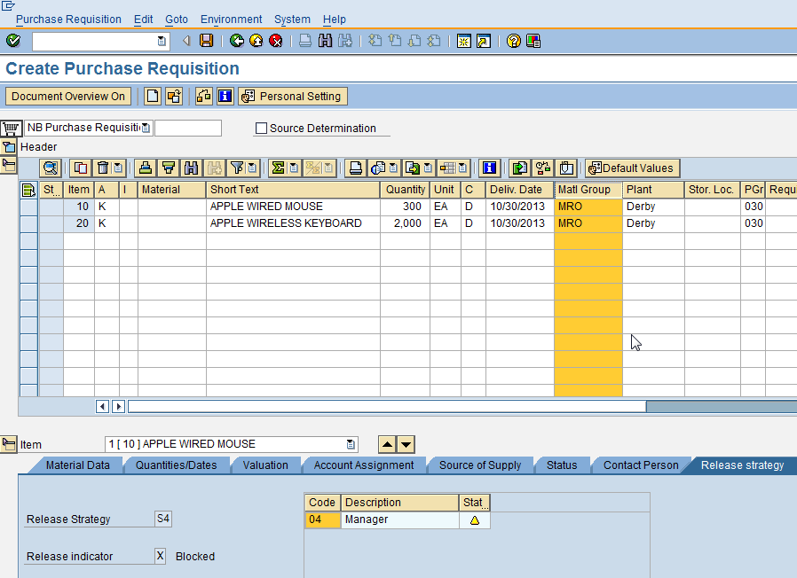

From the above and below screen shots, we can observe that based on net price at item level different strategies (Hierarchies) are determining. Strategy defines who has to release such as Manages, vice precedent etc.
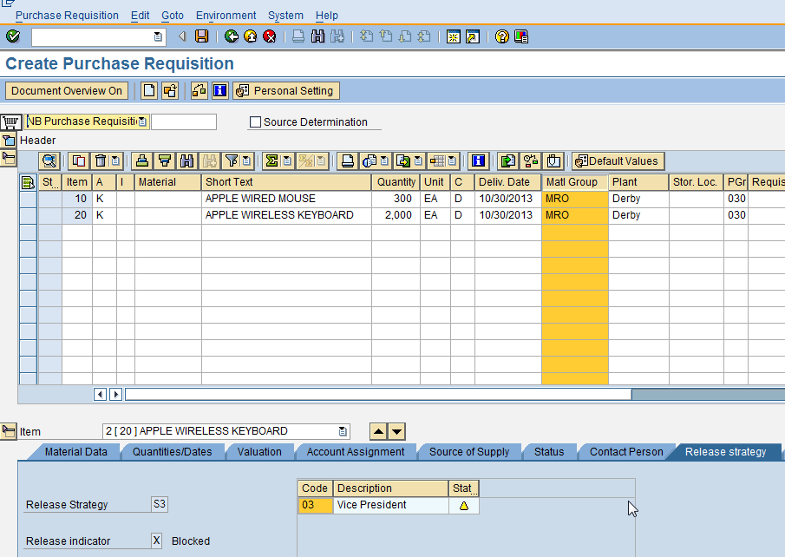

Purchase requisition number 0014634291 created

2.2 Release purchase requisition

2.2.1. Individual Release (me54n)

Please find below procedure for individual release of purchase requisition.

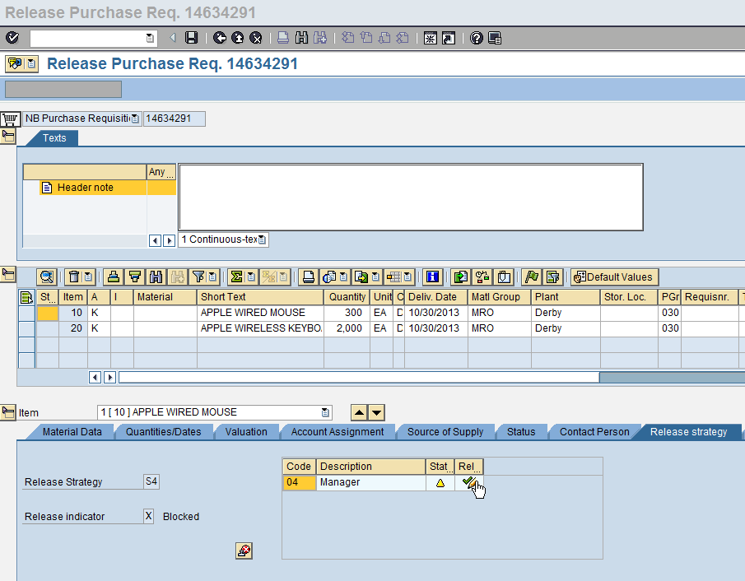

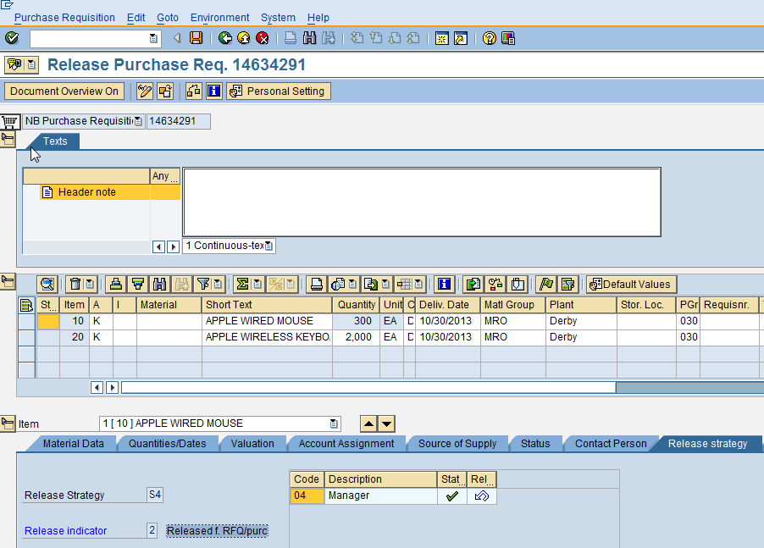

2.2.1. Collective Release (me55)

Please find below procedure for collective release of purchase requisition.

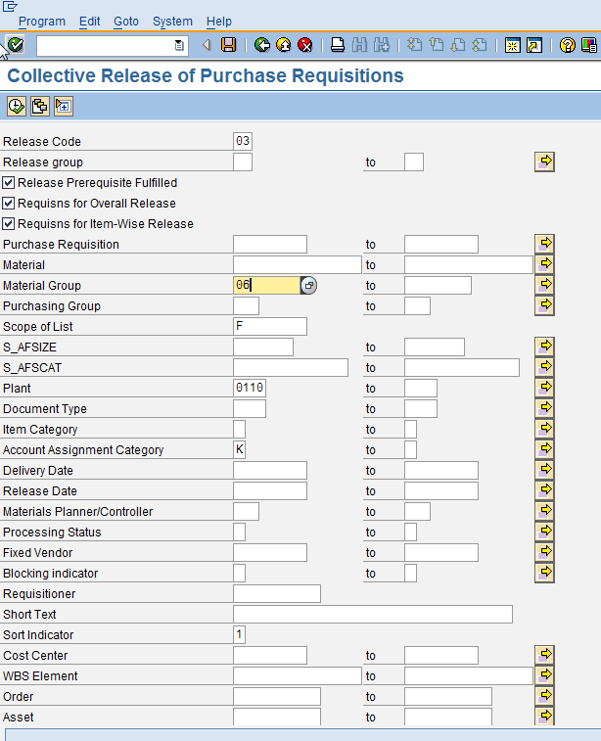

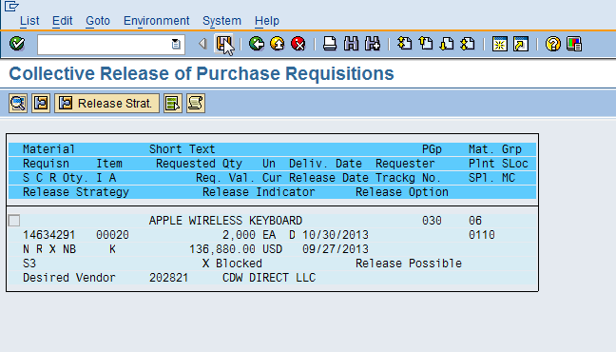

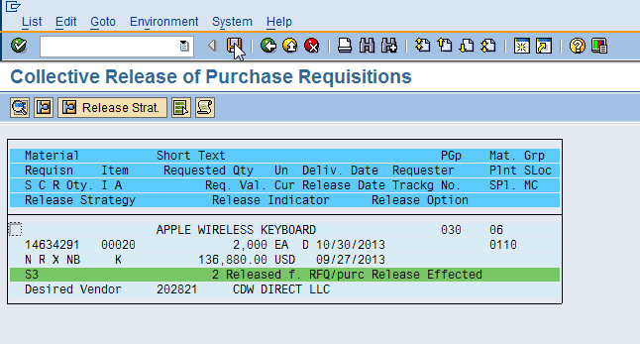

2.3 Create purchase order

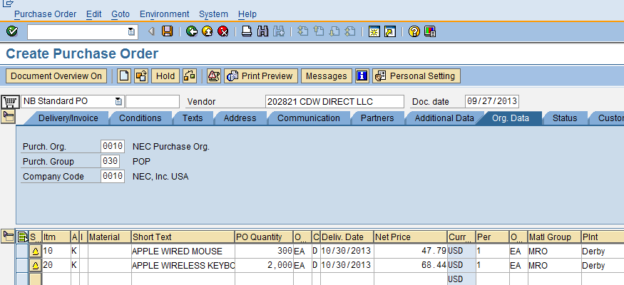

Standard PO created under the number 4500073177 using above released purchase requisition.

3. CONFIGURATION:

3.1 Set up Release procedure

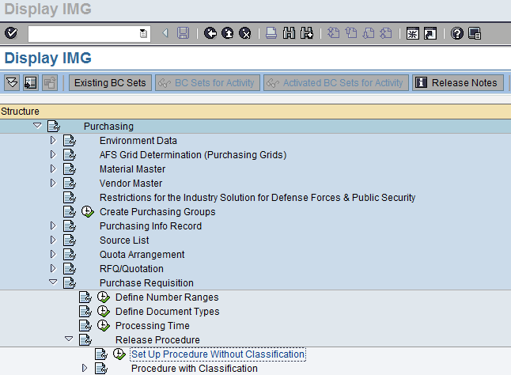

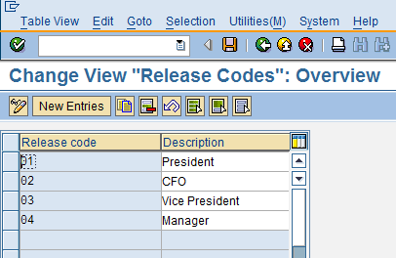

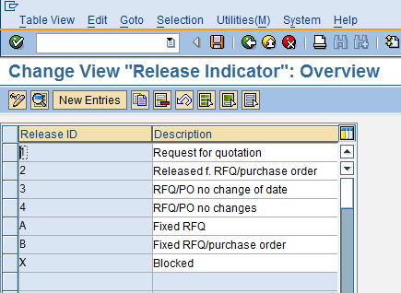

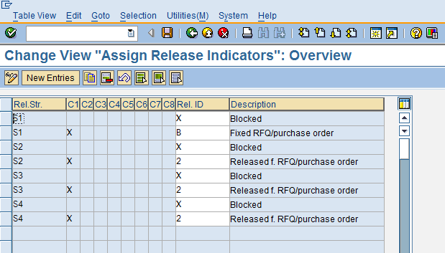

Release codes (Release authorities) are Manager, Vice president, CFO and president. Authorization for release is based on value at item level. This we can understand from the below.
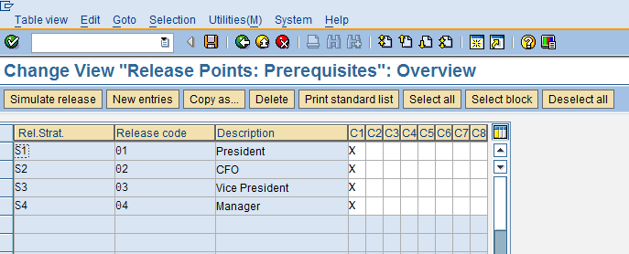

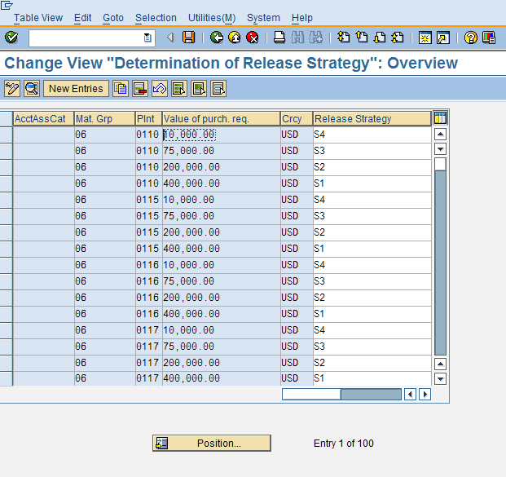

*End of Document*

