1. REQUIREMENT:

8741.400 - Investigate the purchase requisition release process by cost center. The process should also investigate the workflow process to evaluate how release notifications can be sent over to the approver.

1. Set purchase requisition release procedures at header level
2. Trigger workflow for approval based on dollar limits
3. While sending workflow, send approval email to Outlook
4. Use Active directory to determine supervisor to send an approval email
5. Approvals should happen in outlook and correspondingly complete workflow in SAP

2. TRANSACTION FLOW:

2.1 Create purchase requisition (me51n)

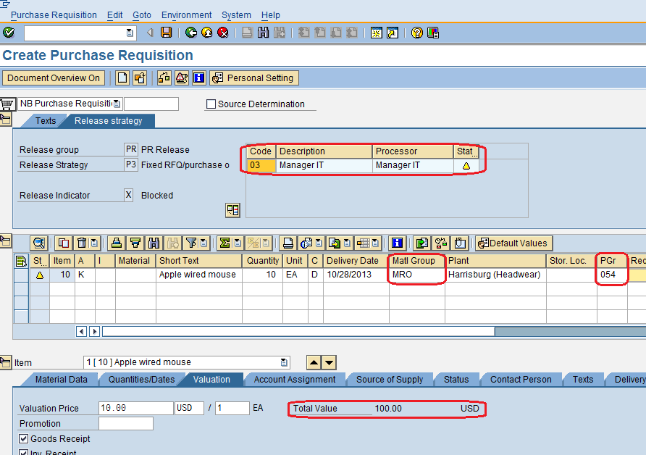

Purchase requisition release procedure is determined by material group, purchasing group and by net value. If net value and purchasing group is changed processor will change. From the above we can understand that if material group is 06, purchasing group is 054 and net value is 0-1000 USD then processor is Manager IT.

Purchase requisition number 0012538805 created

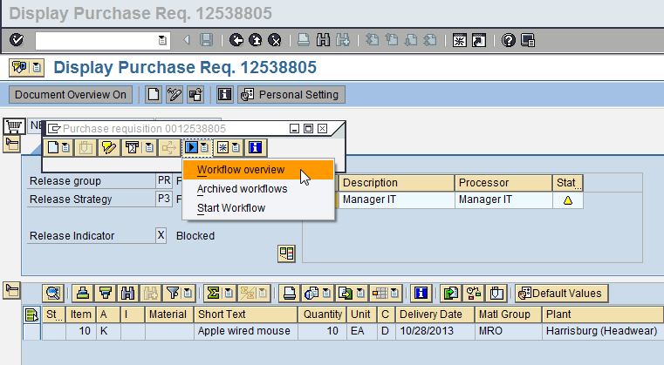

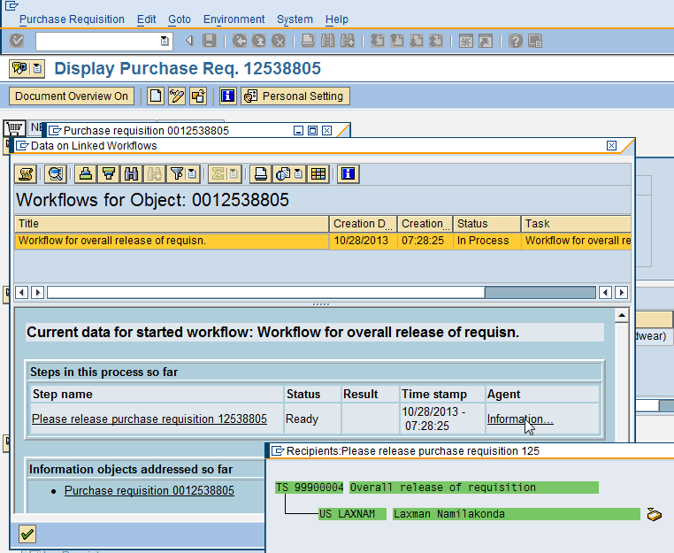

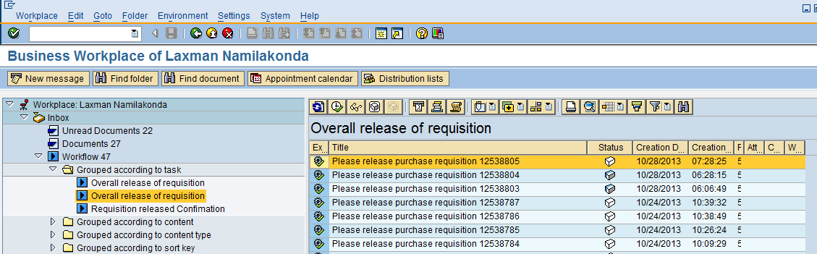

From the above we can understand that once the purchase requisition is saved workflow will trigger a notification to processor (Manager IT) for release. Workflow is configured based on position. So notification will go to Manager IT. For example in our case manager IT is Laxman Namilakonda. So notification will go to Laxman Namilakonda.

If required we can release the purchase requisition form SAP inbox by double click on the notification.

2.2 Release purchase requisition through outlook

As per our scenario we need to get the notification outlook and from there itself purchase requisition is released. So for that we need execute below program. Actually this need be executed as batch job.

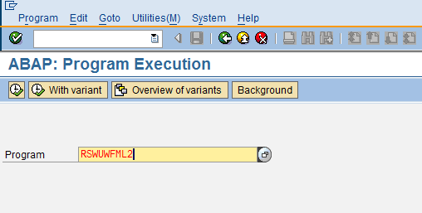

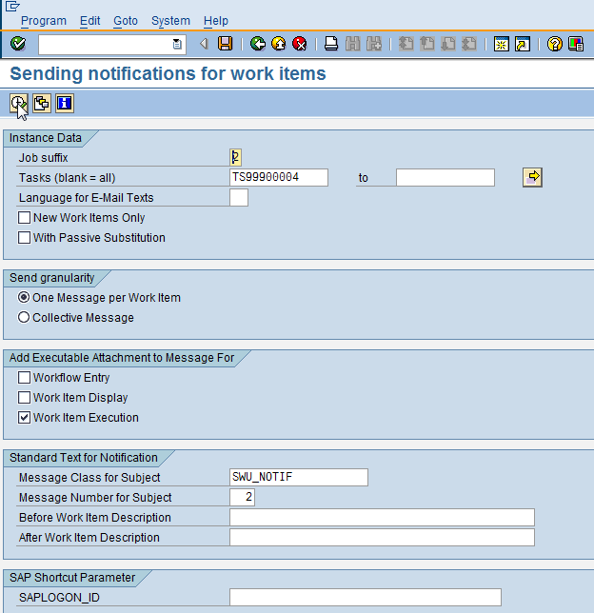

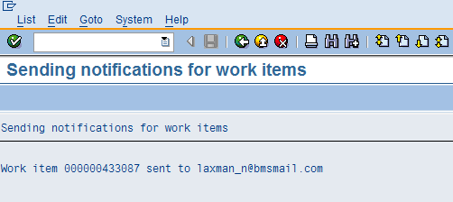

2.3 Send transmission request

As we are aware that all the transmission requests will be need to be processed from SOST transaction. Understand that currently this job is defined as a batch job.

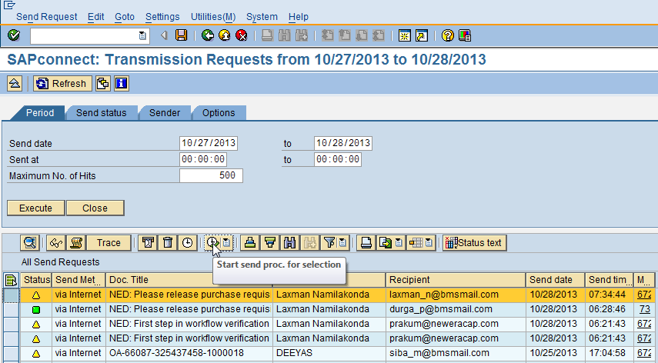

For manual processing select the notification and execute as shown above.

2.4 Release from outlook

Then user will get the notification to outlook as shown below.

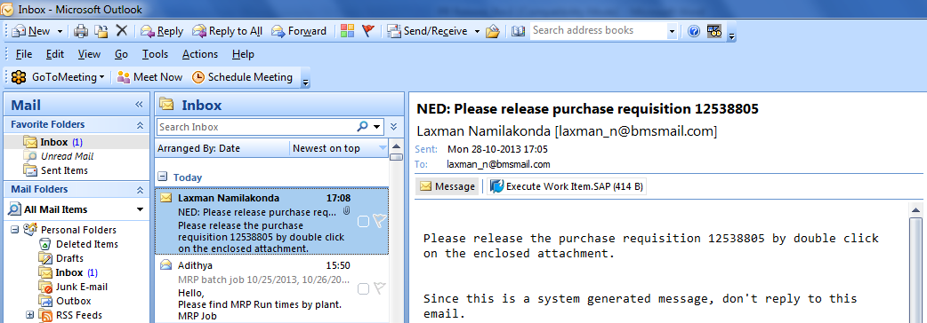

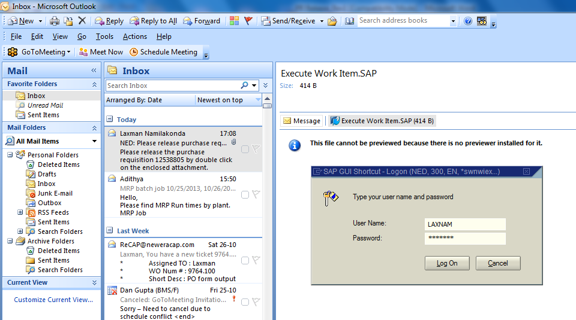

Then by double click on the attachment SAP login will be popup to enter the credentials to release the purchase requisition.

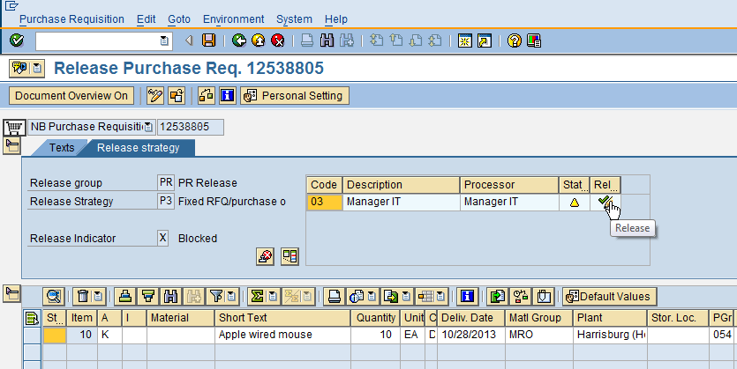

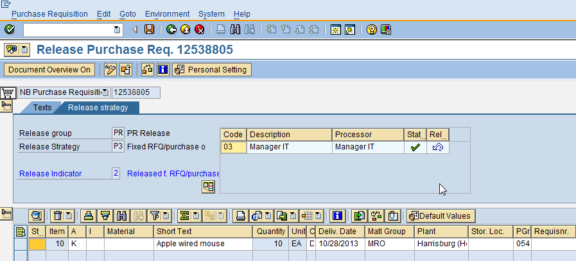

As shown above we need to release the purchase requisition. To restrict the release we need to maintain the authorization object in all the corresponding M_EINK_FRG.

3. PRE-REQUISITIES:

3.1 Create organization structure (T.code: ppoce/ ppome)

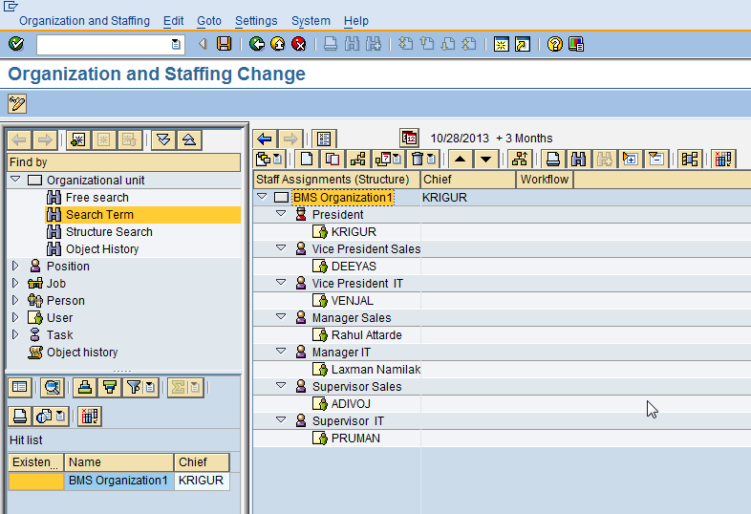

Since we have configured the purchase requisition based on position we need to maintain the organization structure and maintain the relationships (Hierarchies) as shown below.

T. code PP02

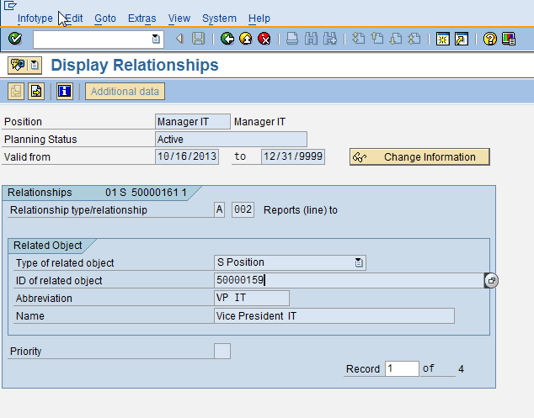

4. CONFIGURATION:

4.1 Set up Release procedure

Since we want workflow setup need to do the configuration as shown below.

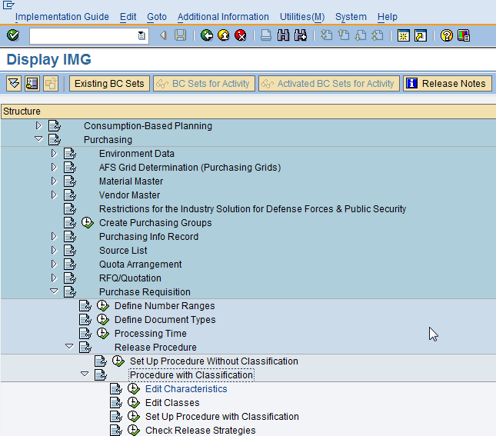

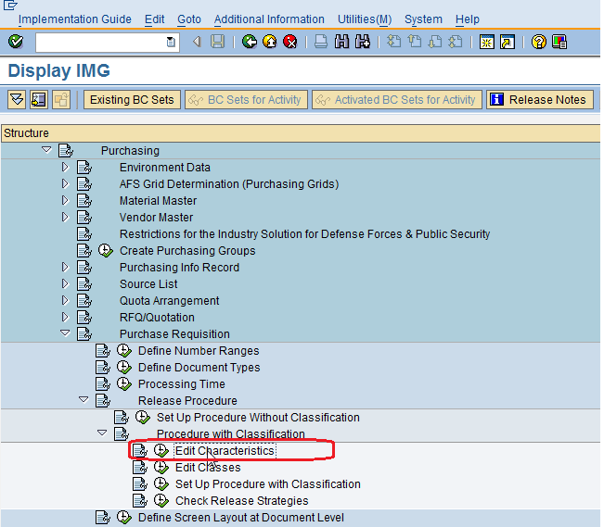

First we need to need to create the characteristics as shown below.
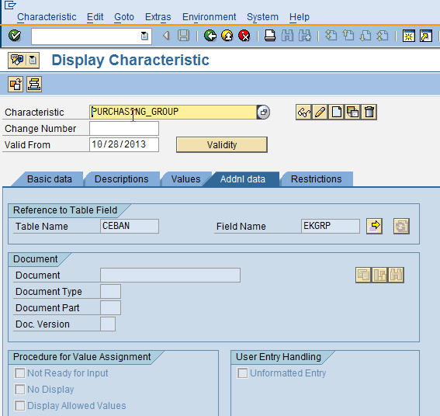

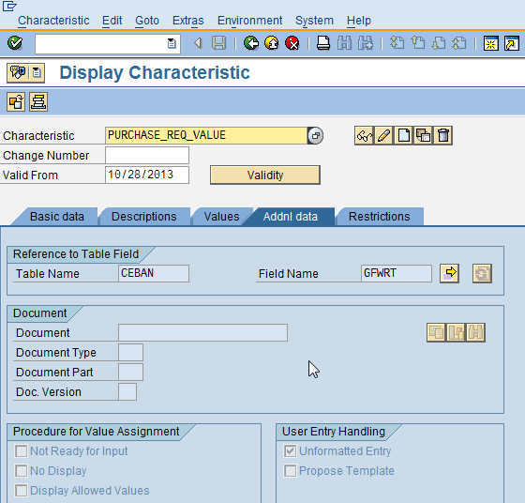

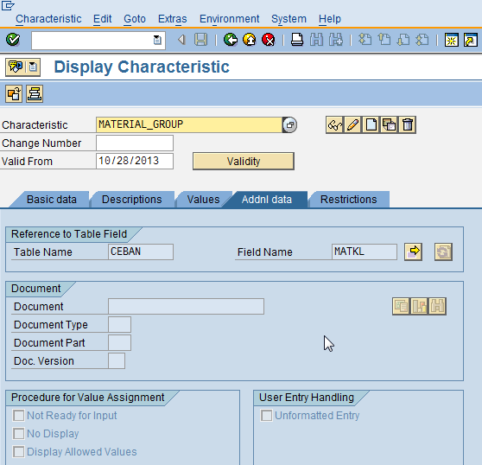

Then we need to configure the class and assign above characteristics as shown below.

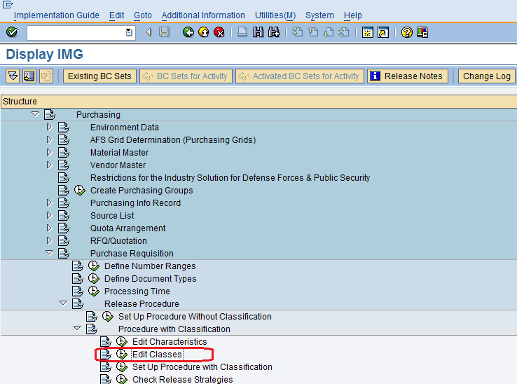

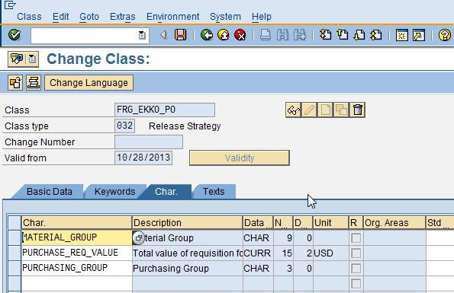

As shown below as per our requirement first we need to configure release codes and groups as shown below. Then we need to configure the release strategy as based on material group, purchasing group and by net price.

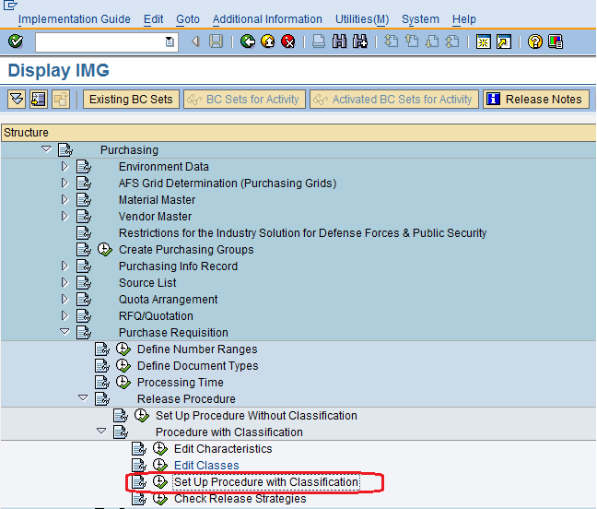

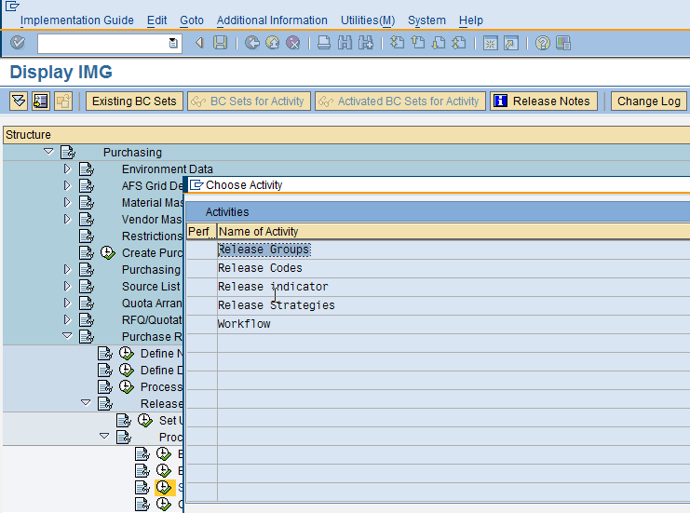

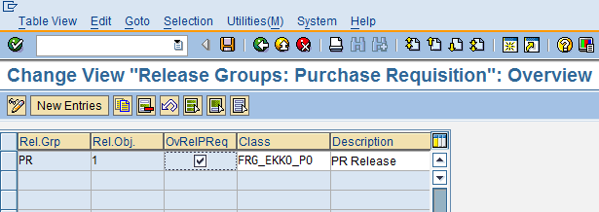

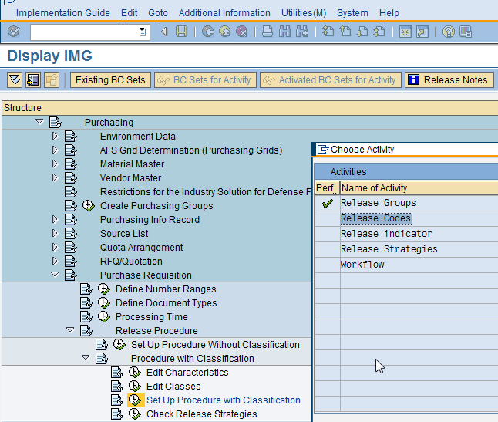

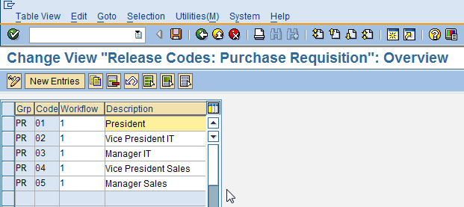

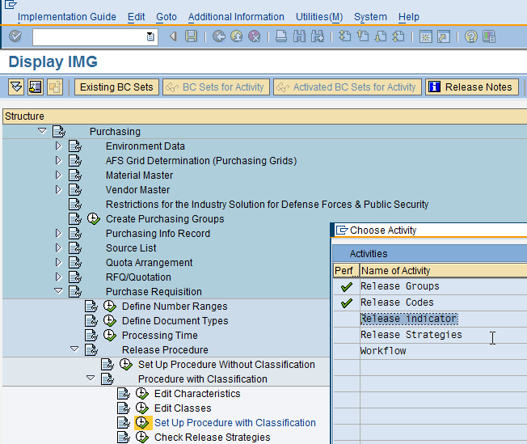

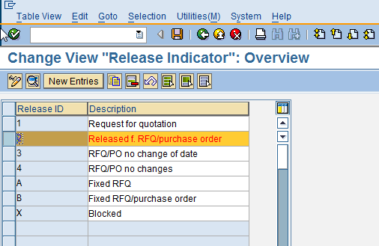

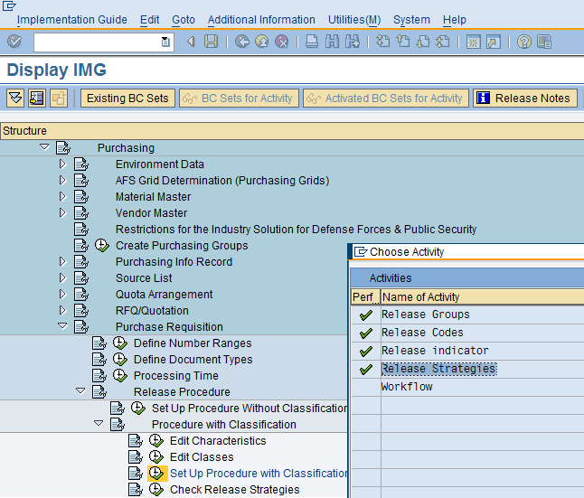

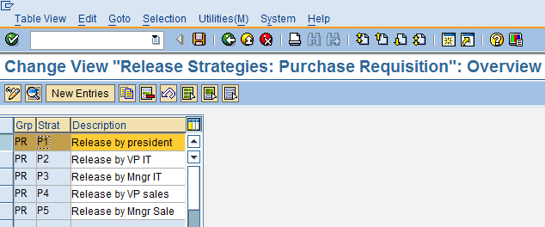

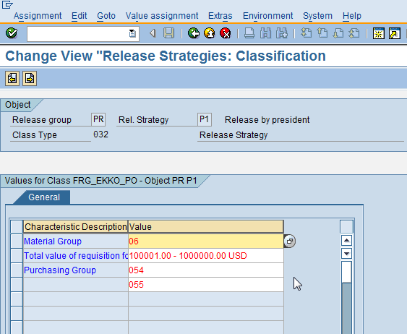

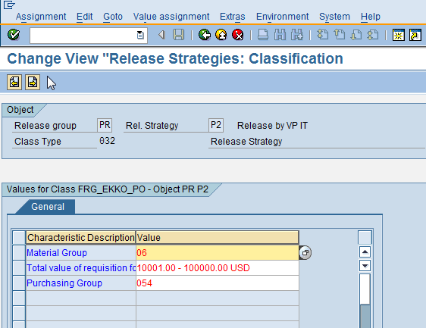

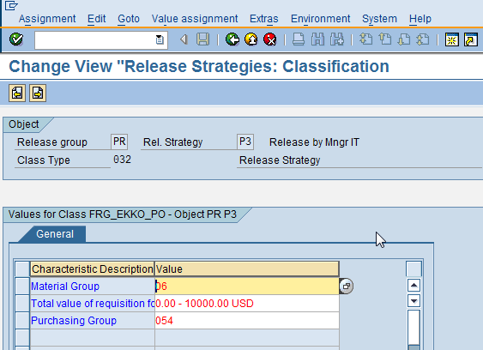

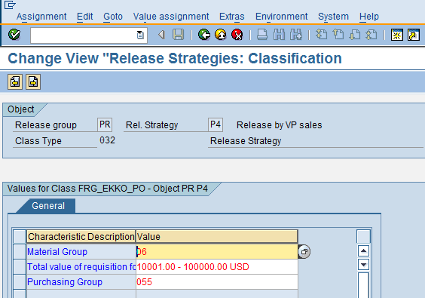

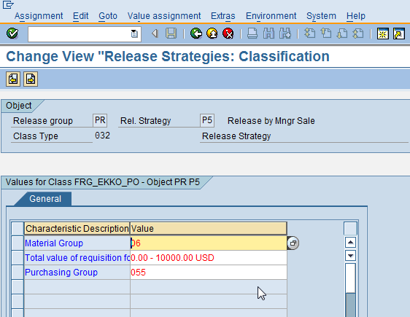

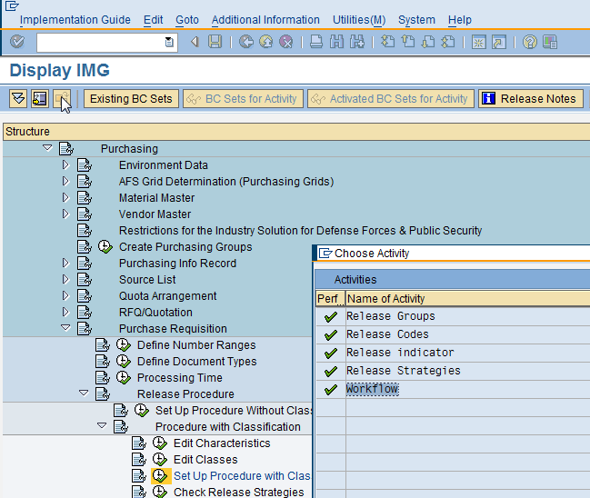

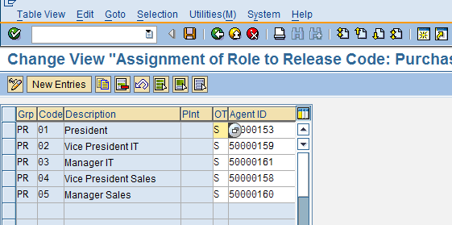

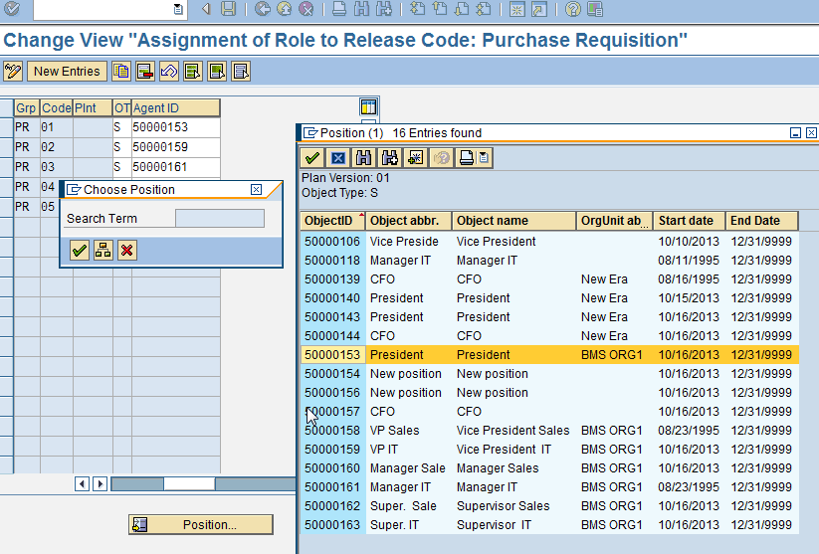

To get the workflow notifications configure the agent assignment by position as shown above. For this we need to define organization structure.

4. WORKFLOW SETUP:

4.1 Workflow setup (SWDD)

Define the workflow as shown below.

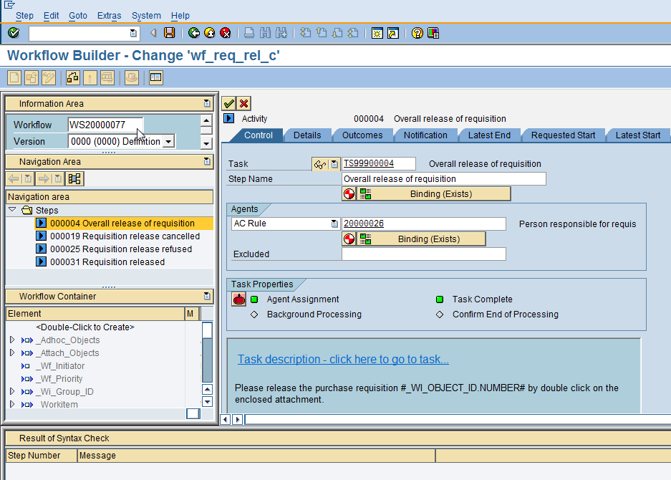

Here we have created our own task TS99900004 as shown below to write our own description.
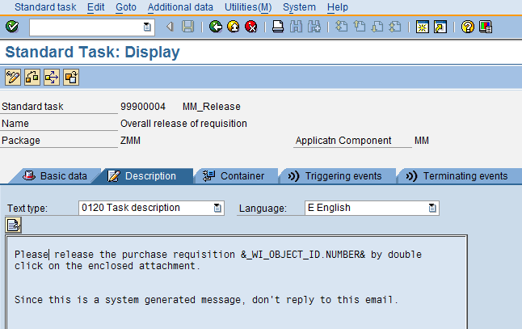

4.2 Extended Workflow setup (SWDD)

Configure the extended workflow setup as shown below to get the notifications in to outlook.
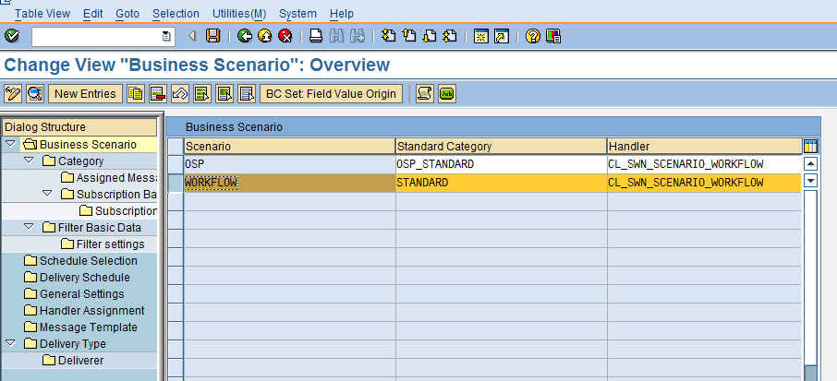

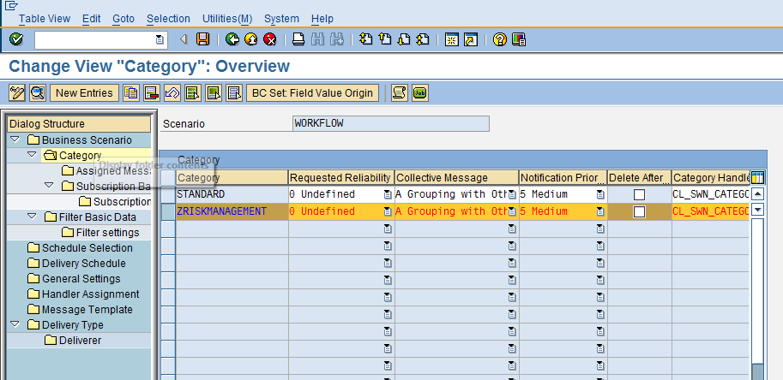
We have created new category ZRISKMANAGEMENT by copying from standard category.

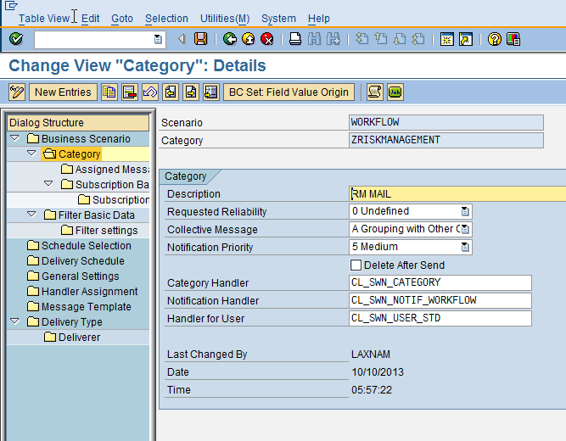

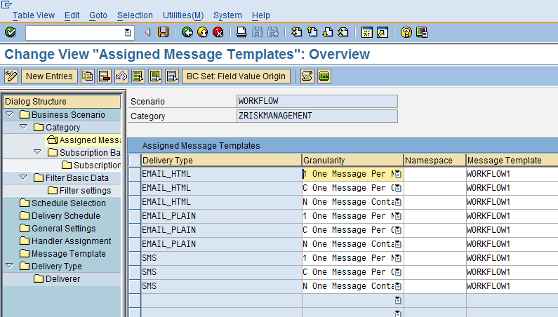

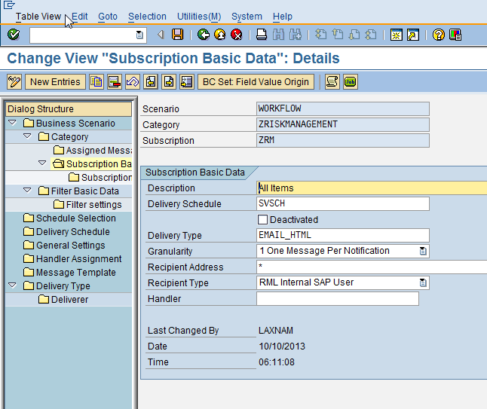

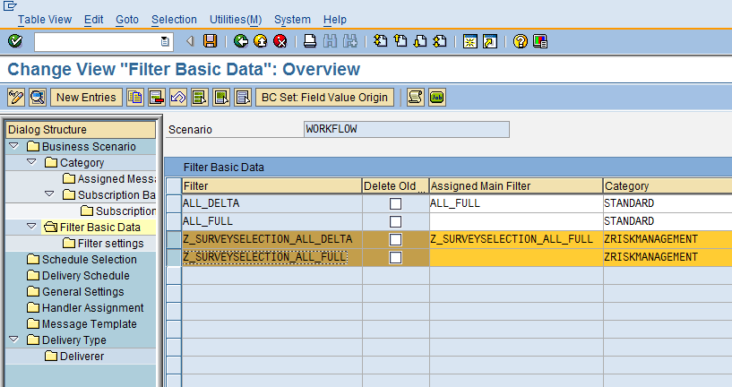
We have to create filters by copying from standard filters and schedule as shown below.

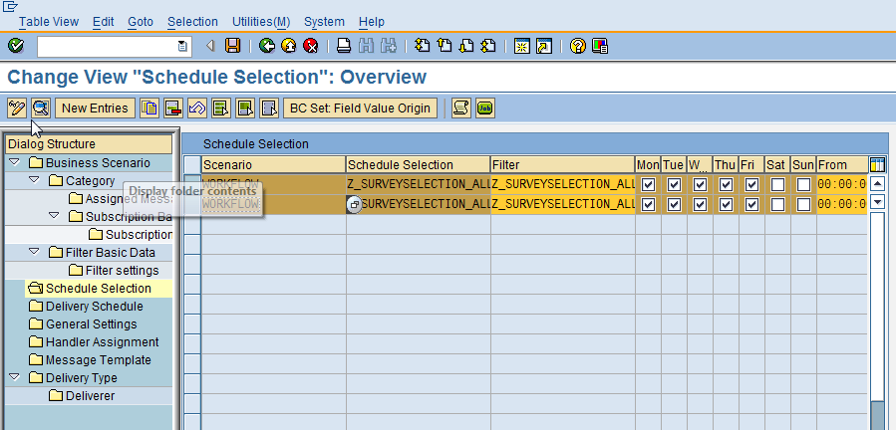

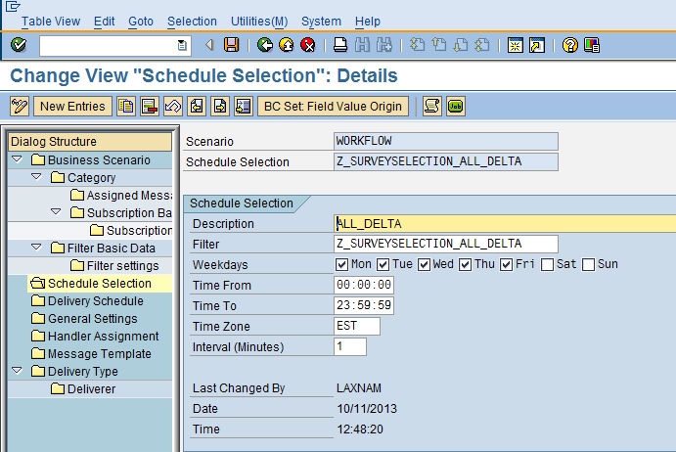

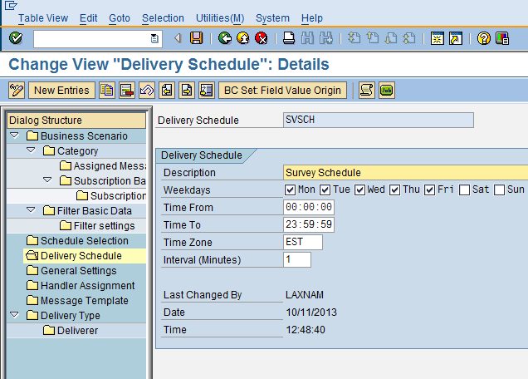

*End of Document*

