Parallel ARUN set up with Direct Access Rule

Pre-requisites:

1. ARUN types are created with S003 (Direct Access)-

**ARUN Type Description**

ZP01 NEC PARUN (Stock)

ZP02 NEC PARUN (Program)

ZPRS NEC Residual PARUN (QS)

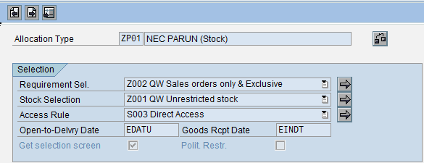

1. Selection sets were created, one each for each of the ARUN types above and for the existing ARUN types aswell-

**Selection Set ARUN Type Access Rule**

100000081 ZP01 S003

100000082 ZP02 S003

100000083 ZPRS S003

100000084 Z001 S003

100000085 Z002 S003

100000086 ZRES S003

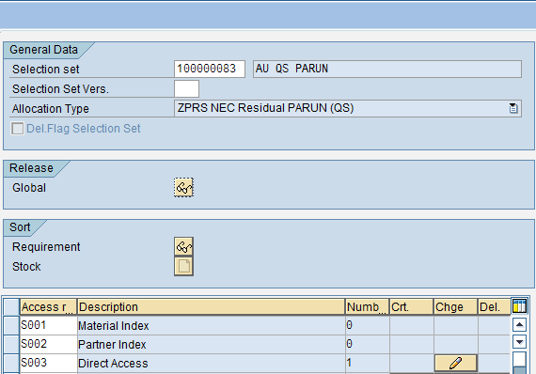

1. Variants were created for each of the selection sets-

**Selection set Variant**

100000081 AU STOCK PARUN

100000082 AU PROGRAM PAR

100000083 AU QS PARUN

100000084 AU STOCK PA1

100000085 AU PROGRAM PA1

100000086 AU QS PA1

NB: The variants (100000081/2/3) were created in Mode -3 and later changed to Mode-1 for testing purposes.

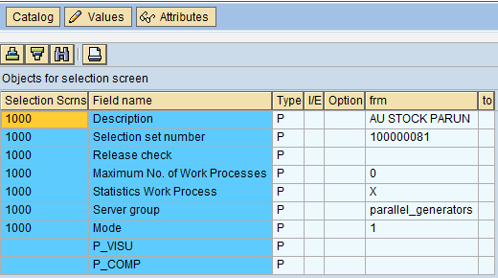

* 1. Job (AU SD PARUN) was set up with the program /AFS/ARUN_PARALLEL and steps were created with variants for testing purpose-

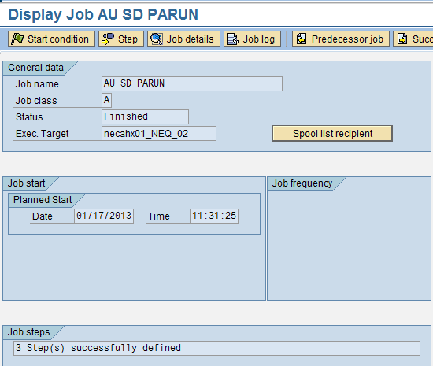

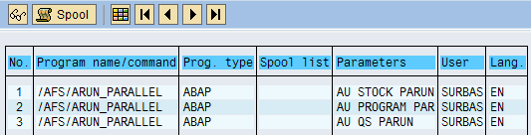

* 1. Job (AU SD PA1) was set up with the program /AFS/ARUN_PARALLEL and steps were created with variants (100000084/5/6) for testing purpose-

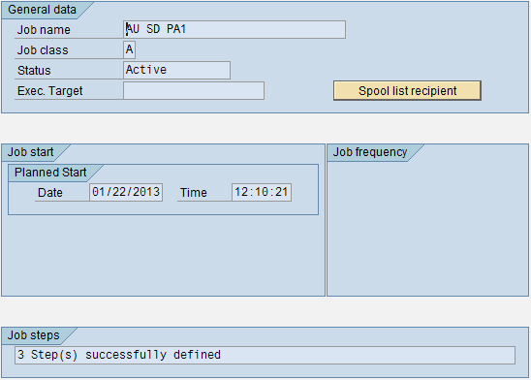

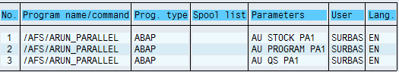

1. The SO/s was de-allocated with the ARUN number/s in J4AB when the Transaction/Job was executed in normal mode.

NB: The job was triggered in Class – A (High priority) and Class – C (Low Priority) for testing purposes.

**The following test Scenarios were executed in system NEQ100:**

1. AU SD PARUN was executed in background with Class – A (High priority) with variants in Mode – 3 (simulation).
2. AU SD PARUN was executed in background with Class – C (Low priority) with variants in Mode -1 (normal).
3. AU SD PARUN was executed in background with Class – A (High priority) with variants in Mode -3 (simulation).
4. AU SD PARUN was executed in background with Class – C (Low priority) with variants in Mode -1 (normal).
5. J4AE was run in dialog with each of the above variants in Modes -3 and 1.

**Observations of AU SD PARUN:**

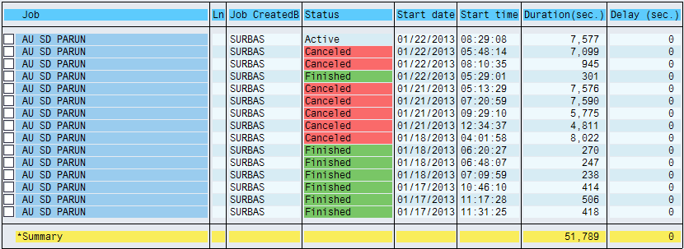

1. The results were inconsistent with the above mentioned scenarios in background with

AU SD PARUN.

The program was successful in few instances and failed when it was rescheduled with the same set up or with changed set up.

|  |  |  |  |  |
| --- | --- | --- | --- | --- |
| **Job** | **Job Class** | **Variant/s Mode** | **Date** | **Result** |
| AU SD PARUN | C | 3 | 01/17/2013 | Pass |
| AU SD PARUN | C | 3 | 01/17/2013 | Pass |
| AU SD PARUN | A | 1 | 01/17/2013 | Pass |
| AU SD PARUN | A | 1 | 01/18/2013 | Fail |
| AU SD PARUN | A | 1 | 01/18/2013 | Pass |
| AU SD PARUN | A | 3 | 01/18/2013 | Pass |
| AU SD PARUN | A | 3 | 01/18/2013 | Pass |
| AU SD ARUN | A | 1 | 01/21/2013 | Fail |
| AU SD ARUN | A | 1 | 01/21/2013 | Fail |
| AU SD ARUN | A | 1 | 01/21/2013 | Fail |
| AU SD ARUN | A | 3 | 01/22/2013 | Pass |
| AU SD ARUN | A | 3 | 01/22/2013 | Fail |
| AU SD ARUN | A | 3 | 01/22/2013 | Fail |
| AU SD PA1 | A | 3 | 01/22/2013 | Active |

The program was required to be cancelled to carry out further tests.

In debug mode, the program was stuck indefinitely for want of free work processes-

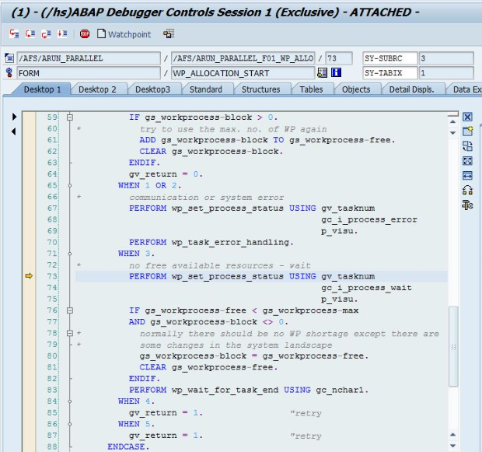

1. Inconsistent results were observed in dialog as well in J4AE.

|  |  |  |  |  |
| --- | --- | --- | --- | --- |
| **Transaction** | **Variant** | **Mode** | **Date** | **Result** |
| J4AE | AU STOCK PARUN | 3 | 01/17/2013 | Fail |
| J4AE | AU STOCK PARUN | 3 | 01/18/2013 | Pass |
| J4AE | AU STOCK PARUN | 1 | 01/18/2013 | Fail |
| J4AE | AU PROGRAM PAR | 3 | 01/18/2013 | Pass |
| J4AE | AU QS PARUN | 3 | 01/18/2013 | Pass |
| J4AE | AU STOCK PARUN | 1 | 01/18/2013 | Pass |

Following run time error was observed-

