**The following types were set up using Direct Access Rule and tests were run in Dialog (J4AE) and in background (Job: AU SD PARUN)**

**ARUN Type Description Selection Set Access Rule Variant**

ZP01 NEC PARUN (Stock) 100000081 Direct Access AU STOCK PARUN

ZP02 NEC PARUN (Program) 100000082 Direct Access AU PROGRAM PAR

ZPRS NEC Residual PARUN (QS) 100000083 Direct Access AU QS PARUN

**Direct Access Rule – S003**

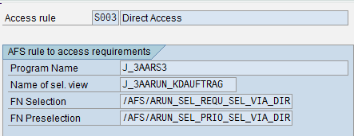

**ARUN Type ZP01 with Direct Access Rule**

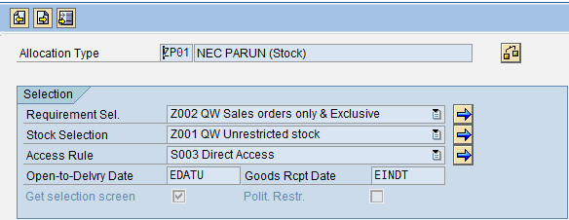

The following scenarios were executed in NEQ100-

**Scenario 1:** Background Job (AU SD PARUN) was set up with program (/AFS/ARUN_PARALLEL). The job priority was set to ‘C’ (Low priority)

Selection sets were created with Direct Access Rule.

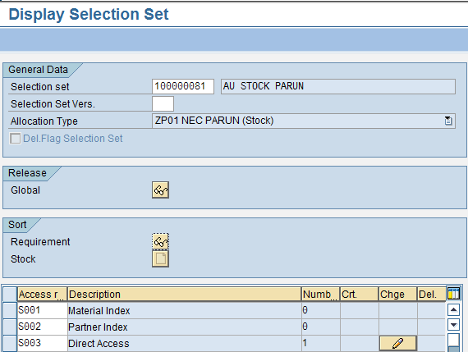

Variants were created in simulation mode-3 with selection sets 100000081/2/3.

**Result:** The job executed successfully in simulation and the ARUN numbers were updated.

|  |  |  |  |  |  |
| --- | --- | --- | --- | --- | --- |
| **Scenario** | **Selection Set/s** | **Variants** | **Job Name/Trans** | **Duration**  **(Sec)** | **Date** |
| Scenario -1 | 100000081/2/3 | AU –  STOCK PARUN, PROGRAM PARUN,  QS PARUN | AU SD PARUN | 414 | 01/17/2013 |
| Scenario -2 | 100000081/2/3 | 506 |
| Scenario -3 | 100000081/2/3 | 418 |

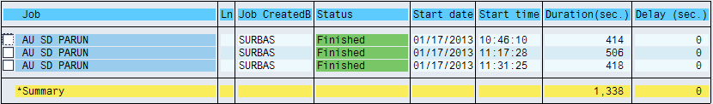

**Scenario 2:** The Job AU SD PARUN was triggered with priority-A (High).

**Result:** The job executed successfully in simulation and the ARUN numbers were updated.

**Scenario 3:** The Job AU SD PARUN was triggered with priority-A (High). The variants were changed to Mode-1 (Normal).

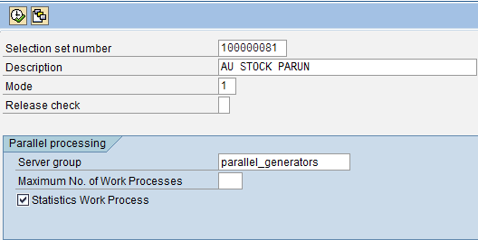

**Result:** The job executed successfully in normal mode and the ARUN numbers were updated. The SO’s were de allocated to carry out further testing.

|  |  |  |  |  |  |  |  |
| --- | --- | --- | --- | --- | --- | --- | --- |
| **Scenario** | **Selection Set/s** | **Mode** | **Job Name/Trans** | **Duration**  **(Sec)** | **Date** | **ARUN Num** | **Comments** |
| Scenario -4 | 100000081 | 3 | J4AE | Run Time error | 01/17/2013 | NA | NA |
| Scenario -5 | 100000081 | 3 | 13 | 01/18/2013 | 1354888 | NA |
| Scenario -6 | 100000081 | 1 | Run Time error | 01/18/2013 | NA | NA |
| Scenario -7 | 100000082 | 3 | 26 | 1354890 | NA |
| Scenario -8 | 100000083 | 3 | 10 | 1354891 | NA |
| Scenario -9 | 100000081 | 1 | 5 | 1354892 | The SO’s were de allocated |

**Scenario 4:** Runtime error

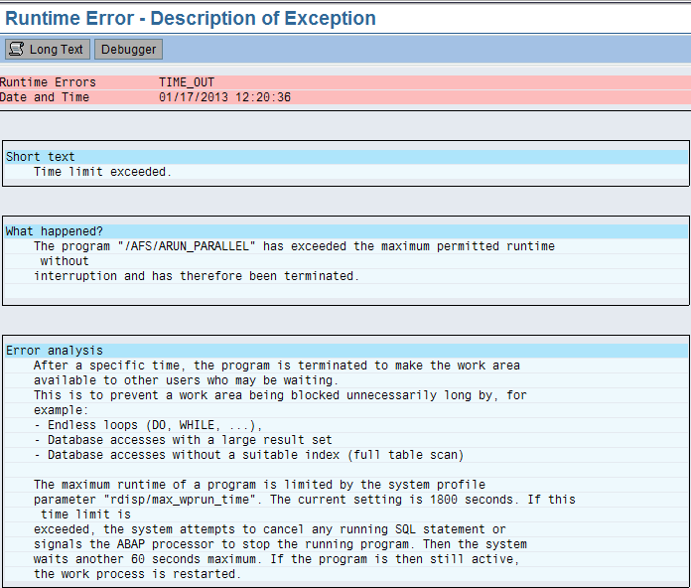

**Scenario 6:** Runtime error

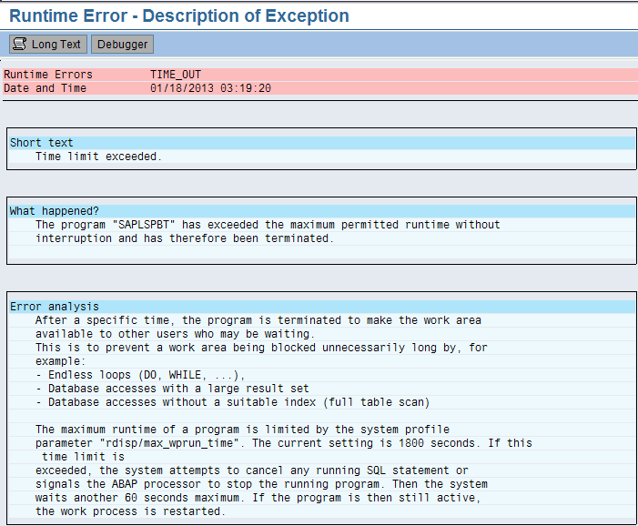

|  |  |  |  |  |  |  |
| --- | --- | --- | --- | --- | --- | --- |
| **Scenario** | **Selection Set/s** | **Variants** | **Job Name/Trans** | **Duration**  **(Sec)** | **Date** | **Comments** |
| Scenario -10 | 100000081/2/3 | In Mode-3 | AU SD PARUN | 8022 | 01/18/2013 | Job was cancelled |
| Scenario -11 | 100000081/2/3 | In Mode-1 | 270 | ARUN updated and was de- allocated |
| Scenario -12 | 100000081/2/3 | In Mode-3 | 247 | ARUN updated |
| Scenario -13 | 100000081/2/3 | In Mode-3 | 238 |

In the above scenarios, the variants were changed to Mode -1, and the job priority was set to

‘A’ (High).

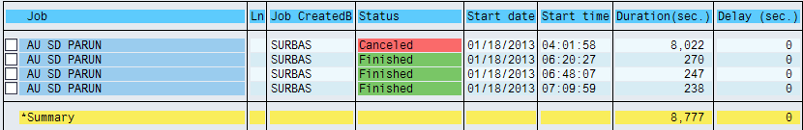

**Scenario -10:** The point at which the program was stuck for lack of work processes.

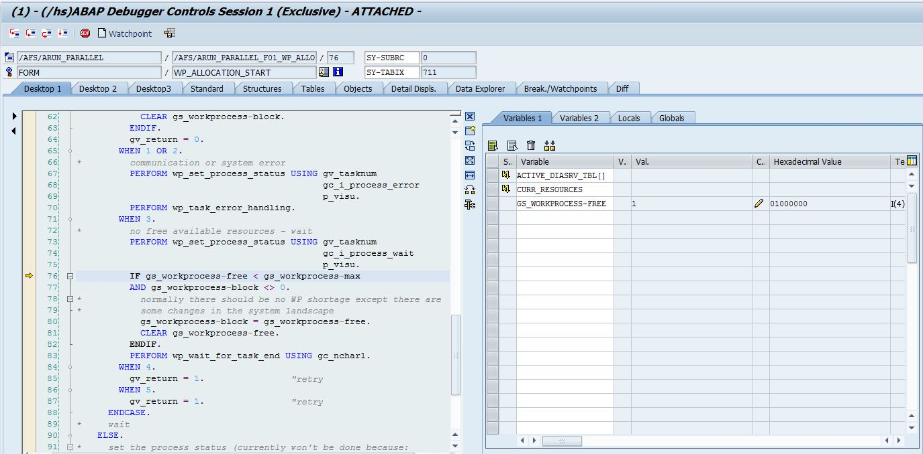

The ARUN job was created in ‘A’-High priority and the variants were changed to normal mode-1 and were triggered. The jobs were required to be cancelled as the program was stuck each time for lack of work processes.

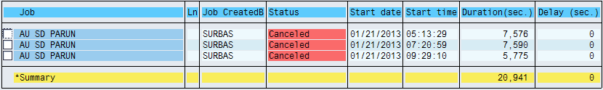

Program in debug mode-

