**Parallel ARUN – Lock Issues**

**Pre-requisites:**

The following selection sets were used and variants were created and steps were maintained in the Jobs-

|  |  |  |  |
| --- | --- | --- | --- |
| **Job/Transaction** | **Selection Set** | **Variant** | **ARUN Type–Access Rule** |
| AU SD PARUN | SDRQ | AU STK BALANCE |  |
| 100000084 | AU STOCK PA1 | Z001 - S003 |
| 100000085 | AU PROGRAM PA1 | Z002 - S003 |
| 100000086 | AU QS PA1 | ZRES - S003 |
| SDRQ | AU FUT RECEPTS |  |
| SDRQ | AU STK BALANCE |  |
| SDRQ | EMEA STK BAL |  |
| EMEA SD PARUN | 100000112 | EMEA CON PARUN | Z001 - S003 |
| 100000113 | EMEA QS PARUN | ZRES - S003 |
| SDRQ | UK FUT RECEPTS |  |
| SDRQ | EMEA STK BAL |  |
| EMEA SD PARUN | SDRQ | EMEA STK BAL |  |
| 100000114 | EMEA CON ZP01 | ZP01 - S003 |
| 100000115 | EMEA QS ZPRS | ZPRS - S003 |
| SDRQ | UK FUT RECPTS |  |
| SDRQ | EMEA STK BAL |  |
| NA SD PARUN | SDRQ | NA STK BALANCE |  |
| 100000102 | NA STK PARUN | Z001 - S003 |
| 100000103 | NA PRG PARUN | Z002 - S003 |
| 100000104 | NA MTO PARUNS5 | Z004 - S003 |
| 100000105 | NA MTO PARUNS8 | Z004 - S003 |
| 100000106 | NA MTO PARUNS9 | Z004 - S003 |
| 100000107 | NA MTOPARUNS12 | Z004 - S003 |
| 100000108 | NA MTOPARUNS13 | Z004 - S003 |
| 100000109 | NA STKPARUN515 | Z001 - S003 |
| 100000110 | NA PRGPARUN515 | Z002 - S003 |
| 100000111 | NA QS PARUN | ZRES - S003 |
| SDRQ | FUTURE RECPTS |  |
| SDRQ | NA STK BALANCE |  |

**Program/s Used:**

1. /AFS/ARUN_PARALLEL
2. /AFS/SDRQ

The following are the issues that are faced in executing the parallel ARUN in background with the program /AFS/ARUN_PARALLEL:

1. Sales Orders and Materials are getting locked (not in all jobs/variants).

Sales Orders and Materials locked-

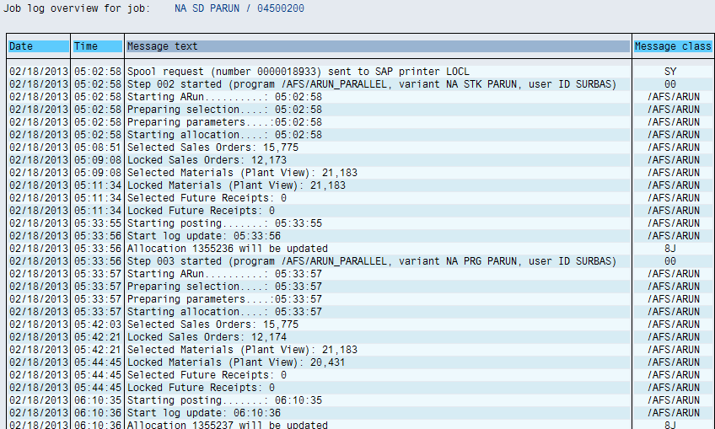

Sales Orders and Material not locked-

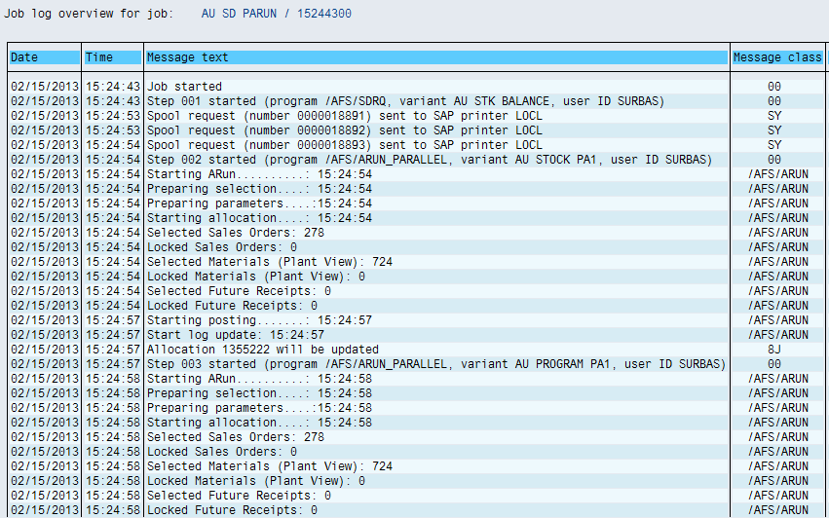

1. Though the job is triggered in the background, some foreground processes are triggered thereby preventing regular transactions like sales order creation, material document posting, TMS is impacted and Transports are not moved etc.

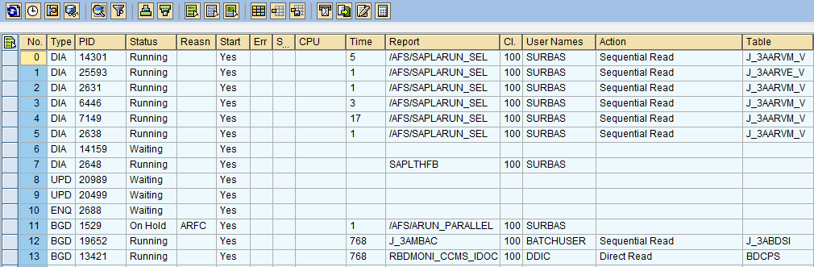

1. Simple transactions like creating sales order are not executing for lock table overflow while the parallel ARUN is in process. The lock appears against the user who actually is not running any transaction using VBAK.

Moreover, the some of the Sales Orders that appear in the lock are outside the selection set criteria.

E.g. Sales Order 819677 with cancellation date 05/02/2012 and delivery date 04/02/2012 is outside the selection set/s criteria in NA SD PARUN job

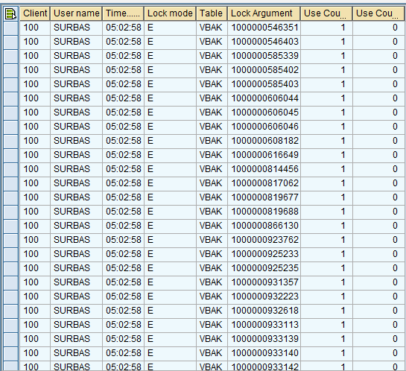

1. Sales Orders are not allocated for the issue reported in Item 1 where the SO’s and Materials are getting locked and even in both the scenario where the SO’s and Materials are not getting locked.

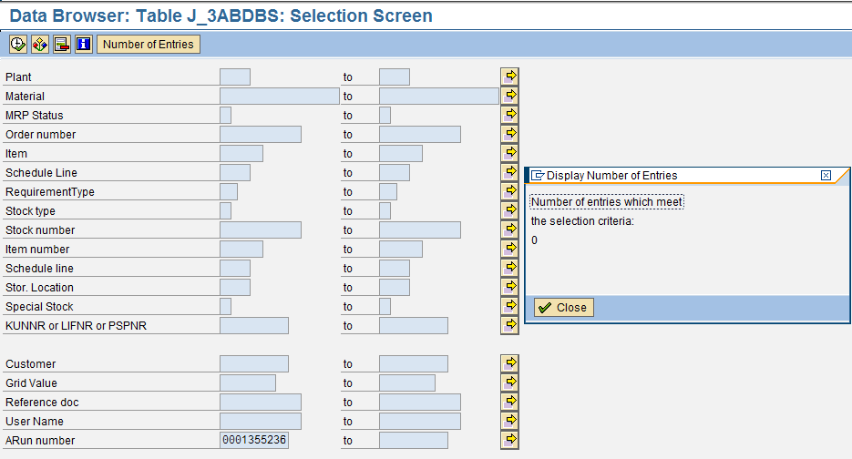

The exception report doesn’t show up all the sales orders that are selected/locked.

Eg. ARUN number 0001355236 exception log provides only 426 sales orders.

Job : NA SD PARUN

Date : 02/18/2013

Selected sales orders 15775; locked sales orders 12173

Exception Log

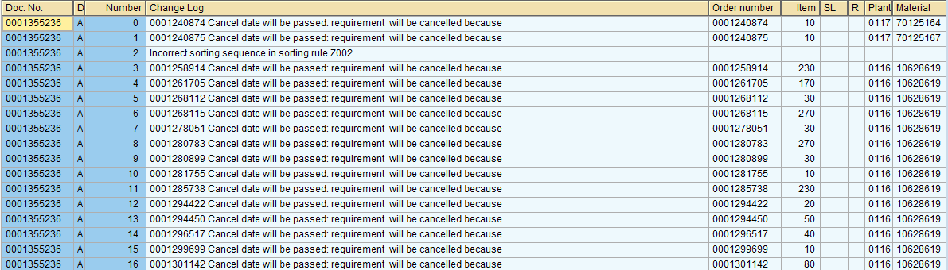

Parallel ARUN analysis (/AFS/ARUN_RFCLST) shows 86 sales orders

