**Issues Update with Examples– Allocation with J3AT Transaction**

**Steps to execute:**

***Method-1:***

Step1: Input ARUN number 1355236 (generated in Parallel ARUN) in transaction /AFS/ARUN_RFCLST (Analyse Parallel ARUN).

Step2: Select the radio button “Step Two – Orders per RFC” and execute.

Step3: Copy the SO’s (Document) from the resulting screen to input in J3AT transaction.

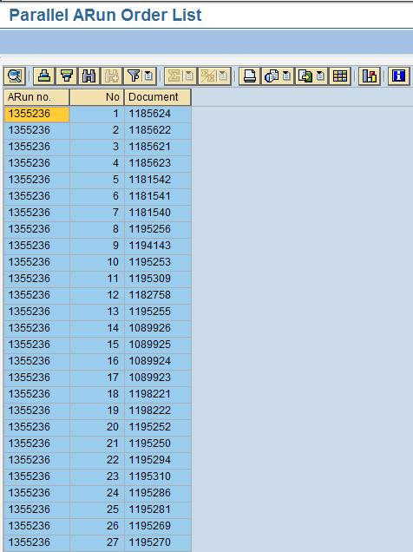

Step4: Input the data in the J3AT transaction as-

* Input plants as in the selection set 100000102

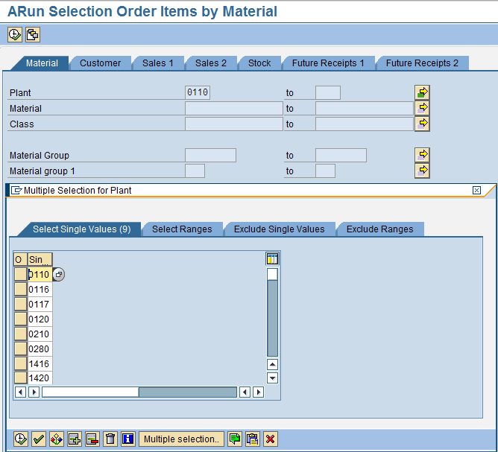

* Input the open to delivery date and the SO’s and execute the transaction. Hit Enter twice on the warning messages.

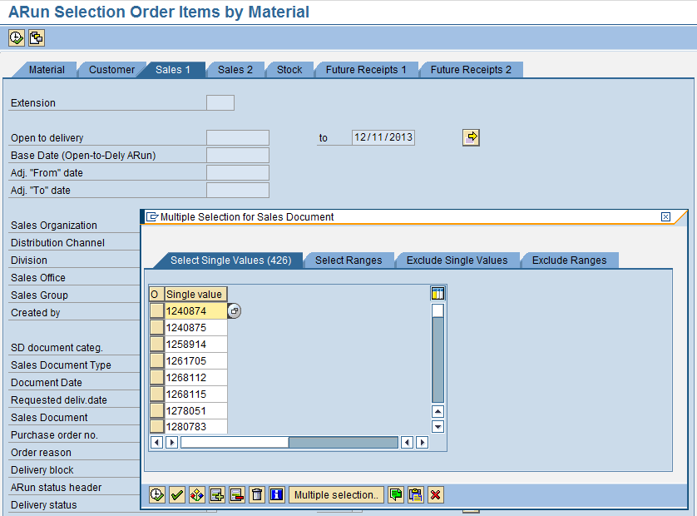

The following screen is displayed:

Screen shot 1-

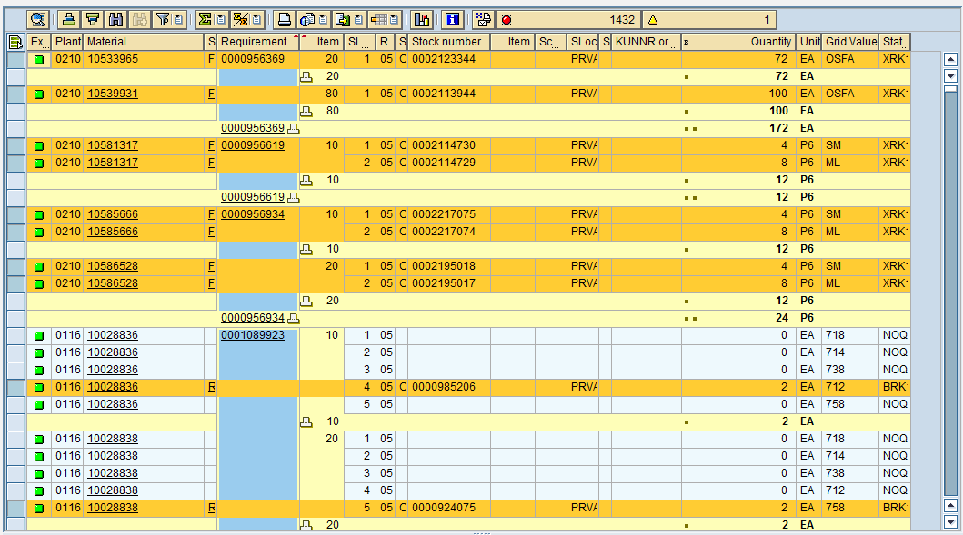

Screen shot 2-

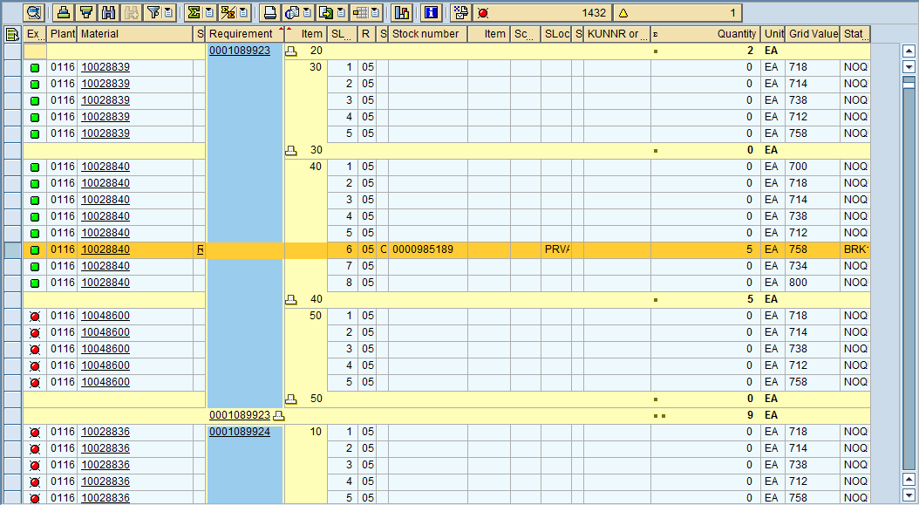

Screen shot 3-

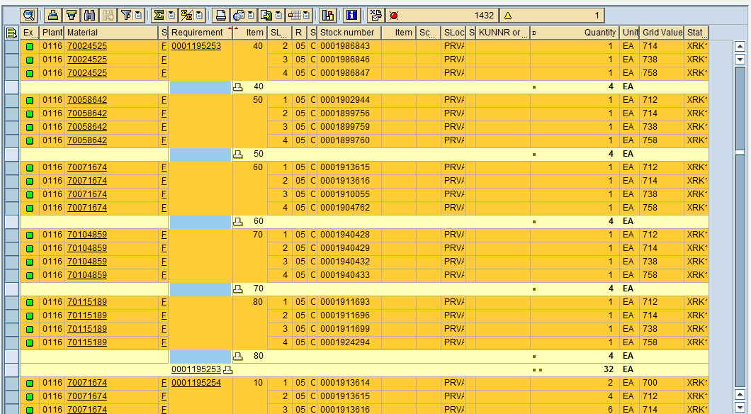

***Method-2:***

Example1: Input one of the SO’s 1200787 that meet the selection set criteria and allocate in

J3AT transaction by inputting the Plant, Delivery Date and SO in the selection screens in the Material and Sales1 Tabs respectively and execute. Hit Enter twice on the warning messages.

The system updates the allocation for the SO.

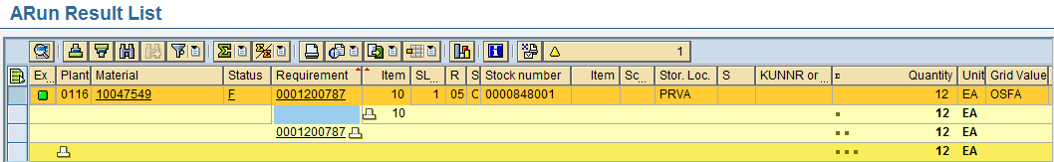

Example2: Repeat the earlier step for SO 1195312.

The system updates the allocation for the SO.

