**Parallel ARun**

**Functionality:**  Parallel ARun is basically used to carry out multiple processes by distributing the load evenly across the available servers.

**How is it performed?**

The relevant sales orders to be processed are selected in the first step. The main program shortlists the most occurred material in the sales orders at the schedule line level and is assigned the first task and then followed by the second task to the second most occurred material and so on.

**How to set up parallel ARUN?**

One task could be created on one server; this one will in turn trigger multiple tasks on multiple servers. We have the option to use all the servers or create a group of servers.

We can specify the number of work processes for a particular server group. If the field is left blank there would be no restriction to the maximum number of processes that could be started.

We have the option to run in simulation (3)/normal (1) mode.

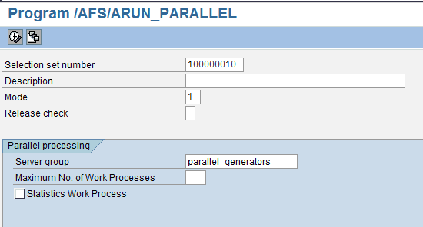

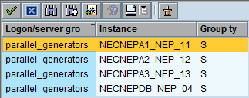

We can create new variants by entering the selection set numbers and then assign them to one or more servers. Alternatively we can assign the existing variant to a particular server.

**Test Data / Test Results Limitations**

Unfortunately, the environment in NED and NEQ doesn’t have the same environment as in NEP i.e., multiple processors set up. Hence, tests couldn’t be carried out to analyse the performance/limitations of the parallel ARUN set up.

**How to analyze parallel ARun?**

The program /AFS/ARUN_RFCLST_DISPLAY can be run to analyze the ARun to –

* Identify the servers used
* Start and End times
* Total number of requirements
* Value of the workload

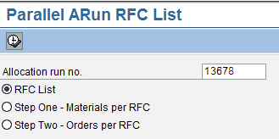

When the “RFC List” radio button is selected, the system displays the server selected for that particular ARUN and the status of the processing.

Likewise, if the second radio button is selected, the system displays the Materials selected and;

If the third radio button is selected, the system displays the Sales Orders selected for that particular ARUN.

**How to delete ARun logs/results?**

The program /AFS/ARUN_RFCLST_DELETE can be run to delete the results of the previous ARun’s.

**Limitations of parallel ARun**

* Dynamic credit checks can’t be performed
* VAS, that require additional physical VAS materials (such as hangers, special labels etc) can’t be handled by parallel ARun as these materials are separate stock and cannot be allocated together in parallel. However, VAS that doesn’t have separate materials (such as printing, stitching etc) can be handled by parallel ARun.

**Key Issues reported and applicable correction notes**

1. Long processing time experienced during parallel ARUN

SAP Note: 1618658

Prerequisites:

You have attached a determination logic (not used at NEC) to the ARun type to determine the release rule from the sales order.

1. Long processing times J4AE

SAP Note: 1442963

1. Parallel ARun doesn’t consider selection set values. Instead the settings from ARun customizing are considered; as a result the ARun results are incorrect.

SAP Note: 1506172

Prerequisites:

1. Selection set is created referring an ARun type via Transaction J4AS

2. The Selection set values are later changed via Transaction J4AR

1. Parallel ARun doesn't consider release rule determination

SAP Note: 1271115

Reason:

The Release rule determined via the determination is not being passed to the subsequent release rule. Hence only the default release rule is being used.

Prerequisites:

- Create a ARun type with the following:

- Attach some release rule.

- For the Determination Logic, maintain it as 'S 1st from Sales Order, 2nd default.

- Attach a different release rule to the sales order.

- Create a selection set for the sales order.

- Allocation using Parallel ARun.

1. Allocation does not happen using Parallel ARun even if there are enough work processes for execution

SAP Note: 1085430

Reason:

The parallel ARun program dumps with the runtime error

CALL_FUNCTION_SEND_ERROR.