**Selection set 100000102**

1. Execute selection set in background via Job NA SD PARUN_102_SO using variant NA STK PARUN (Date: 03/18/2013; Time: 10:41:45)

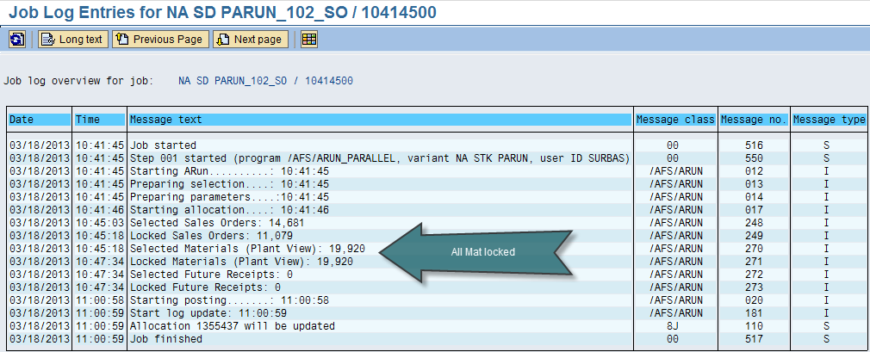

Result 1: ARUN Number was updated and only 2 SO’s were allocated-

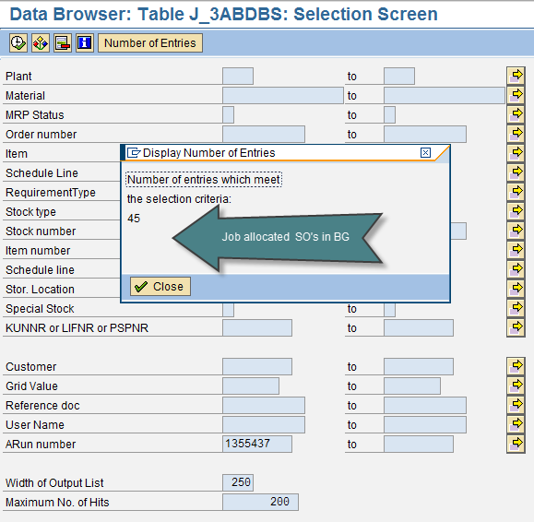

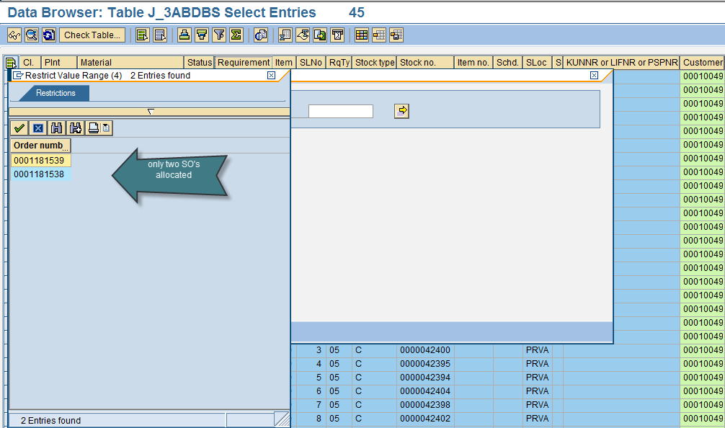

Result 2: Dialog processes were triggered while the job was running and no other Dialog/Background process was running while the parallel ARUN job was running that uses the same Material or SO as in the selection set-

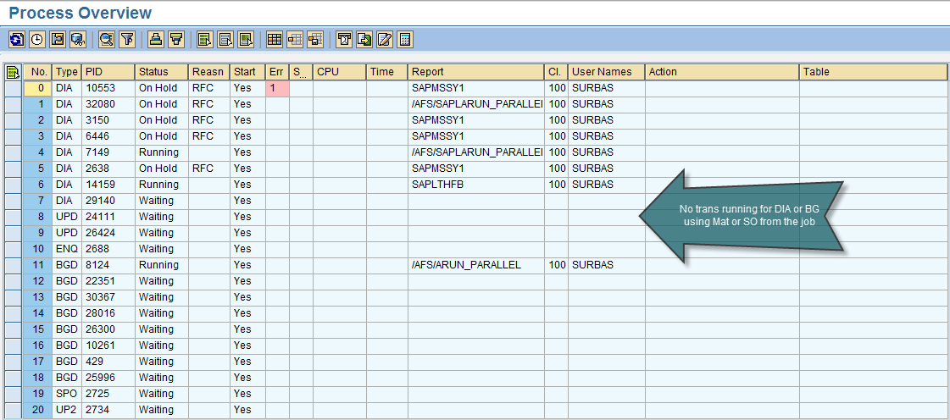

Result 3: VA01 transaction was not executed while the job was running due to lock table overflow-

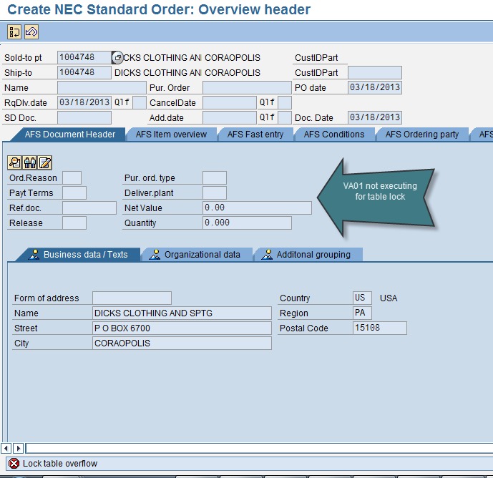

**Questions**

1. /AFS/ARUN_RFCLST shows 15 SO’s with ARUN Num -1355437 of which SO-1181539 & 1181538 were allocated. Why are the other SO’s not allocated?

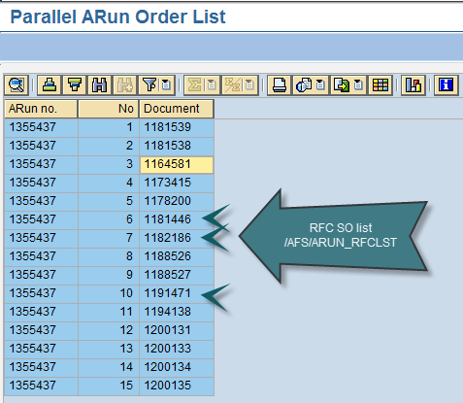

1. The remaining 13 SO’s were input in selection set 100000121 and was executed via Job (NA SD PARUN_121_SO_102) with variant NA STK_102_SO of which 10 SO’s were allocated?

The other three SO’s from the RFC log that are not allocated as pointed above are already partially allocated.

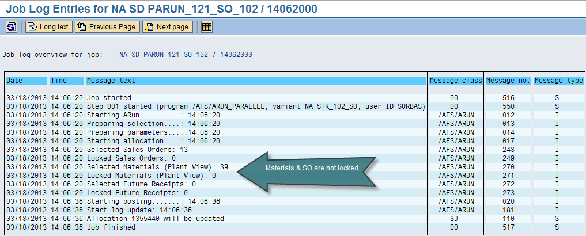

1. The SO’s that didn’t allocate via job, when input in J3AT were allocated-

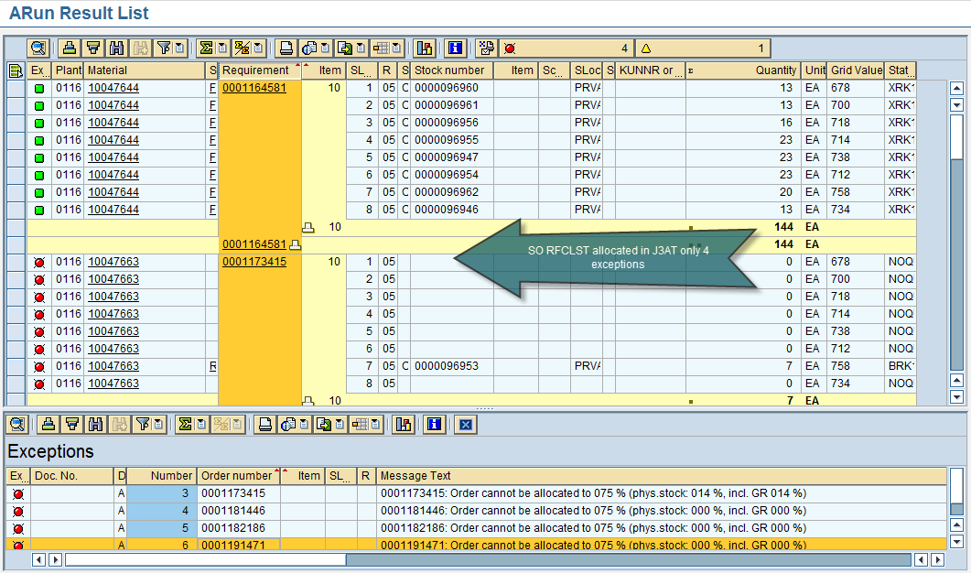

1. Why are the Materials and SO’s not locked in this case, although run via job?
2. Why did the SO’s not allocate via J4AE with the selection set 100000102?

