**Parallel ARUN types w/o statistics group**

The change (statistics group blank) was made to the Parallel ARUN types –

ZP01, ZP02, ZPRS as recommended and tests were carried out.

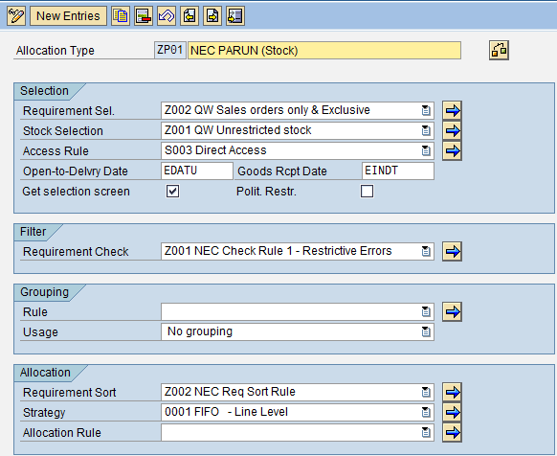

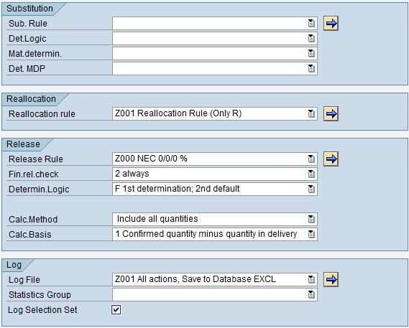

**Following was set up for tests in NEQ100:**

1. New selection sets were created with the Direct Access Rule.

**Selection set Parallel ARUN Type Variant**

100000090 ZP01 AU STK PA-11

100000091 ZP02 AU PRG PA-11

100000092 ZPRS AU QS PA-11

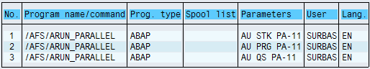

The above variants were created in Mode 3 (simulation) with “parallel_generators” as the server group.

1. New Job (AU SD PARUN-S) was set up priority A (High) with the above variants using the program - /AFS/ARUN_PARALLEL and with server - necahx01_NEQ_02.
2. New Job (ARUN NEW JOB) was set up with priority C (Low) with the existing variants AU STOCK PARUN, AU PROGRAM PAR, AU QS PARUN)

**Following tests were performed:**

1. The existing job, AU SD PARUN was run with the existing variants (AU STOCK PARUN, AU PROGRAM PAR, AU QS PARUN).
2. New job, ARUN NEW JOB was run with the existing variants (AU STOCK PARUN, AU PROGRAM PAR, AU QS PARUN).
3. New job, AU SD PARUN-S was triggered with the new variants (AU STK PA-11,

AU PRG PA-11, AU QS PA-11) with the following combinations-

1. “Max No. Of work Processes” with blank
2. “Max No. Of work Processes” with a value
3. “Statistics work Process” was flagged
4. “Statistics work Process” without being flagged

**Observations and Results:**

1. The jobs failed consistently in each of the cases mentioned above.

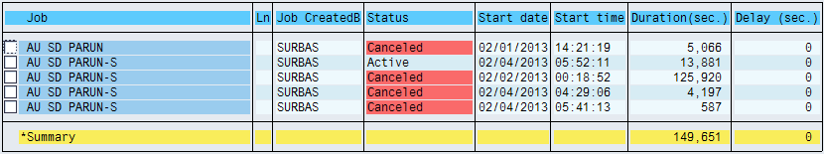

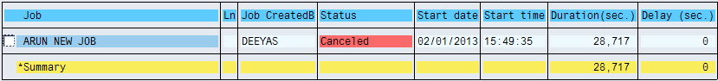

1. The jobs were required to be cancelled as the log was not being updated beyond a certain point and the process was in a loop for want of WPs.

Scenario - 2

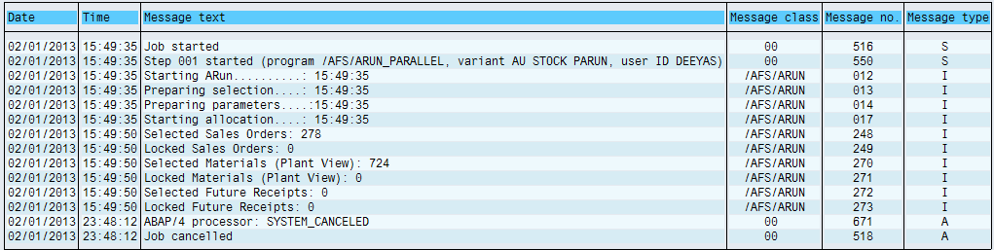

Scenario-1

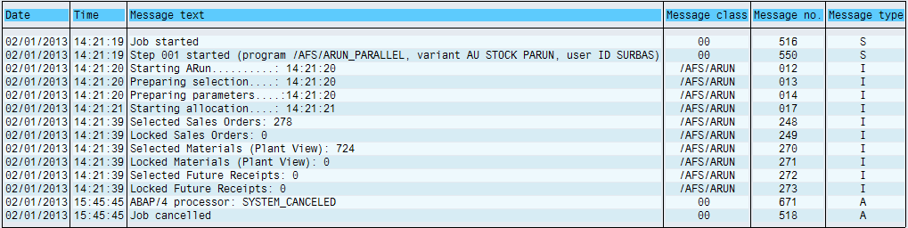

In Debug Mode

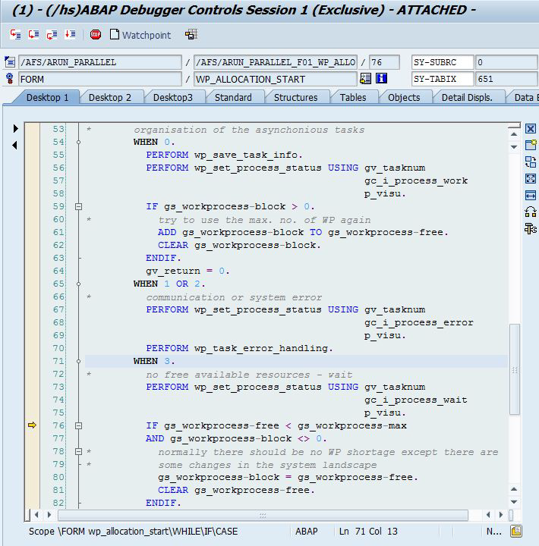

1. In the previous tests i.e., with statistics group 0001 assigned to the parallel ARUN types the job failed on some occasions and passed a few times.

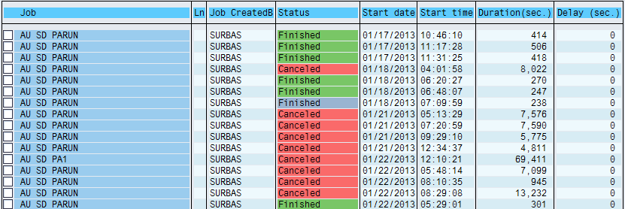

1. The only point of difference in the current tests is the exclusion of Statistics group (blank) in the Parallel ARUN types.