Physical Inventory Count

Pre-requisites:

- Make sure all the shipments have been completed if any.
- If the counted quantity is less than the reserved quantity (ARun and Deliveries) then the difference cannot be posted. So, all the stock shortfalls must be deallocated.
- All transactions including any shipping receipts, storage location transfers, customer returns and quantity adjustments are done before starting the count.
- There should be no physical inventory documents existing with status difference not posted.

Process:
This is a three step process. The first two steps will be processed by the custom program (Transaction ZMM_MI40) and the third step will be through the standard program (Transaction MI40).
- Downloading the spreadsheet with the existing data.
- Entering the counted quantity in the spreadsheet and uploading into application server.
- Creating physical inventory document, Posting count and difference.
Steps:
- Execute the transaction ZMM_MI40.Input the selection options as necessary for the material, storage location and plant combination. Select the radio button for the “Create Inventory File”.
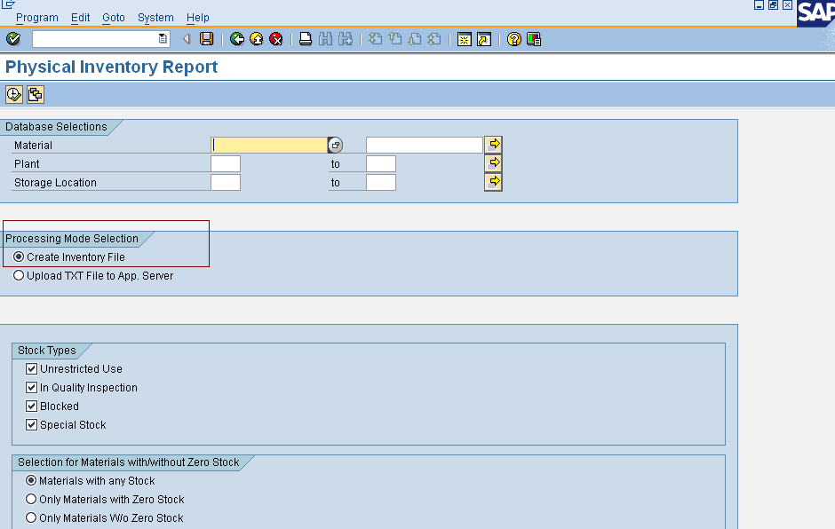
- Flag the check box for the required stock types.
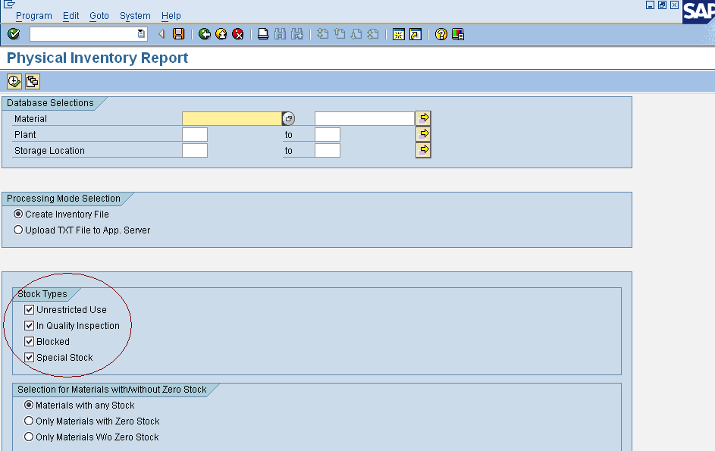

- Select the radio button to select the materials with zero stock or with stock. By default the radio button to select all the materials will be selected.
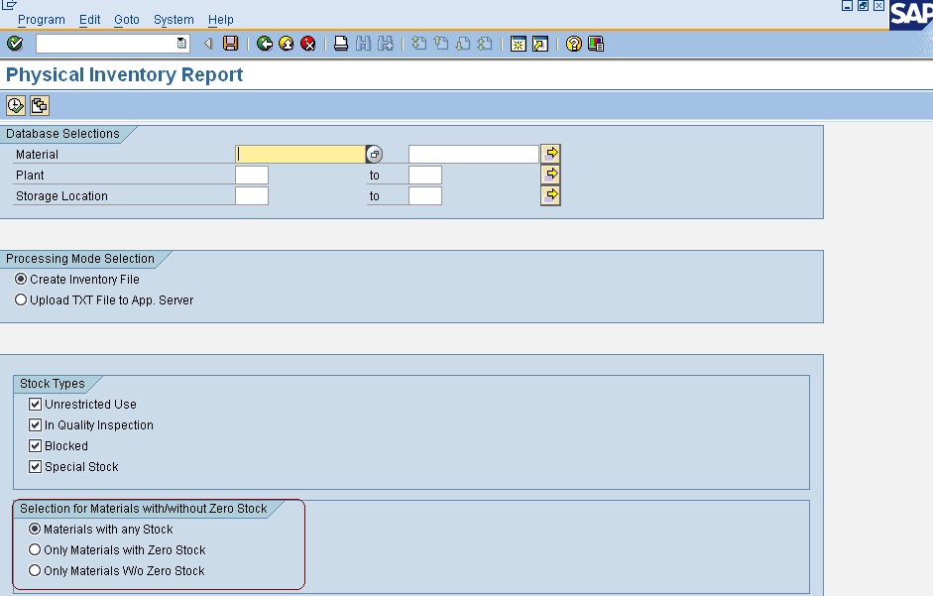

- Select the path to download the file on the frontend. By default the file will be downloaded into the C drive and the path will be “C:\PhysicalInventory.xls”.
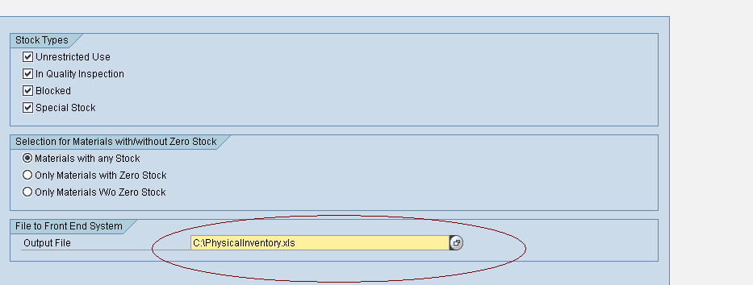

Hit the execute icon on top and the file will be downloaded into the C drive with the name “PhysicalInventory01”.
Once the spreadsheet is downloaded, now the counted quantity has to be entered and has to be uploaded into the application server.
To set the posting block set the X-plant material status to “03” for all the materials through the transaction MASS. This will block all the inventory movements for the material and will allow only the physical inventory related movements.

- Once the counted quantity is entered in the spreadsheet now upload the file to application server. Select the radio button “Upload TXT File to App. Server”
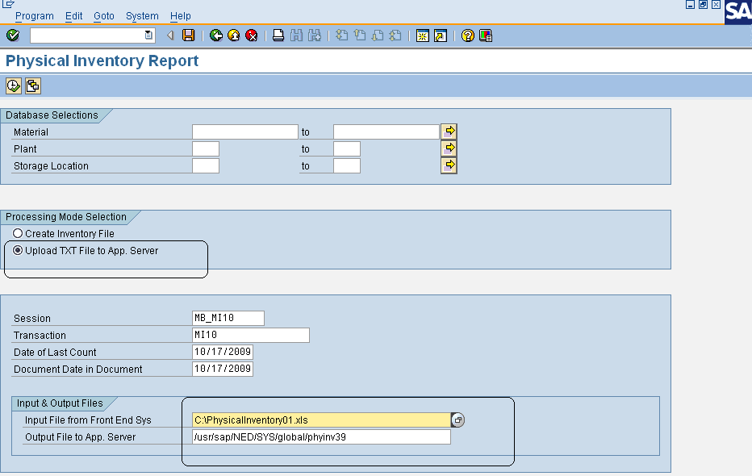

Select the file from the frontend by F4.The path of the application server will be defaulted. Once the file is selected hit the execute icon on top. Now the file will be uploaded into the app. Server
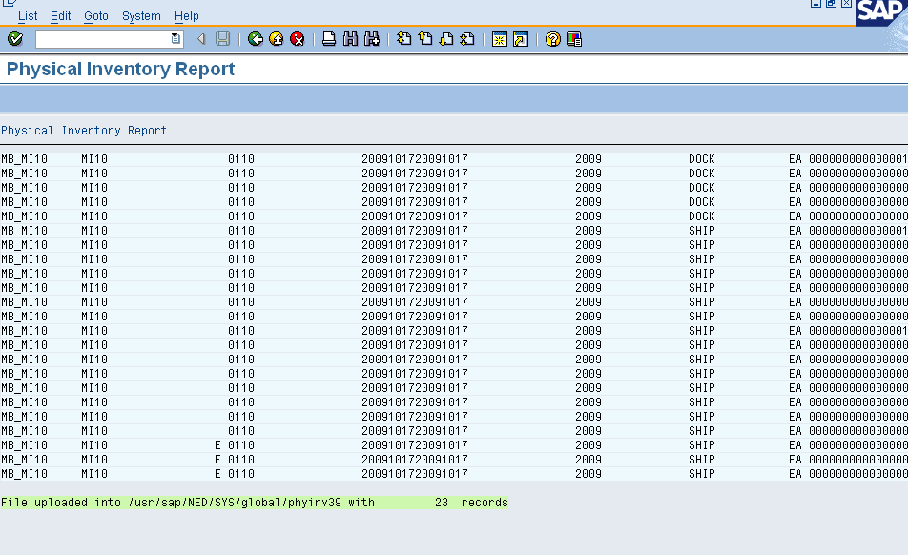

- Now execute the transaction MI40.By default the no. of items in the document will be 20.Pull the variant “PHYINV_MI40” and hit execute icon. A batch session will be created.
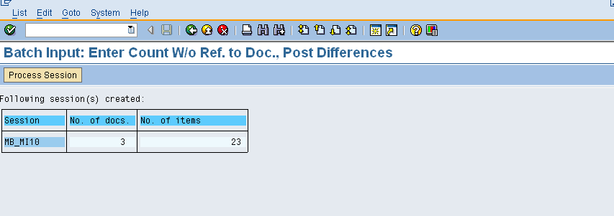

- Now hit the icon “Process session”.
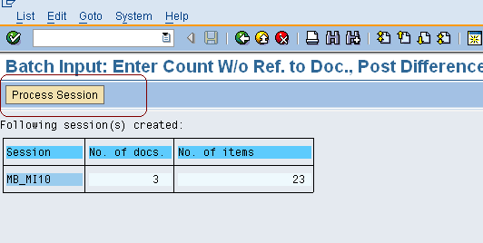

- Now select the row and hit the “Process” icon.
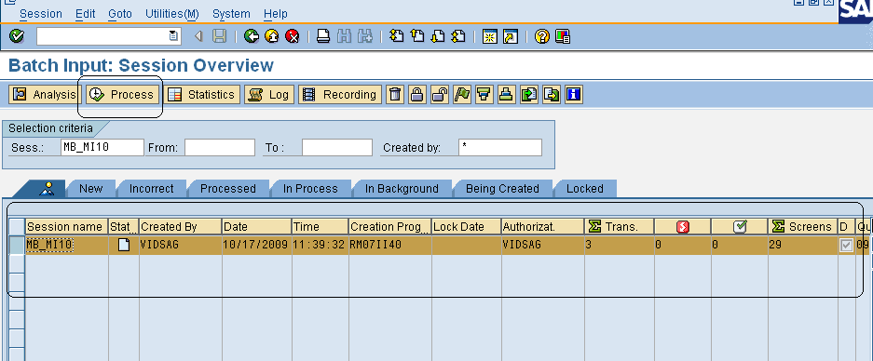

- Select the radio button for the background process and hit Process.
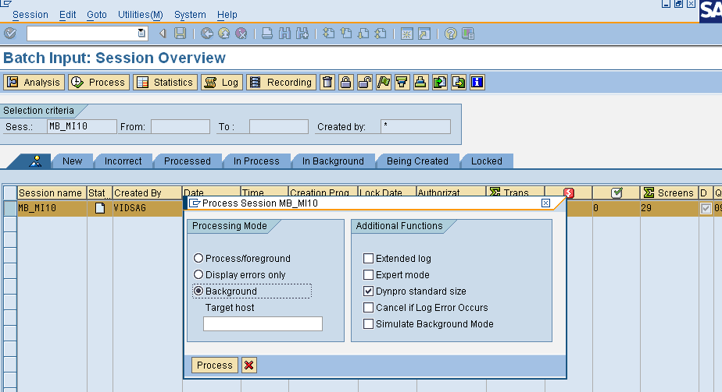

- The session will be executed and the physical inventory document will be created, count will be posted and the difference posting will be done and the log can be seen.

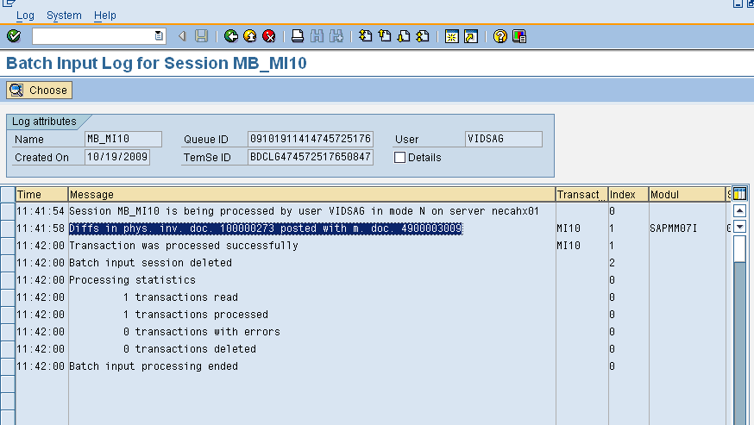

Once the physical inventory count is completed remove the block in the materials.

