**PO Locked Issue**

**Step: 01**

Schedule Download job in SNQ System.

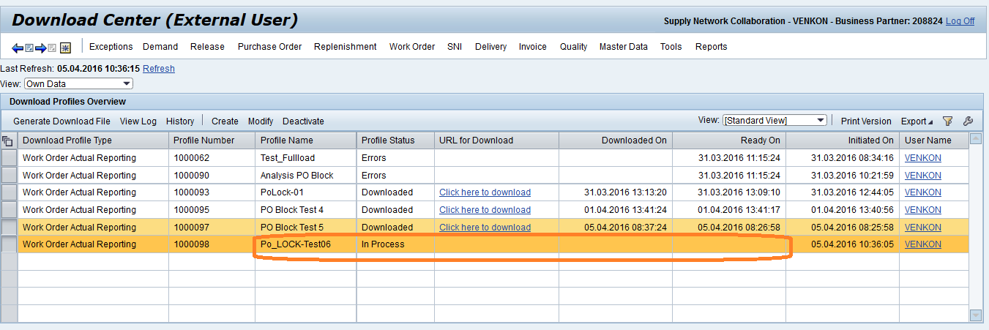

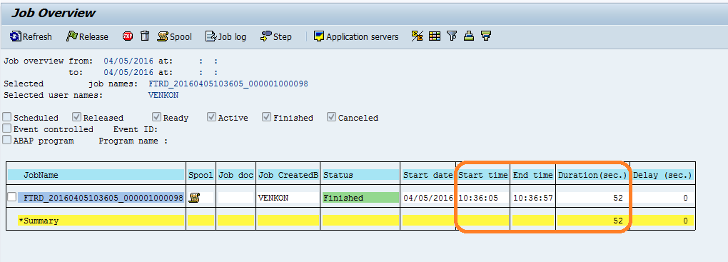

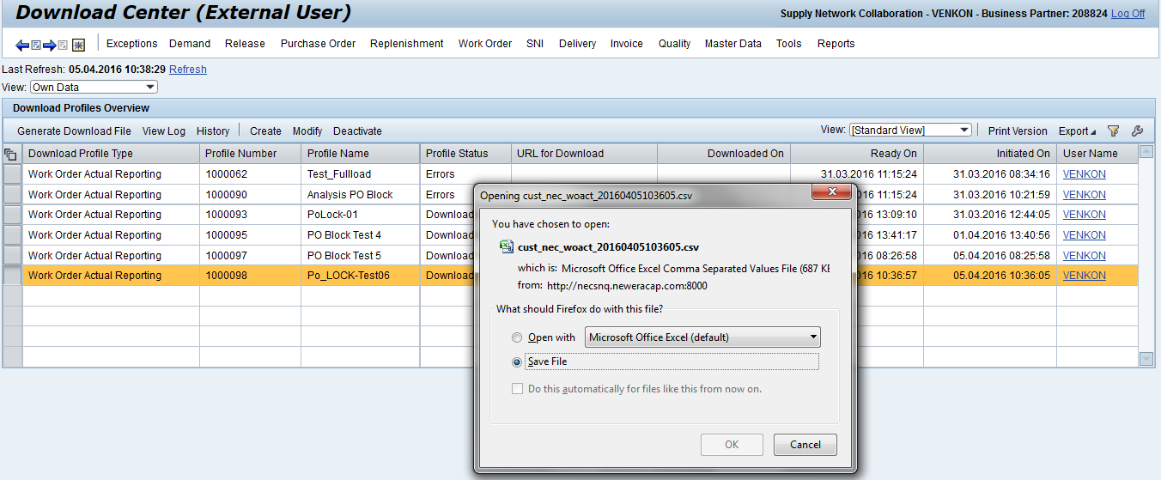

**Step: 02**

Update the confirmations phases in downloaded file.

**Step: 03**

Create a Some 3rd party PO's & Change already existing 3rd Po's in NEQ600 System.

**Step: 04**

Upload the Confirmation files in SNQ vendor page.

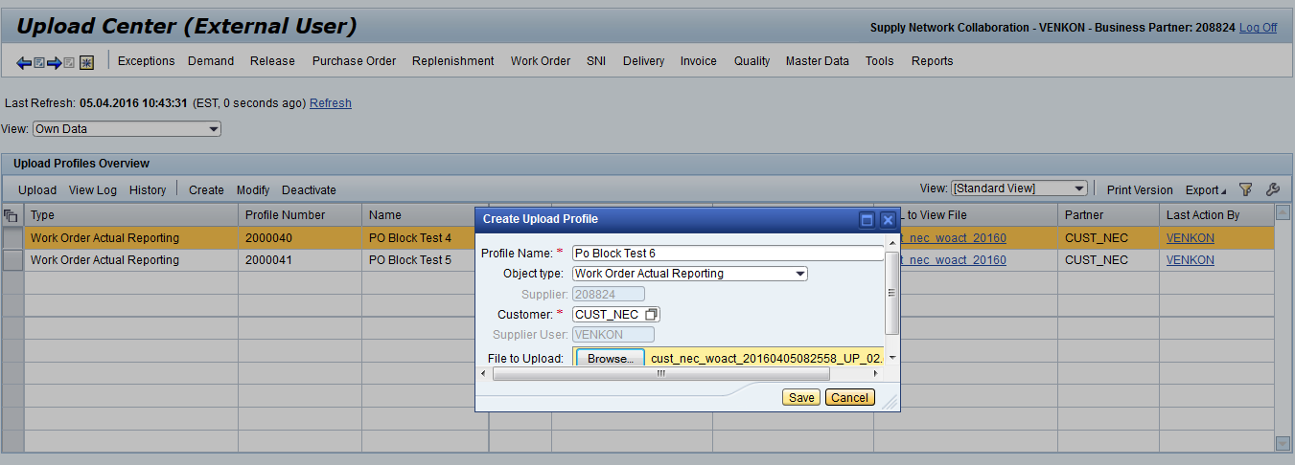

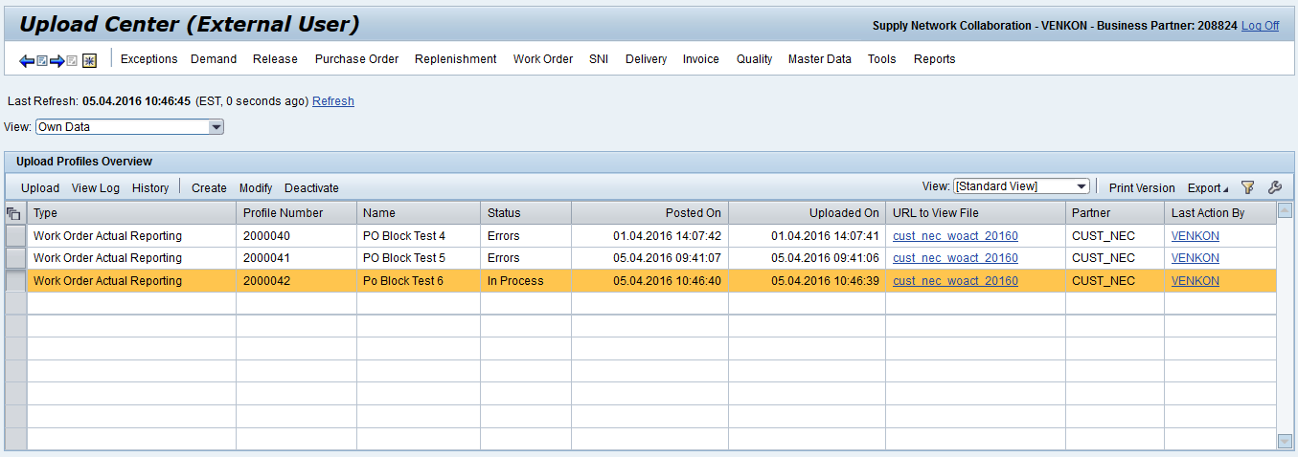

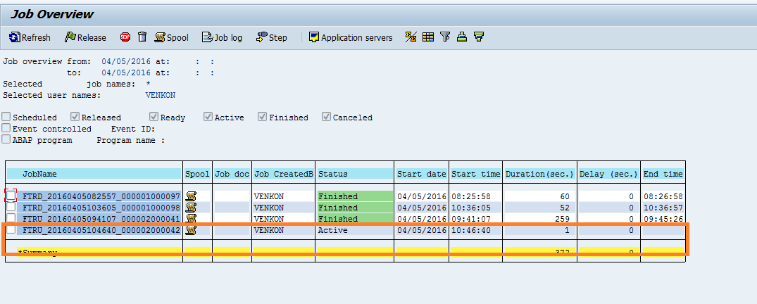

**Step: 05**

Schedule Po push job in NEQ600 system.

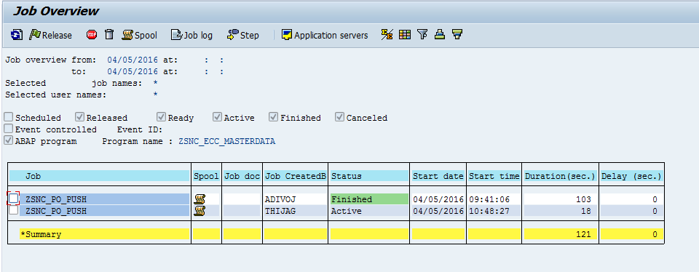

**Step: 06**

Check job Completed times in SNQ & NEQ Systems.

Po Push Job:

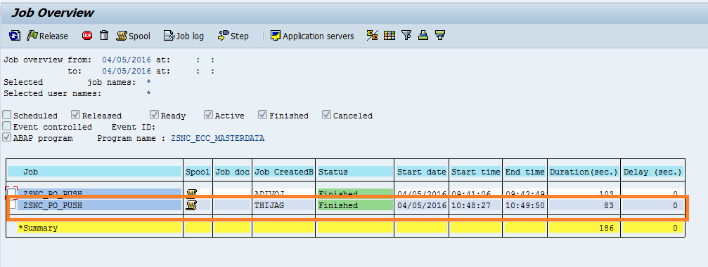

Upload job:

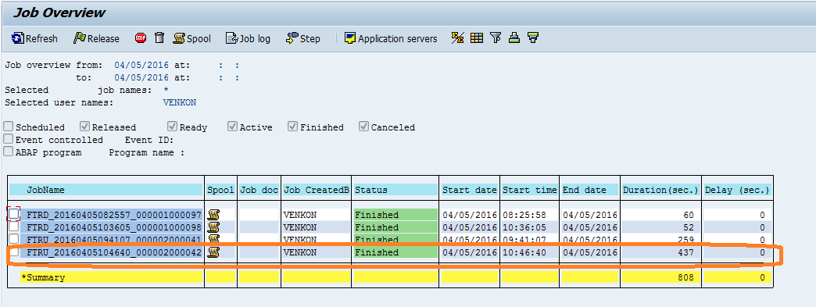

**Step: 07**

Check SMQ2 in SNQ100 System.

