Prior to uploading Positive Pay files into WebInfoPLU$, a file definition needs to be created to tell WebInfoPLU$ how to read your file.

WebInfoPLU$ can upload either a Delimited (comma, tab, etc.) or Fixed Width (text) file.

Creating an File Definition

Inside of WebInfoPLU$, click on the Administration Module, File Mapping option.

Click on the + to add a new profile

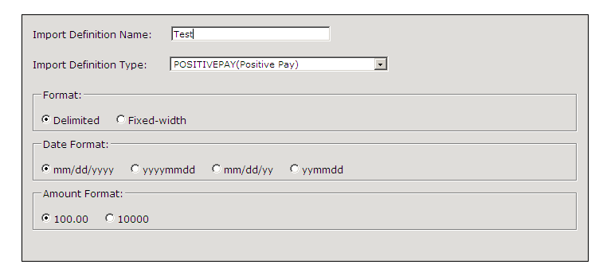

Please note the date formats and amount formats available as per above.

The required fields for a Positive Pay file are as follows:

* Amount
* Issue Date
* Serial # (check #)
* Payee Name (if Payee Positive Pay)
* Transaction ID – if included in the file: IS = issue, CN = voids\*
* Account # - if included in the file\*

The Transaction ID and Account # can also be defaulted on the system and does not need to be included in the file to upload.

We will default the Financial Institution to: M&TBank.

We will ignore the Description field as it is not required.

Below please see the differences between the Delimited and Fixed Width file formats:

DELIMITED:

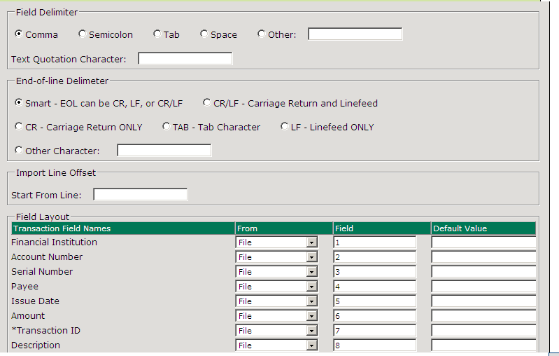

FIXED WIDTH:

