Problem: For Negative Assets all the depreciation is getting carried in the year that it is aquired..The reason beeing the depreciation key LINA
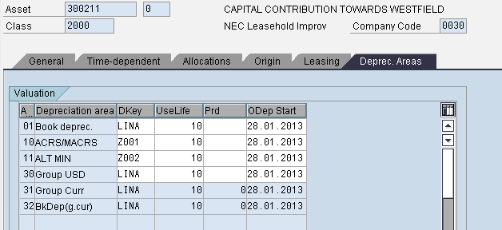

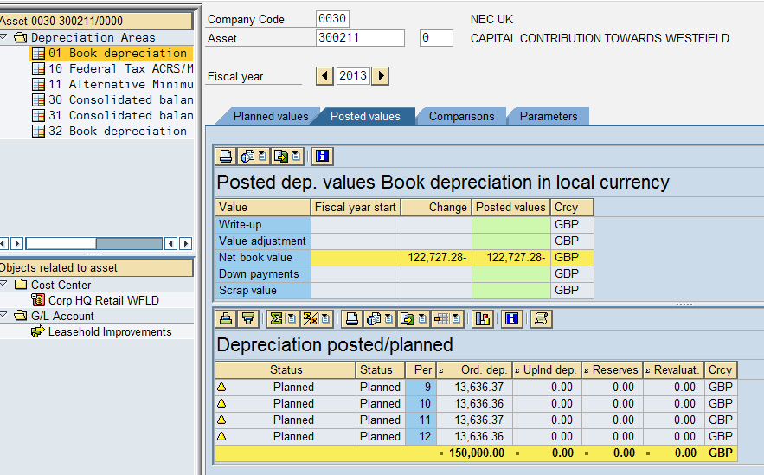
Solution:
1.To remove the reconciliation indicator in OAMK from 160020.
2.Reverse the FI postings for 160020 account
3.Put back reconciliation indicator in OAMK.

4.Change the depreciation Key LINW asset master
5. Rerun the depreciation

After changing the depreciation key from LINA ti LINW
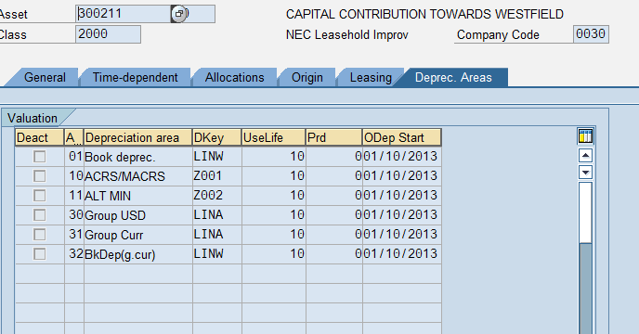

Delete the reconciliation Indicator OAMK
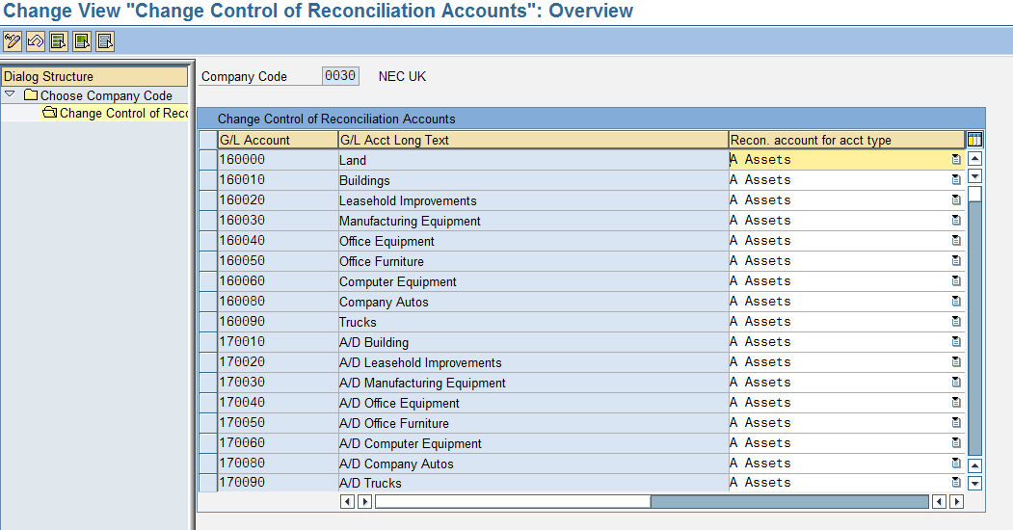
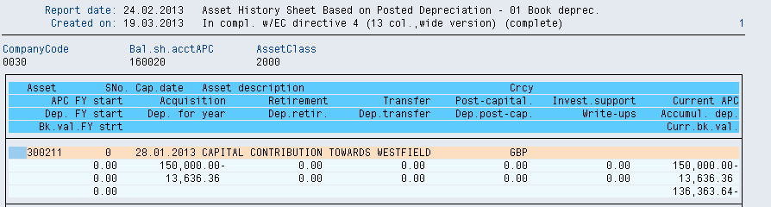
Reverse the document:
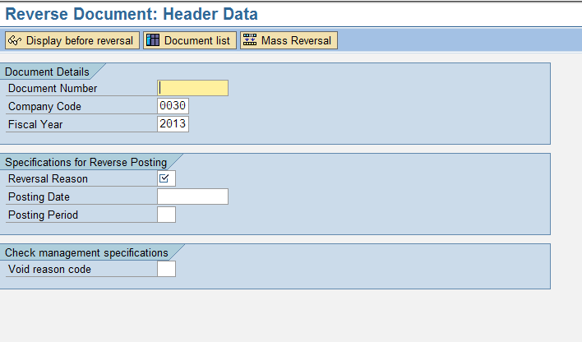
Put back the Indicator in the reconciliation account:

Rerun the depreciation again:

