Requirement Summary: Production Order Release taking long time. Improve the Performance of the production order release.

Solution Summary: It was suggested by SAP for Production Order Release performance to add an entry in table /AFS/REGISTRY

- Entries in table /AFS/REGISTRY in NED100 before adding of new record.

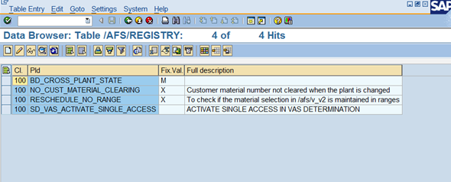

- Entries in table /AFS/REGISTRY in NED300 before adding a new record.

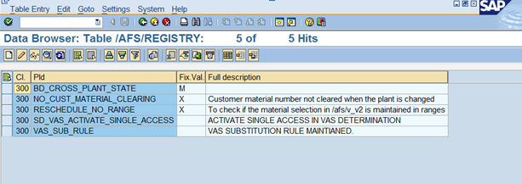

- Entries in table /AFS/REGISTRY in NEQ100 before transporting the Table entry to QAS.

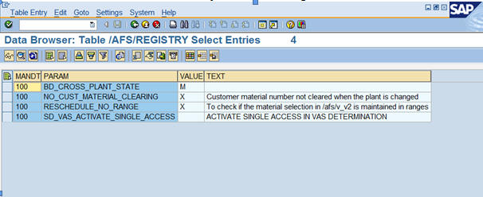

- Entries in table /AFS/REGISTRY in NEP100 before transporting the Table entry to PRD.

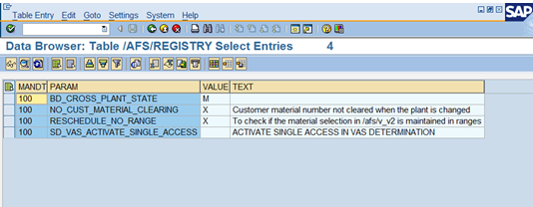

As per the note suggested by SAP(1071025), In order to increase the performance of the production order release we have to insert a entry in table /AFS/REGISTRY with the following field values.

For field PARAM, value is PPL_SUM_ATP_PP.
For field VALUE, value is X.
For field TEXT, value is 'SD METHOD FOR MM/PP ATP FOR BACKGROUND MODE'.

Reason for this is if we insert the value in table, the system will not check for Explain ATP functionality if is in background mode.

- Entries in Table /AFS/REGISTRY in NED100 after inserting the new record.

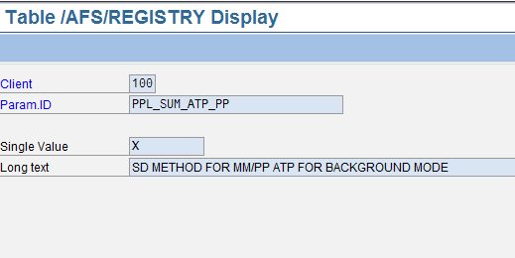

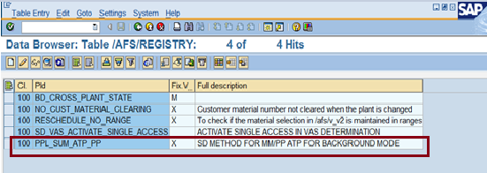

We have to move this entry to NEQ for further testing.

