**Specification Document Commodity codes Z-transaction and master table.**



**Purpose**

* Ensure global customs compliance by assigning proper commodity codes for materials.
* Provide visibility to correct commodity codes on customs / shipping documentation leading to correct import duty calculations and faster customs processing times.
* Set foundation to calculate correct standard costs based on proper import duties.
* Provide foundation for correct Intra-stat report in EMEA.

|  |  |
| --- | --- |
| **Project Title** | : Operations enhancements- Foreign trade/Commodity Codes |
| **Initial Specification** | : 6/17/2013 |
| **Created By** | : Babu Lankipalli |
| **Created Date** | : 6/17/2013 |
| **Assigned to** | : Adithya/Durga |
| **QA by** | : Adithya/Babu |
| **Requested By** | : David Velasquez |
| **Integration Testing By** | : Babu Lankipalli |
|  |  |

**Revision History:**

|  |  |  |
| --- | --- | --- |
| Revision Number | Date | Summary of Change |
|  |  |  |
|  |  |  |
|  |  |  |
|  |  |  |
|  |  |  |

**References (Document, URL, and Email etc.):**

|  |  |  |
| --- | --- | --- |
| Version | Date | Name of the document |
|  |  |  |
|  |  |  |
|  |  |  |
|  |  |  |
|  |  |  |

**Estimation:**

|  |  |  |  |
| --- | --- | --- | --- |
| Module | Item | Task Description | Hours |
| MM |  |  |  |
|  |  |  |  |
|  |  |  |  |
|  |  |  |  |
|  |  |  |  |
|  |  | **Total Number of Hours** |  |

**Functional Requirement:**

Ensure global customs compliance by assigning proper commodity codes for materials.

Provide visibility to correct commodity codes on customs / shipping documentation leading to correct import duty calculations and faster customs processing times.

Set foundation to calculate correct standard costs based on proper import duties.

Provide foundation for correct Intra-stat report in EMEA.

**Proposed - Solution Approach & Impact:**

**Solution Summary**

Create **transaction** and table in SAP to maintain FCC code, Silhouette, plant and corresponding commodity codes. Update material creation program logic to read corresponding commodity codes from the master table while creating materials in SAP accordingly.

Provide **crystal report** for the customs compliance team to view commodity code master data. Input parameters will be FCC code and the output parameters are FCC code, Silhouette, Country and commodity code.

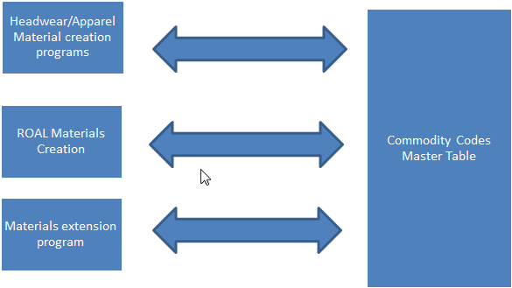

**Transaction to maintain commodity code master data:**

A transaction needs to be created so that users can maintain commodity code master data as follows:

* T.Code to maintain Commodity codes: ZMM_CommodityCodes
* After entering the transaction, from menu there will be dropdown option with Create/Change/Display as shown in figure2.
* For each new entry Source Country, FCC Code, Plant Country and Commodity Code are mandatory.
* For Display/Change: Source Country, FCC code and Plant Country are mandatory.
* Source Country, FCC Code, Plant Country, Silhouette and Commodity Code are selectable with F4 option along with the text.
* For Source Country, FCC Code, Country and Commodity Code show corresponding descriptions.
* Validation check: If same combination entry already exists then Popup error message entry already exists.

**Figure2:**

**Create Commodity code (Initial Screen)**

**Source Country:** CN China

**FCC Code:** 011 Cotton (denim)

**Silhouette:** 044 KNIT

**Plant Country:** CA CANADA

**Commodity Code:** 65059030 Hats



**Commodity code master data table:**

The table to hold master data using the transaction will have fields FCC Code, Silhouette, Country and Commodity code as shown below.

|  |  |  |  |
| --- | --- | --- | --- |
| **Commodity Codes Master Table** | | | |
| FCC Code | Silhouette | Plant Country | Commodity Code |
| 001 | VISOR | US | 610120020 |
| 001 | VISOR | CA | 610120100 |
| 001 | VISOR | MX | 61012001 |
| 001 | VISOR | NL | 610120103 |
| 001 |  | US | 610120010 |
| 001 |  | CA | 610120020J |
| 001 | KNIT | US | 610200200 |

**Material creation logic:**

**Master table did not find corresponding commodity code:**

1. Manual material upload file process by engineering team:
   * If commodity code is not found, users will get error in simulation mode and therefore they will not create materials until customs compliance team maintain necessary data.
2. Automated material upload file process (ROAL, MCP):
   * Materials will not be created and SAP materials creation job will fail.

* ROAL materials creation has exception report.
* Design exception report for MCP materials creation similar to ROAL.

**Alternative solutions considered/Limitations:**

* Maintain master table in non-SAP application (SQL): Material creation programs in SAP will not read data from non-SAP application.
* Get commodity codes from MCP: If commodity codes master data table is maintained in MCP application then upload file from MCP application will be good for materials creating through MCP. But the ROAL, Cap-machine, material creation sheet from engineering (headwear, apparel) and material extensions will not work.