**QAS System:**

Here is the PO for which there is no Work Order but it shows that Work Order is created by having flag in the WO Created checkbox.

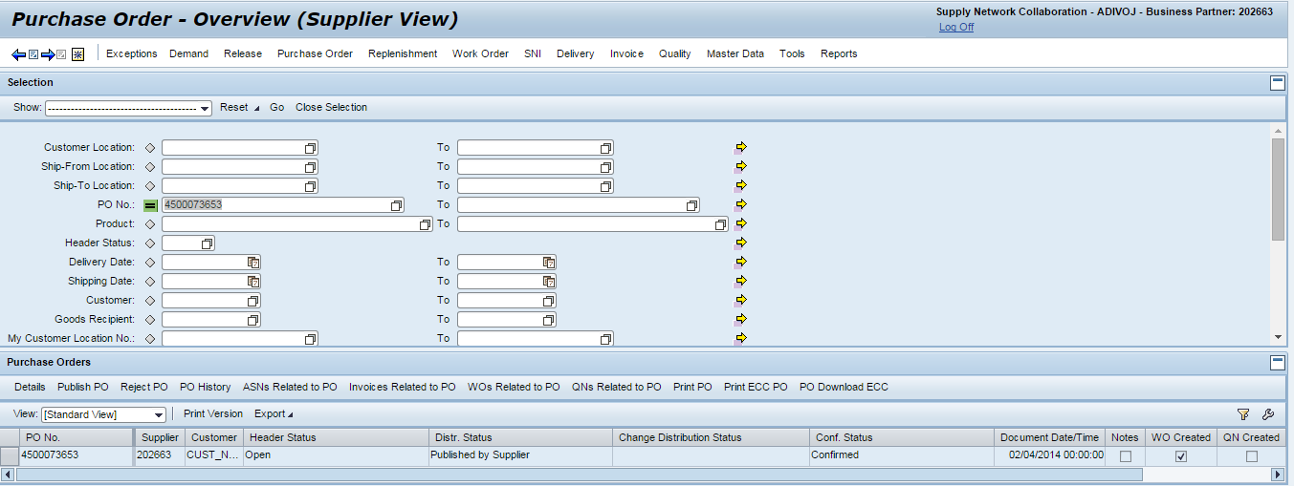

Here is the Work Order Work list screen showing that there are no Work Orders for that PO.

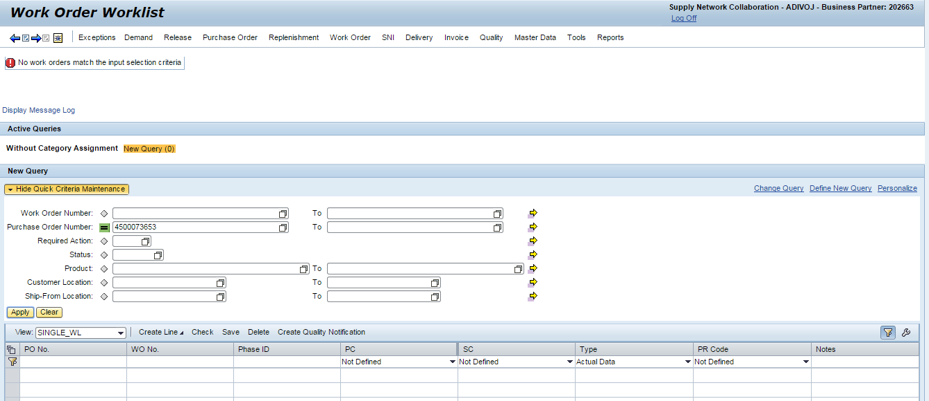

Run the Program with multiple POs:

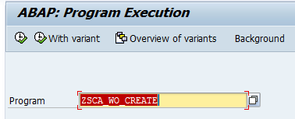

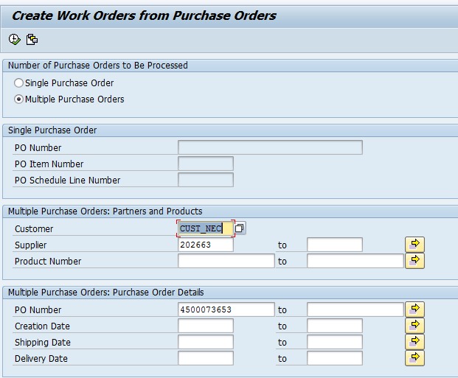

Here is the Log where we see that the Work orders are not created.

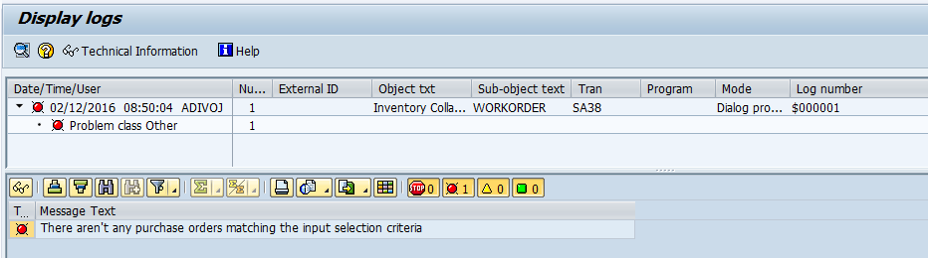

Ran the program with single PO:

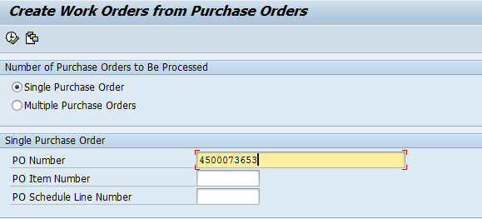

Using Single PO also the Work Order is not created with the program.

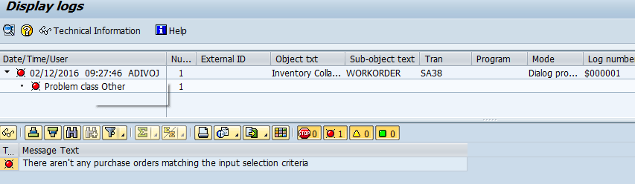

Whenever the Work Order is deleted manually the Work Orders have to be created manually.

We use T Code: /N/SCA/WO_CREATE to create the Work order, but in Dev I think the program is allowing to create WO for such Pos.