**Resolution for Lockbox document missing issue – updated by Joan on 10-16-2012**

**Issue:**

Due to numerous reasons, lockbox document is not available in Tcode FLB1 in SAP. This is normally noticed first by the Finance team (Judy). The easiest way to check whether a lockbox file is missing is to go to FLB1, click on “Lbox overview” button and sort it by date. If say we are expecting lockbox file from 07/05/2012, and there is no selection for 07/05/2012 from the lockbox overview, then we have an issue.

**Contacts:**

1. New Era Infrastructure team:
   1. Jeremiah Randolph [jeremiah.randolph@neweracap.com](mailto:jeremiah.randolph@neweracap.com)
   2. Michael Webb [michael.webb@neweracap.com](mailto:michael.webb@neweracap.com)
   3. Or anyone from IT Infrastructure [Infrastructure@neweracap.com](mailto:Infrastructure@neweracap.com)
2. New Era Functional team:
   1. Jingsha Brennan Jingsha.brennan@neweracap.com
3. New Era business contact:
   1. Judy Sanchez [judy.sanchez@neweracap.com](mailto:judy.sanchez@neweracap.com)
4. Contact from M&T bank:
   1. LBXSUPPORT@mtb.com
   2. Worang, Eric [EWORANG@mtb.com](mailto:EWORANG@mtb.com)        Technical team who normally reprocesses the file transmission
   3. Schellinger, Lauren' [LSCHELLINGER@mtb.com](mailto:LSCHELLINGER@mtb.com)             Business contact

**Steps to resolve the issue:**

First step, upon notified, IT team should check the latest lockbox file in location: \\necdelego\LockBox

By displaying the file, you will see whether this file is the one we are looking for or not by checking the date on the top and the total amount at the end. 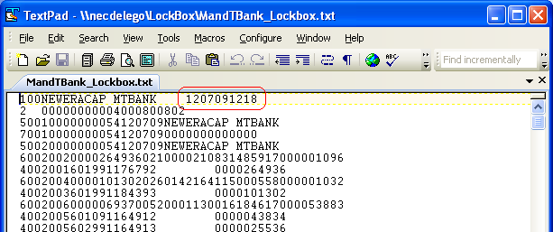

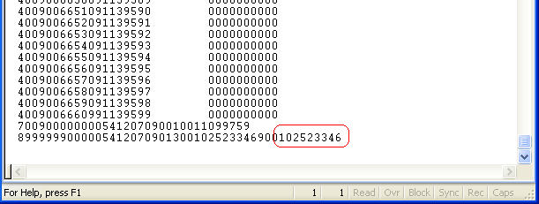

**Scenario 1: when the lockbox file is missing from the transmission.**

1. In this scenario, the file in \\necdelego\LockBox is not the one that business is expecting for that date. This means we will need to first get the proper bank file.
2. To understand the solution, functional team should understand the process of the lockbox jobs. For a lockbox file to be processed in SAP successfully, there are two different batch processes.
   1. First one is a FTP job. It goes out to a FTP location and gets the bank file, which is “MandTBank_Lockbox.txt”. Location \\necdelego\LockBox will always have one and only one file. What the FTP job does is, first, rename the “MandTBank_Lockbox.txt” to MandTBank_Lockbox_[date stamp].txt”, then move the renamed file to \\necdelego\Archive. Secondly, goes out to get bank file from the FTP location for the current date and overwrite the existing MandTBank_Lockbox.txt in location \\necdelego\LockBox.
   2. Second job a SAP job, which also contains two steps. NEC_LOCKBOX_UPLOAD and RFEBLB00-LOCKBOX. RFEBLB00-LOCKBOX is triggered by NEC_LOCKBOX_UPLOAD automatically.

Server: necdelego

Location:  C:\FTP_Scripting\get_FilesFromFTP.bat

The Windows Server Scheduled Task “get_FilesFromFTP” runs the above .bat file.

1. When we miss a bank file, we will have infrastructure team to re-execute both the FTP job and the SAP job. Once completed, go to \\necdelego\LockBox and see if the file was updated to the correct bank file, and whether in SAP Tcode FLB1 shows the lockbox doc is available.
2. If re-executing the jobs still does not fix the issue, we will need to contact M&T bank, and have them to re-transmit the correct bank file, then re-execute all jobs from the NEC end.
3. **Lastly, and very very importantly. unless the issue was discovered and resolved within the same calendar date, Infrastructure team will need to make sure that the archived file is renamed properly.** If say the issue is for a file for 07/05/2012, we didn’t fix it until 07/06/2012, the archived file is going to be named MandTBank_Lockbox_07062012. This is fine until the FTP job tries to get the new file on 07/06/2012, it would fail due to the duplicate.

**Scenario 2, when the lockbox file is correct, but failed to load to SAP:**

1. If the file date is the date you are looking for, that means we did get the correct lockbox file from the bank. We will need to re-execute the SAP batch job NEC_LOCKBOX_UPLOAD, which will also automatically kick off job RFEBLB00-LOCKBOX. New Era infrastructure will be the ones re-execute the batch job.
2. Once the job was completed, check in FLB1 and see if the lockbox file for the date in concern is available. If so, the issue is resolved, please notify the business; if not, see next step.
3. If re-running the batch does not resolve the issue, yet you are sure that the file is correct, then try to download the file to your computer desktop, and then execute tcode FLB2 manually as below: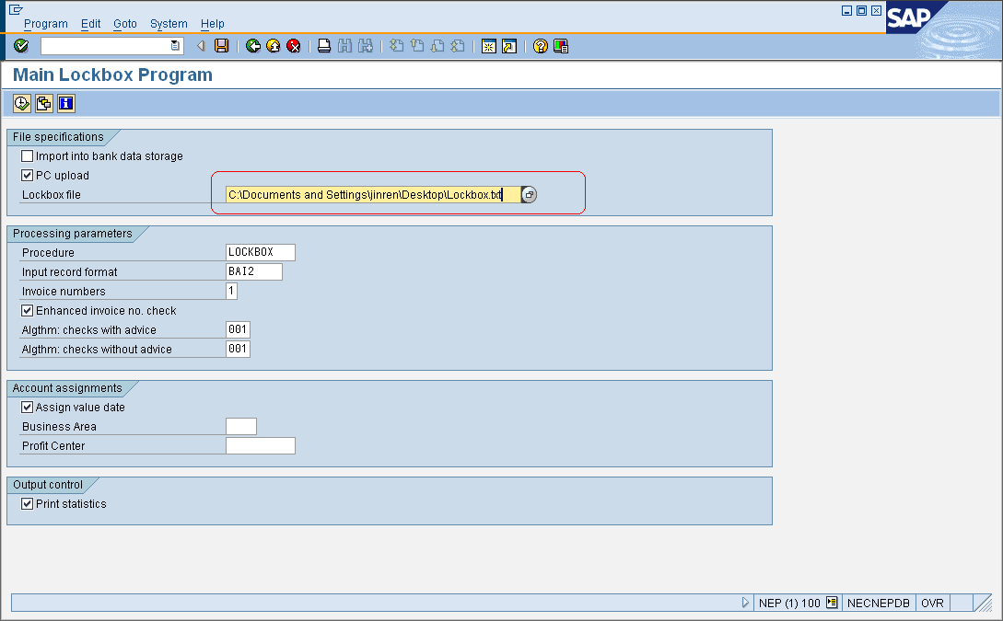
4. Once done, check the FLB1, you should see the lockbox document available now.

