**Business Requirement**

The Japan POS system will provide information in certain format and a customized program should be developed to read this information and create payment transactions based on the data extract from POS system.

**Assumptions**

In order for this process to work, the following assumptions have been made:

1. The Customer account number is determined based on the first 4 characters (store ID) of the SIT file. Mapping of the store ID - Customer number will be maintained in the customized table 2
2. The cash GL account or Bank account will be determined by the tender type. GL-Tender type mapping will be maintained in the customized table 1
3. Upload file has/has no header

**Solution**

A customize SAP program is needed in order to obtain the necessary information from the upload files and create payment documents in SAP.

1. Upload file

The upload file is as attached:



1. Preprocessing is needed. In both scenarios, document type should be DZ.

* If the Subtotal of each ID is >= 0, the document creation program should be based on tcode F-28.
* If the Subtotal of each ID is < 0, the document creation program should be based on tcode F-53.

Hint, F-28 and F-53 are very similar with small differences. In F-53, some default fields need to be overwritten by the program, such as Document type and Account type.

1. Use F-28 to create the payment document if the subtotal of item is positive, fields should be entered as below:
2. Document date: This date needs to be extract from the transaction ID, from the 5th character to the 10th character, formatted as YYMMDD. For example 000A1310220015121, date should be 10/22/2013.
3. Company code – hard code 0060
4. Posting date – Default to today’s date (This is TBD and subject to change. We potentially may use the same date as document date extracted from transaction ID )
5. Currency – Hard to JPY
6. Reference – use the first 4 characters (store indicator), “-“ and the 11th to the 20th character (For example, in the first column of the SIT file, the ID is 000A1310220015121, the program should enter 000A-0015121 (which is the highlighted number like this 000A1310220015121) into the Reference field.
7. Doc. Header Text – full ID from file (this field is 20 character long even though only 17 is being used here)
8. (Bank) Account: Based on the customized table 1
9. Amount: Subtotal of each Invoice number (the long ID that is currently 17 characters but could have 20 character max long ID in the SIT file)
10. (Customer) Account – Based on the customized table 2
11. Click on Others to proceed with further selection
12. Item Text - full ID from file (this field is 20 character long even though only 17 is being used here)

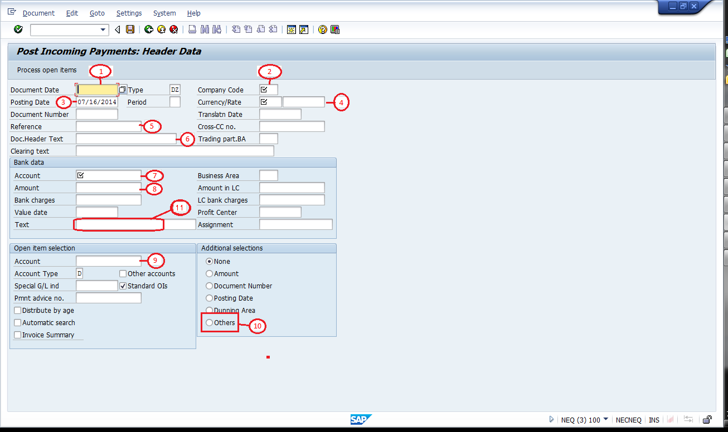

Then in the next screen, choose Reference

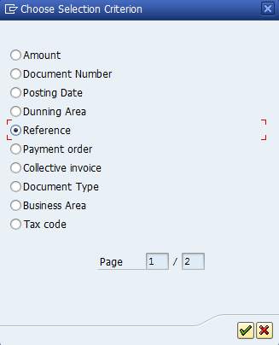

Then enter the Reference number. Reference number starts from the 5th character of the long ID in the upload file (For example, in the first column of the SIT file, the ID is 000A1310220015121, the program should take 1310220015121 and enter it in the reference field). This is because the first 4 characters that represents store ID will also be truncated in the SD document reference field. Click on Process Open item after entering the reference field.

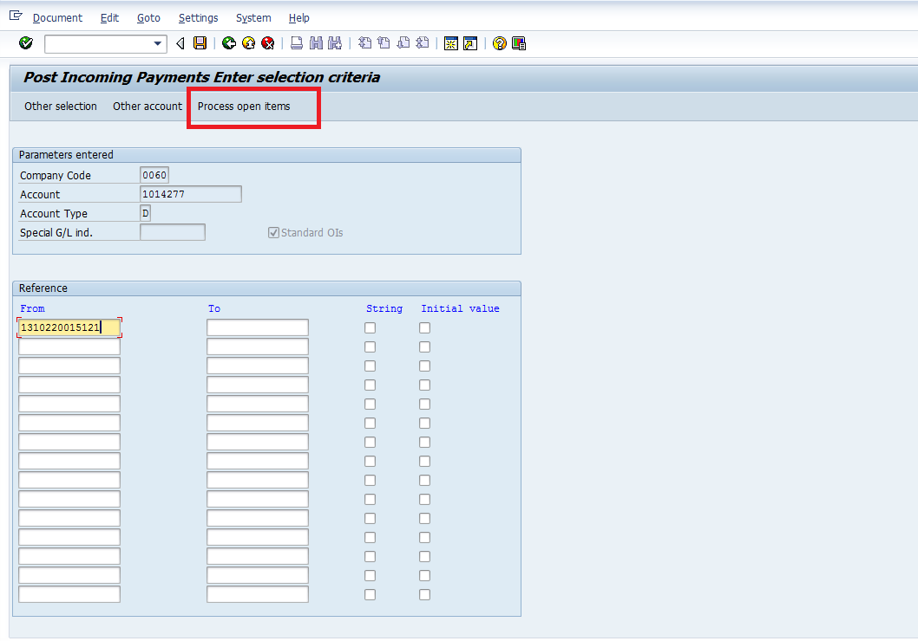

In the next screen, first select “Select all”, then “Activate the item”, and then Save the document

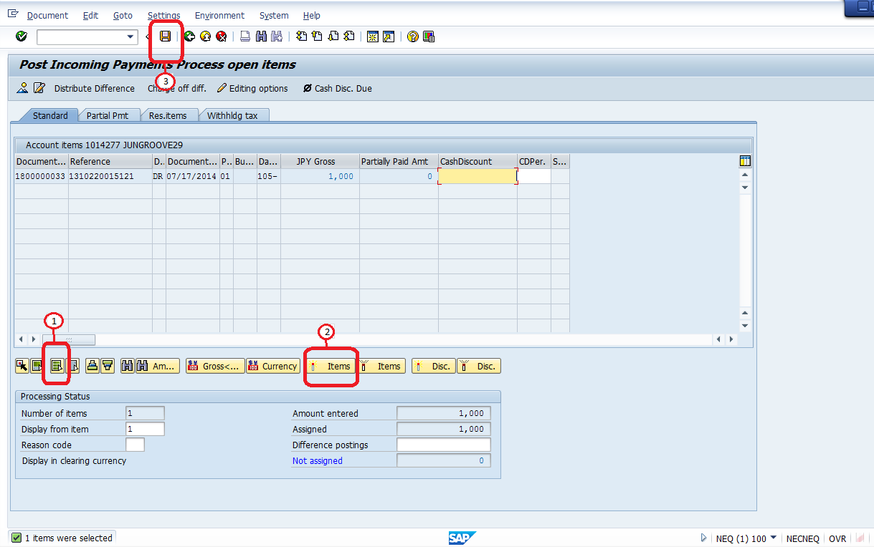

The payment document would look like below, where the line for Posting key 40 would show the GL based on the customized table 1, and the line for posting key 15 should show the customer ID.

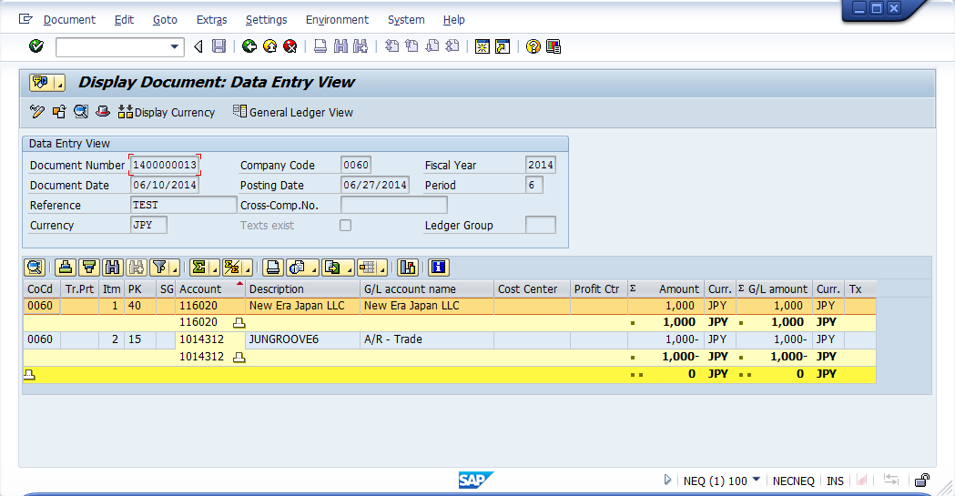

1. Use F-53 to create the payment document if the subtotal of transaction is negative, below fields should be entered as below:
2. Document date: This date needs to be extract from the transaction ID, from the 5th character to the 10th character, formatted as YYMMDD. For example 000A1310220015121, date should be 10/22/2013.
3. Document type: Overwrite KZ and enter DZ.
4. Company code – hard code 0060
5. Posting date – Default to today’s date (This is TBD and subject to change. We potentially may use the same date as document date extracted from transaction ID )
6. Currency – Hard to JPY
7. Reference – use the first 4 characters (store indicator), “-“ and the 11th to the 20th character (For example, in the first column of the SIT file, the ID is 000A1310220015121, the program should enter 000A-0015121 (which is the highlighted number like this 000A1310220015121) into the Reference field.
8. Doc. Header Text – full ID from file (this field is 20 character long even though only 17 is being used here)
9. Account: Based on the customized table 1
10. Amount: Subtotal of each Invoice number*-1 (the long ID that is currently 17 characters but could have 20 character max long ID in the SIT file). In this scenario, the subtotal is negative number, but SAP Transaction F-53 will not allow a negative value input, therefore the amount entered here needs to be an absolute number.
11. (Customer) Account – Based on the customized table 2
12. Account type K here needs to be overwritten with Account type D
13. Click on Others to proceed with further selection
14. Item Text - full ID from file (this field is 20 character long even though only 17 is being used here)

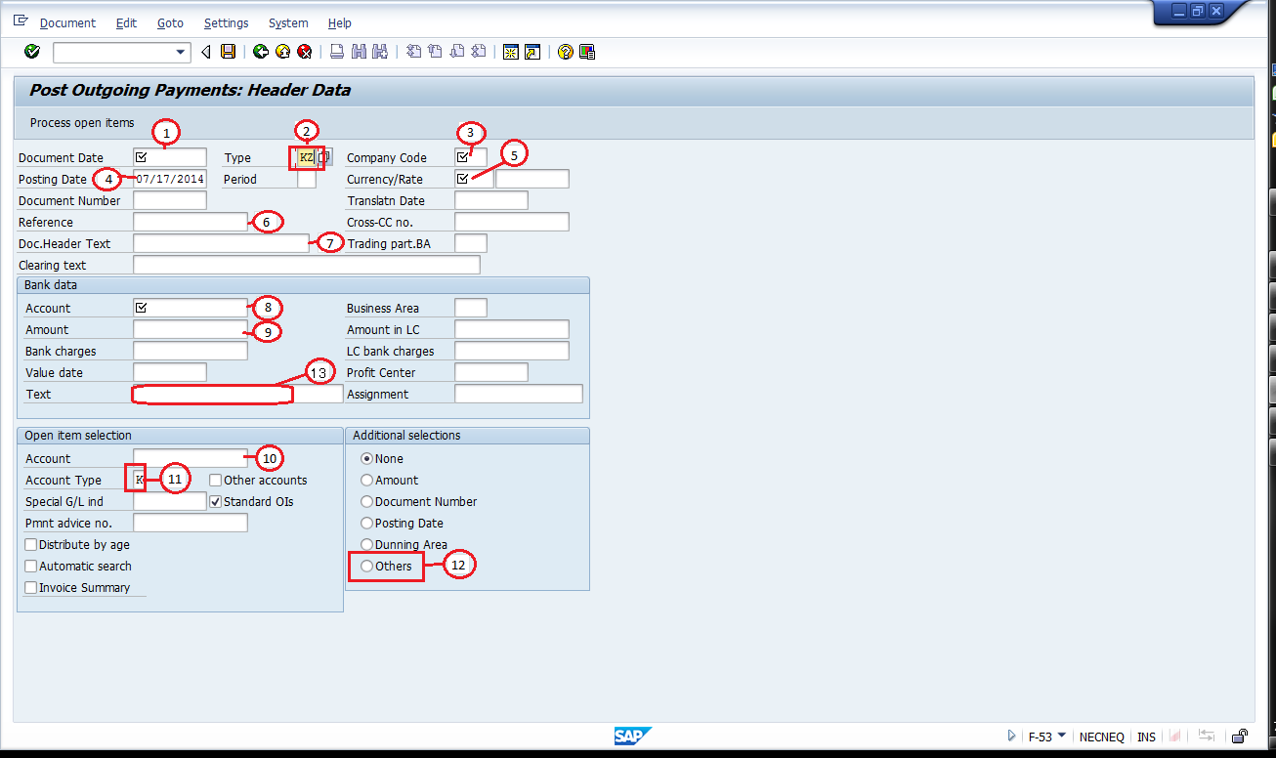

Then in the next screen, choose Reference



Then enter the Reference number. Reference number starts from the 5th character of the long ID in the upload file (For example, in the first column of the SIT file, the ID is 000A1310220015121, the program should take 1310220015121 and enter it in the reference field). This is because the first 4 characters that represents store ID will also be truncated in the SD document reference field. Click on Process Open item after entering the reference field.

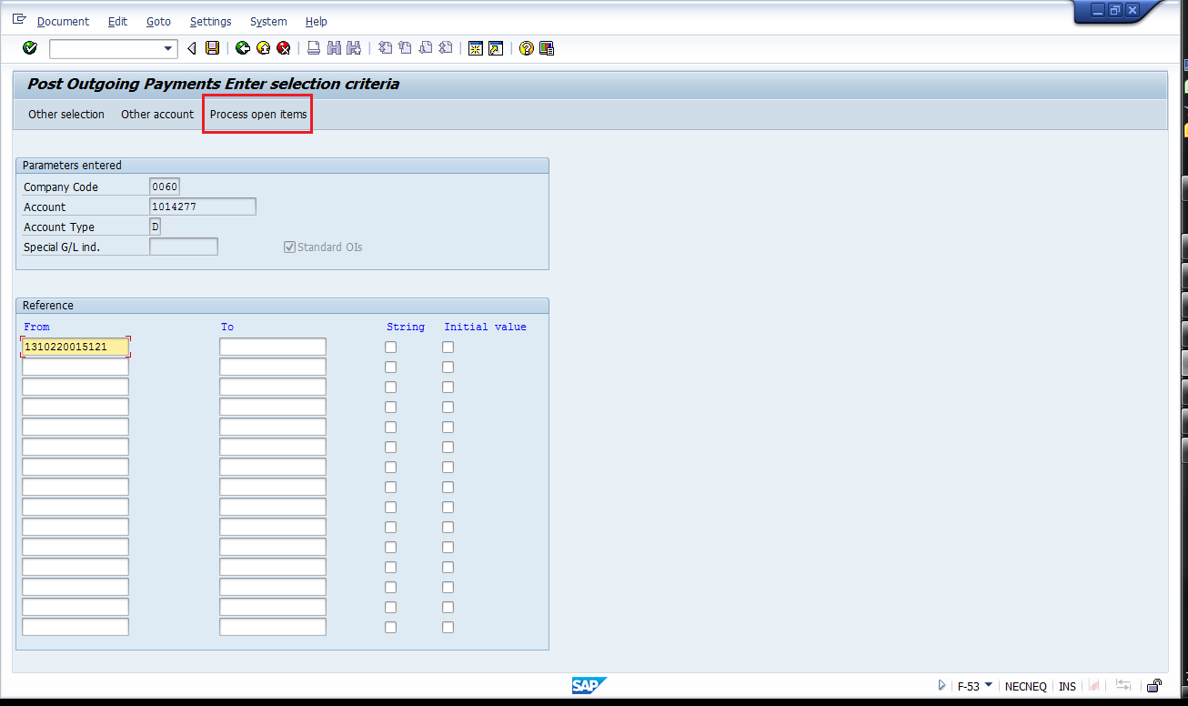

In the next screen, first select “Select all”, then “Activate the item”, and then Save the document

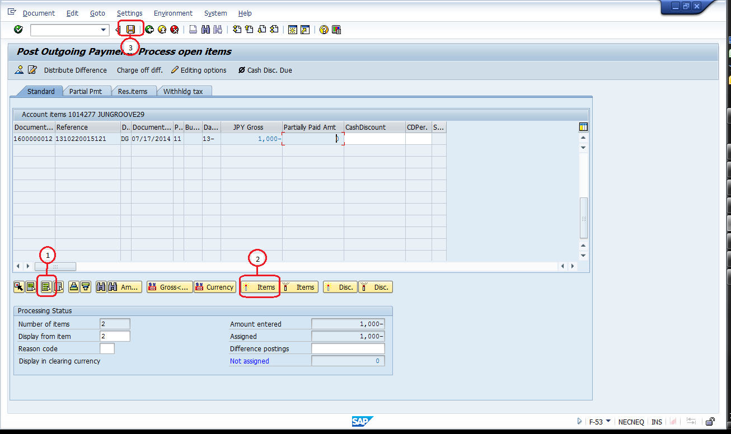

The payment document would look like below, where the line for Posting key 50 would show the GL based on the customized table 1, and the line for posting key 05 should show the customer ID.

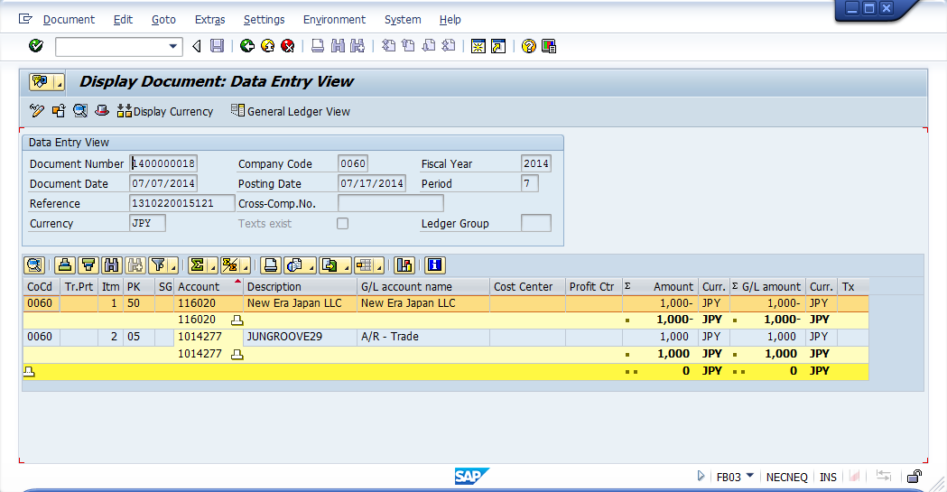

1. **Customized table**

2 *Customized tables (or one table, two tables) will be required:*

1. *Tender type - GL*

|  |  |  |  |  |
| --- | --- | --- | --- | --- |
| **Payment Method** | **Further information** | **fdlDesc** | **fldTenderType** | **GL account** |
| Cash |  | Cash | 1 | i.e. 113100 |
| COD |  |  | 2 |  |
| Deposit |  |  | 3 |  |
| StoreCredit |  |  | 4 |  |
| FC |  |  | 5 |  |
| gift 2 |  |  | 6 |  |
| CreditCard | Visa/Master | 1 | 7 |  |
| CreditCard | JCB/Diners/AMEX | 2 | 7 |  |
| Charge |  |  | 8 |  |
| Payment |  |  | 9 |  |
| Gift |  |  | 10 |  |

1. *Store – Customer ID*

|  |  |
| --- | --- |
| Store ID | Customer |
| 000A |  |
| 001A |  |
| 002A |  |
|  |  |
|  |  |

1. **Log**

Log file should show the item row number, if the payment was created, show the payment document ID, if the payment was not created, show the errors.

1. **Development hints:**

Note that the file could contain multiple items for the same Reference/invoice number, payment creation only need to create one payment per transaction, which means a pre-processing is required to get the invoice subtotal before creating the payment.

**Potential Issues / Questions**

N/A