**Functional Specification**

**BI and Report Development**

**SA170 – Shipped + Open by Region and Country**

**New Era Cap Inc.**

**Revision History**

|  |  |  |  |
| --- | --- | --- | --- |
| **Date** | **Author** | **Version** | **Description** |
| 01/28/2015 | M.Grzechowiak | 1.0 | Create functional specification draft |
|  |  |  |  |
|  |  |  |  |
|  |  |  |  |
|  |  |  |  |
|  |  |  |  |

Table of Contents

Description / Usage 3

Report Features 3

Business Rules 4

Report Layout (mockup) 4

Information Security 5

Report Parameters 5

Schedule Considerations 5

Assumptions 5

Out of Scope 6

Open and Closed Items 6

Approvers 6

# ****Description / Usage****

1. **Description**

**Report displays Shipped / Open Revenue for the current and previous year in a grid format by month. Current report has grouping options for Region>Country>Sales Rep>Customer, Region>Sales Manager>Sales Rep>Customer and Region>Sales Manager>Country>Sales Rep>Customer. The ask is to have a year group added above the region level which will allow users to drill into data for either the Current \ Previous Year or the Current Year +1 and Current Year (i.e Year>Region>Country>Sales Rep>Customer).**

1. **Business Need (Why?)**

**As the year progresses and orders begin to fill in for the upcoming year users need to have visibility into that data.**

1. **Usage Frequency & Data Availability Requirements (i.e. real time, warehoused)**

**Report(s) will run daily on current regional schedules**

1. **Distribution Method**

**Default crystal report format**

# ****Report Features****

1. **Report Type**

**Crystal Report(s)**

1. **Required Details (fields)**

***No changes required for this area***

1. **Key Figures, Calculations and Summations**

***No Changes required for this area***

1. **Required Groupings**
   1. **Year > Region > Country > Sales Rep > Customer**
   2. **Year > Region > Sales Manager > Sales Rep > Customer**
   3. **Year > Sales Manager > Country > Sales Rep > Customer**
2. **Sorting Order**

***No changes required for this area***

1. **Other**

# ****Business Rules****

Report should always include two year groups

* Current Year / Previous Year (i.e. 2015 / 2014)
  + Display as **2015**
* Current Year +1/ Current Year(i.e. 2016/2015)
  + Display as **2016**

Within the groups the report should maintain its current format, the data in the *Shipped*, *Open*, *Total*, *Last Year*.. etc fields would reference either **2015** or **2016**  for current year data in the above example.

# ****Report Layout (mockup)****

1. Group Parameter

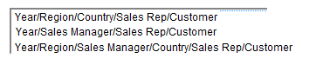

1. Group Tree

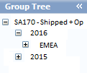

1. Report Grid (2015)

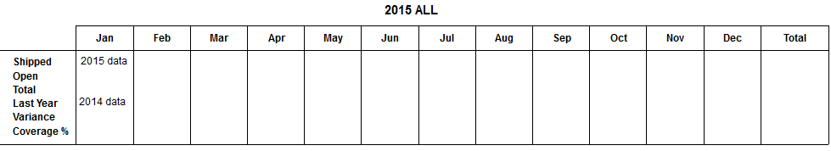

1. Report Grid (2016)

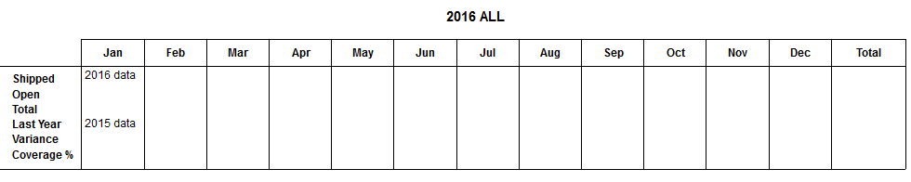

# ****Information Security****

1. **Users and Groups**

**Folder level security will be enforced on this report at a regional level**

1. **View Time Security (VTS)**

**N/A**

# ****Report Parameters****

No changes are required in this area, other than adding the year option to the groups.

# ****Schedule Considerations****

1. **Report Run Frequency**
   1. Scheduled
   2. Frequency: Daily, by regional schedule
      1. EMEA
      2. North America
      3. Japan
      4. Emerging APAC
      5. Emerging Latin America

# ****Assumptions****

Report and associated data source (if necessary) will be adjusted for each of the 6 versions of this report (GLOBAL, EMEA, NORTH AMERICA, JAPAN, EMERGING APAC, EMERGING LATIN AMERICA)

# ****Out of Scope****

N /A

# ****Open and Closed Items****

1. **Open**

|  |  |  |  |
| --- | --- | --- | --- |
| **Identified Date** | **Description** | **Resolution** | **Target Date** |
|  |  |  |  |
|  |  |  |  |

1. **Closed**

|  |  |  |  |
| --- | --- | --- | --- |
| **Identified Date** | **Description** | **Resolution** | **Target Date** |
|  |  |  |  |
|  |  |  |  |

# ****Approvers****