**Business Requirement:**

BI reports WMS510, WMS520 and WMS530 display all VAS codes in the system and the associated customer accounts they are currently associated with based on VAS Condition records. As new key combinations have been added over the years, the table and programs called to run these reports have not been updated.

**Functional Specification:**

These reports are run off of table ZSDVAS, which is updated by program ZRSD_VAS_UPDATE and is called nightly by batch job NA_SD_VA. The program has variant ALLVAS currently calls the following key combinations: 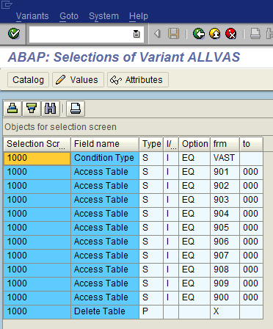

But the current existing VAS combinations are: 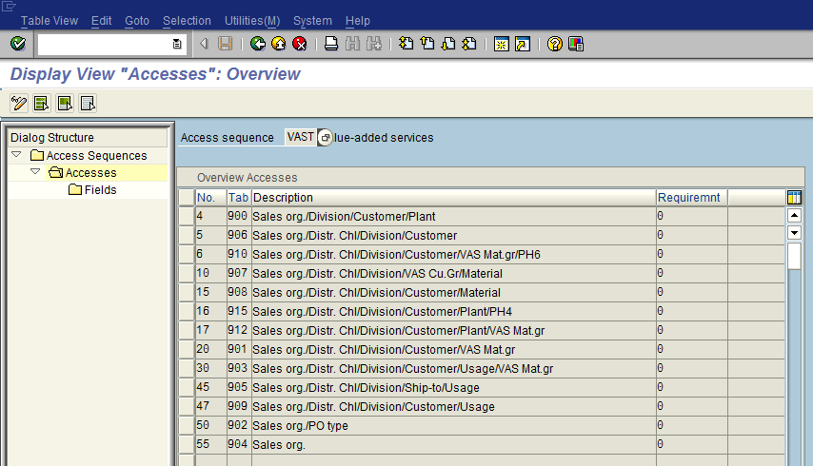

Variant Update

The missing key combinations from the program variant are:

1. 910 – Sales org./Distr. Chl/Division/Customer/VAS Mat.gr/PH6
2. 915 – Sales org./Distr. Chl/Division/Customer/Plant/PH4
3. 912 – Sales org./Distr. Chl/Division/Customer/Plant/VAS Mat.gr

Therefore the above key combinations need to be added to the variant ALLVAS of program ZRSD_VAS_UPDATE.

Table Update

The ZSDVAS that stores all these VAS details also needs to be updated, because it includes all fields of all key combinations in order to store the data to be pulled by the reports.

The missing fields that need to be added are:

1. PH6 – product hierarchy 6 – license
2. PH4 – product hierarchy 4 – silhouette

Program Updates

Program ZRSD_VAS_UPDATE also needs to be updated to accommodate the new key combinations and populate the correct fields in the table based on the condition record and key combinations.

Report Updates

The reports may need to be updated to pull the new fields into the corresponding reports.

WMS510, VAS Codes ALL, shows all VAS codes with a description, data that appears on the label and an attached picture example of the label, if applicable.

WMS520, VAS Codes by Customer, shows all VAS Codes associated with each customer, as well as, the VAS description, data that appears on the label and an attached picture example of the label, if applicable.

WMS530, VAS Codes by Customer with Drilldown, shows all VAS Codes associated with each customer, either by Customer or VAS Code, as well as, the VAS description, data that appears on the label and an attached picture example of the label, if applicable.

**Assumptions:**

1. All new VAS need to be picked up by the program and displayed on the WMS VAS reports.

**Known Issues:**

1. As new VAS key combinations are added, the table, program and reports need to be updated.

**Technical Specification:**

| Technical Object | Type | Description |
| --- | --- | --- |
| ZSDVAS | SAP Table | Consolidated VAS data for Crystal reporting |
| ZRSD_VAS_UPDATE | SAP Program | Program to update VAS data into table ZSDVAS |
| WMS510 | Crystal Report | VAS Codes ALL |
| WMS520 | Crystal Report | VAS Codes by Customer |
| WMS530 | Crystal Report | VAS Codes by Customer with Drilldown |

**Source Control:**

| Change Object | Application | Developer | Description |
| --- | --- | --- | --- |
|  |  |  |  |
|  |  |  |  |

**Related Documents (Document, URL, Email, etc.):**

| Document Name | Location | Created By | Description |
| --- | --- | --- | --- |
|  |  |  |  |
|  |  |  |  |

**Test Scenarios:**

| No. | Test Scenario | Expected Results | Actual Results | Application / Environment | Tester | Creation  Date | P/F | Panaya |
| --- | --- | --- | --- | --- | --- | --- | --- | --- |
| 001 | Program variant ALLVAS updated | Program variant is populated with all VAS tables that exist in configuration |  |  |  |  |  | ☐ |
| 002 | Program ZRSD_VAS_UPDATE is updated | Program is updated to include all VAS tables that exist in configuration |  |  |  |  |  | ☐ |
| 003 | Table ZSDVAS updated | New fields for PH4 and PH6 have been added to the table and are populated appropriately |  |  |  |  |  | ☐ |
| 004 | WMS510 updated | WMS510 report is updated to show all VAS codes that exist in the system |  |  |  |  |  | ☐ |
| 005 | WMS520 updated | WMS520 report is updated to show all VAS codes associated with a customer |  |  |  |  |  | ☐ |
| 006 | WMS530 updated | WMS530 report is updated to show all VAS codes associated with a customer and all customers associated with a VAS code |  |  |  |  |  | ☐ |

**Panaya Scripts:**

| No. | Panaya Script | Test No. | Tester | Description |
| --- | --- | --- | --- | --- |
|  |  |  |  |  |
|  |  |  |  |  |
|  |  |  |  |  |

**uPerform / Camtasia:**

| No. | uPerform Script | Creation Date | Language | Description |
| --- | --- | --- | --- | --- |
|  |  |  |  |  |
|  |  |  |  |  |
|  |  |  |  |  |

**TDMS Requirements:**

Is a new TDMS client required? If yes:

1. When is it required?
2. For how long will it be required?
3. What is the date range of data to be copied?
4. What box and client should the data be copied from?