**SNC PO Push Production Issue**:

There are 45 Pos which were created on 01/13/2016 and if we take a look in the SNC system there are only 24 Pos moved to it.

Here are the Pos which are created:

|  |  |  |  |
| --- | --- | --- | --- |
| 4500150070 | 4500149960 | 4500150010 | 4500150037 |
| 4500150071 | 4500149961 | 4500150011 | 4500150044 |
| 4500149947 | 4500149962 | 4500150012 | 4500150052 |
| 4500149949 | 4500149963 | 4500150013 | 4500150055 |
| 4500149950 | 4500149964 | 4500150014 | 4500150056 |
| 4500149951 | 4500149966 | 4500150016 | 4500150057 |
| 4500149952 | 4500149986 | 4500150018 | 4500150058 |
| 4500149953 | 4500149988 | 4500150019 | 4500150059 |
| 4500149956 | 4500150007 | 4500150020 | 4500150060 |
| 4500149957 | 4500150008 | 4500150025 | 4500150061 |
| 4500149958 | 4500150009 | 4500150031 | 4500150062 |
| 4500149959 |  |  |  |

Here are the Pos which are not moved to SNC:

|  |  |  |  |
| --- | --- | --- | --- |
| 4500150070 | 4500149960 | 4500150014 | 4500150044 |
| 4500150071 | 4500149961 | 4500150016 | 4500150057 |
| 4500149950 | 4500149963 | 4500150019 | 4500150059 |
| 4500149951 | 4500150007 | 4500150025 | 4500150060 |
| 4500149956 | 4500150009 | 4500150031 | 4500150061 |
| 4500149959 |  |  |  |

Here is the Job log of the SNC PO Push:

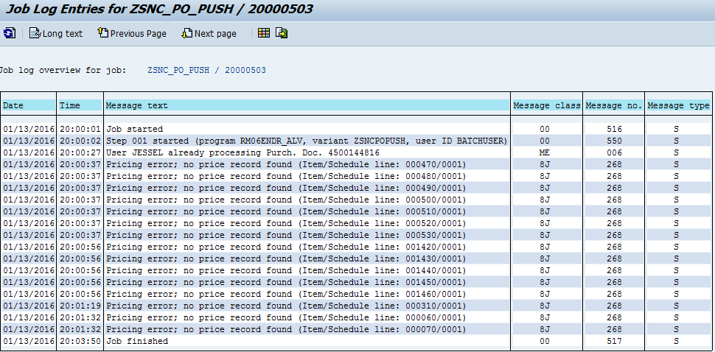

Understand that there is an issue with 4500144846 PO.

If we look at the SXI_MONITOR we do not see any error messages, which means all the Pos has to be moved to SNC systems.

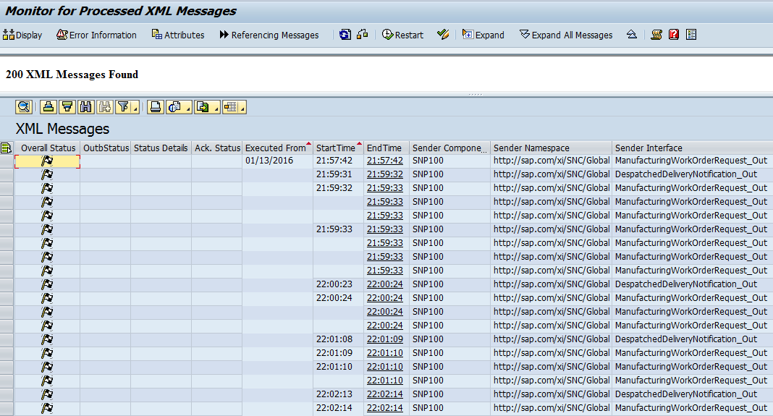

Understand that there is an inbound queue which is formed due to unknown reason:

**SMQ2:**

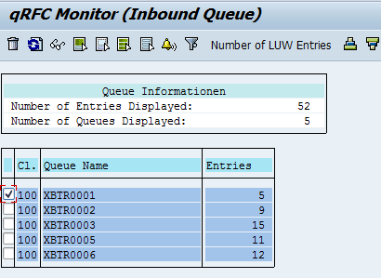

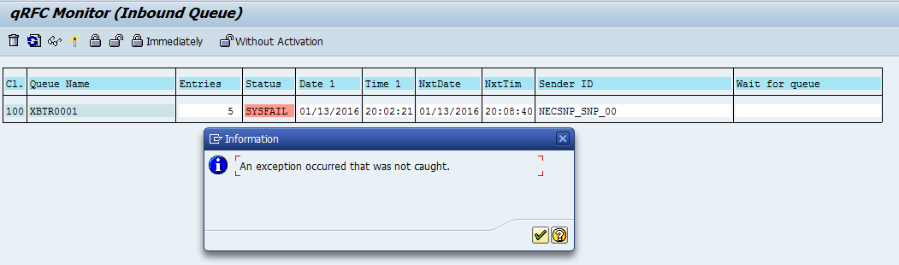

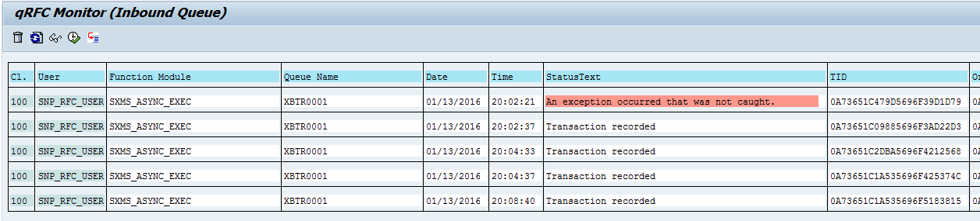

If we look at the queue:

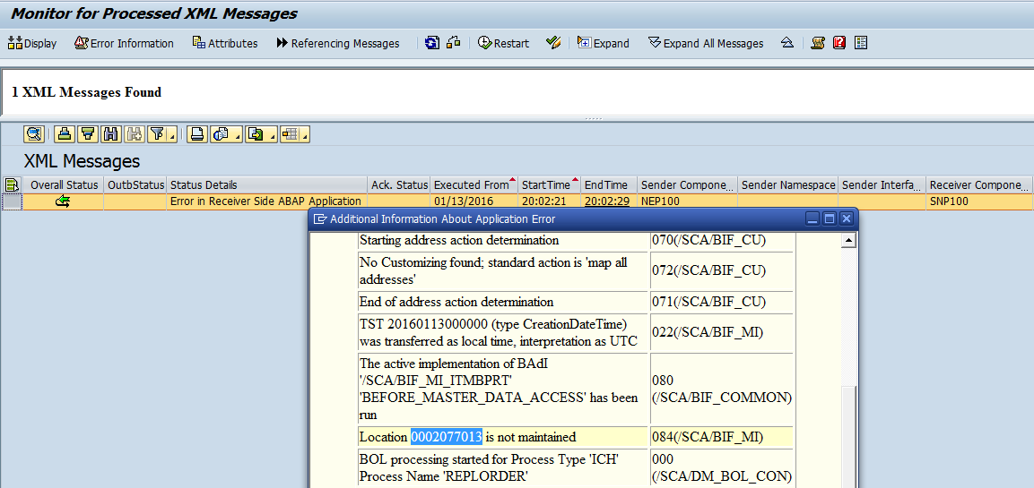

We see that the queue is formed due to a location which is not maintained in the SNC system.

If we take a look at the PO and in the sales order we understand that the ship to location is being changed in the Sales order.

Originally the ship to location was 2038472 and was moved by our daily master data CFM. As this ship to “2077013” it may be the reason the queue is formed and it had blocked all other Pos.

Move the Customer 2077013 CFM:

Re process the queue

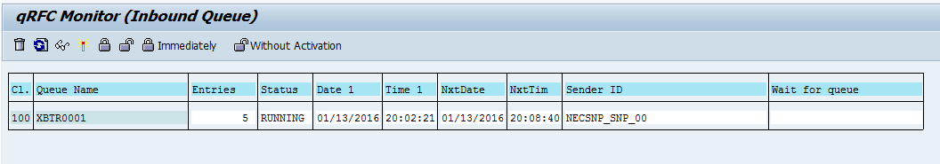

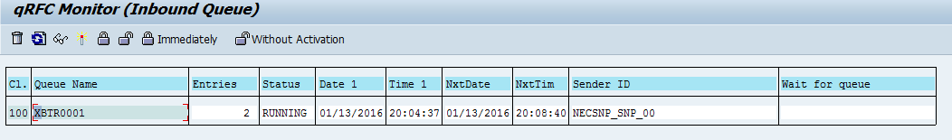

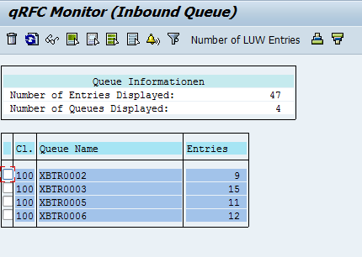

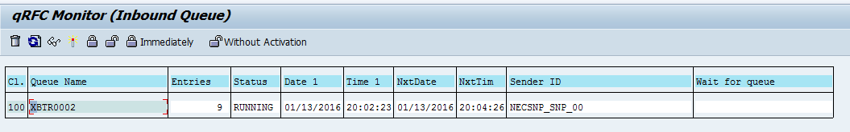

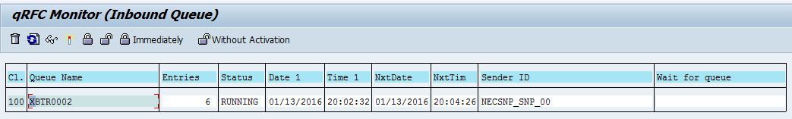

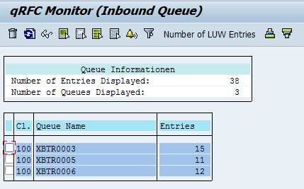

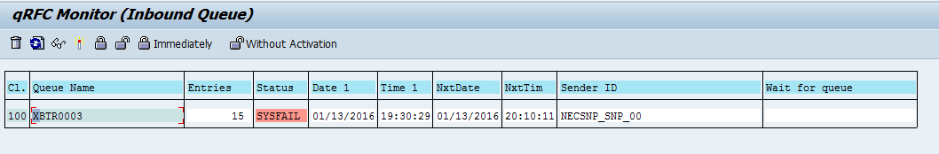

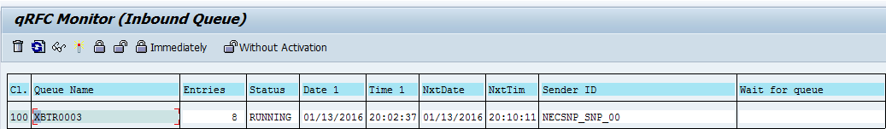

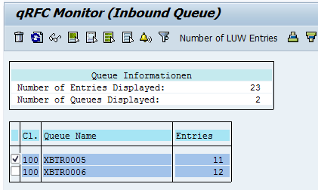

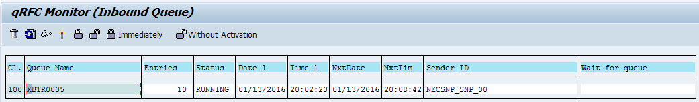

After Queues are processed successfully the Pos are there in the SNC system