**Issue:** Purchase Order Data is Different in ECC and SNC systems.

**Reason:** When the Delivery date or Ex Fac Date is changed in ECC using ZPO_DATECHG transaction

**Analysis:** It is observed that two Messages are generated when the EX Fac Date and Delv Date are changed at a time for a PO with the transaction ZPO_DATECHG.

Two Outputs are created first one for delivery date and second one for ex fac date. Sometimes the second IDOC is failing.

This is causing the data inconsistency in the PO of ECC and SNC.

**Solution:** One of the Solution is we can change the Dispatch time of the Output Message to ***"Send with periodically scheduled job"*** so that there may be any number of changes and we can process the messages at once making sure that all messages are processed and data is same in SNC and ECC.

This will send the most recent changes in the PO.

***Below Examples show the Most Recent Data is transferred to SNC with Creation& Change IDOCs:***

1. **ORDERS IDOC (PO Creation)**

Create a Purchase Order: A Purchase Order # 4600007468 is created and ZSNC Message is generated (not Processed) as shown in the below screen shots:

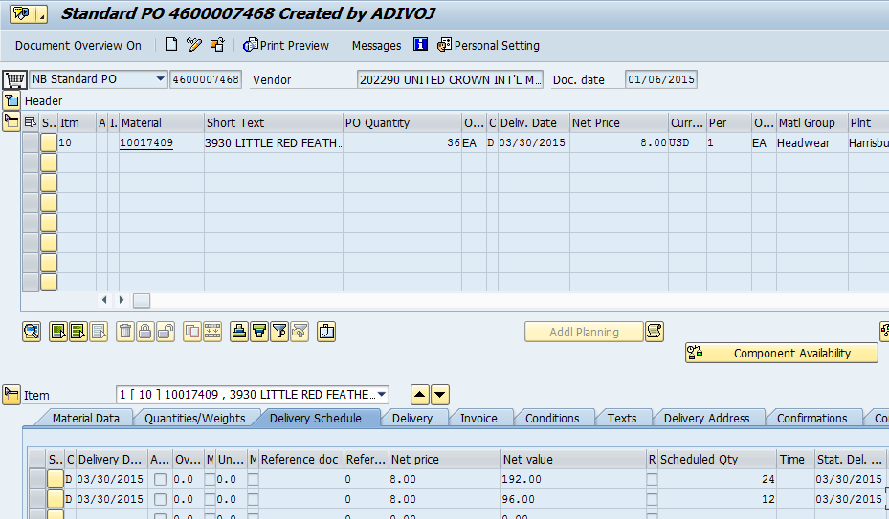

Message Output ZSNC is not processed:

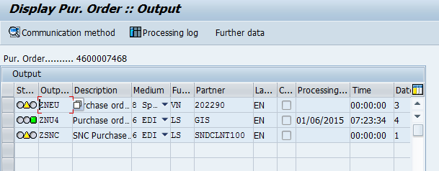

This message is generated for creation of PO which is for ORDERS IDOC.

Delivery date in the PO is 03/30/2015 and Ex fac Date is 03/30/2015

1. Delivery date is changed form 03/30/2015 to 01/22/2015 and Ex Fac date changed from 03/30/2015 to 01/21/2015 for PO # 4600007468

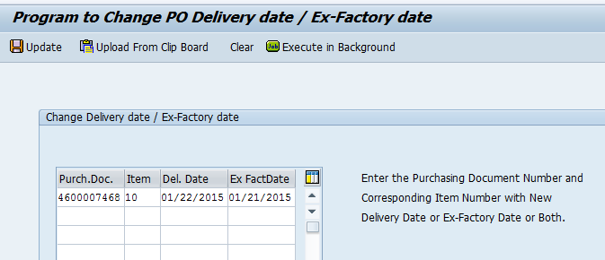

1. Change the Ex Fac date through ME22N from 01/21/2015 to 01/22/2015

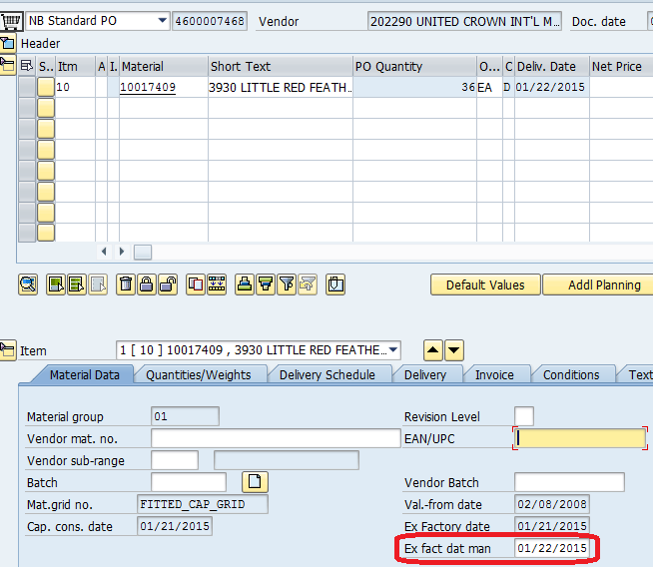

1. Change the Quantity in the Purchase Order using ME22N

Quantity is changed from 24 EA to 36 EA for Grid 612 and from 12 EA to 24 EA for grid 700 as shown in the below screen shots.

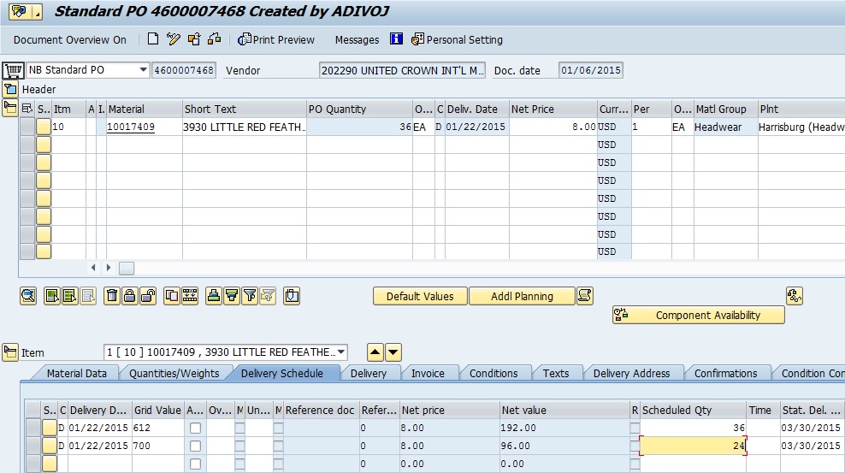

1. Change the Delivery date form 01/22/2015 to 02/10/2015 and Ex Fac date form 01/22/2015 to 02/09/2015 using ZPO_DATECHG.

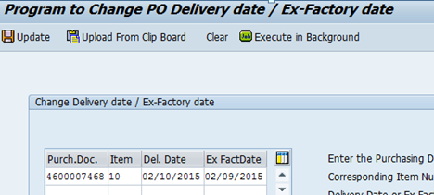

***Process the Out Put Message using ME9F:***

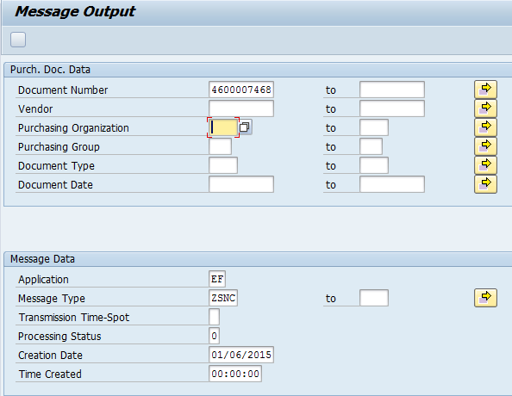

The Output Message is processed as shown in the below screen shot:

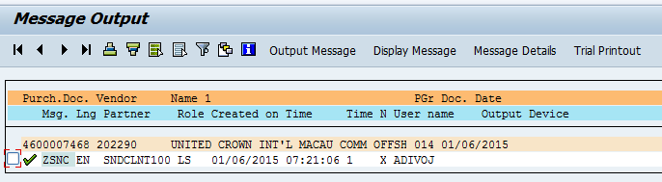

Here we see the ZSNC Output Message is processed:

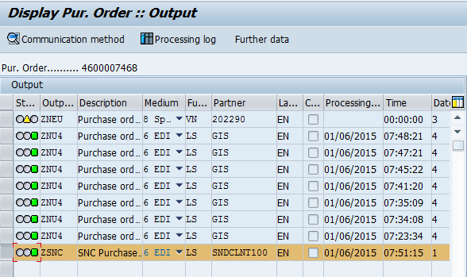

When we process the ZSNC Output Message (ORDERS IDOC) the most recent changes are carried in the IDOC and are sent to SNC.

IDOC 355693 is generated:

If we look in to the IDOC the most recent changes in the PO are carried into the IDOC.

* Ex Factory date in the IDOC is “02/09/2015” which is the most recent changes before the Message is processed.
* Delivery date in the IDOC is 02/20/2015 which is the most recent changes before the Message is processed.
* Quantities in the IDOC are 36 EA for grid 612 and 24 EA for grid 700, which are the most recent changes done before the Message is processed.

Data in the IDOC are given below screen shots:

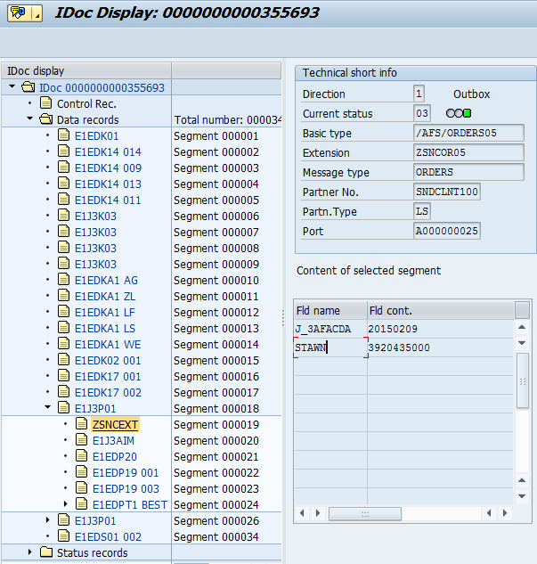

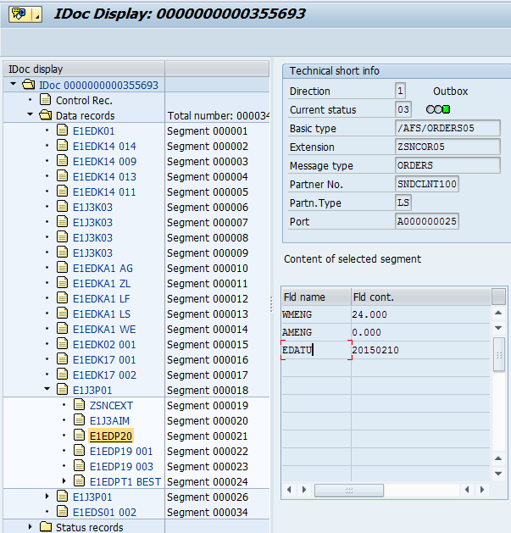

The Same Most Recent changes are carried to SNC as shown in the below Screen shot (PO from SNC)

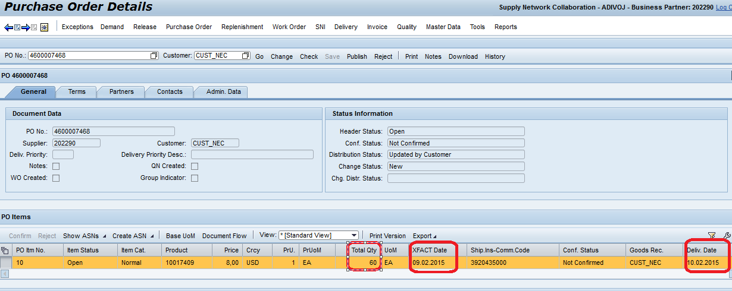

1. **ORDCHG IDOC (PO Change)**

PO # 4600007470 is created and the PO is transferred to SNC with ORDERS IDOC.

Quantity

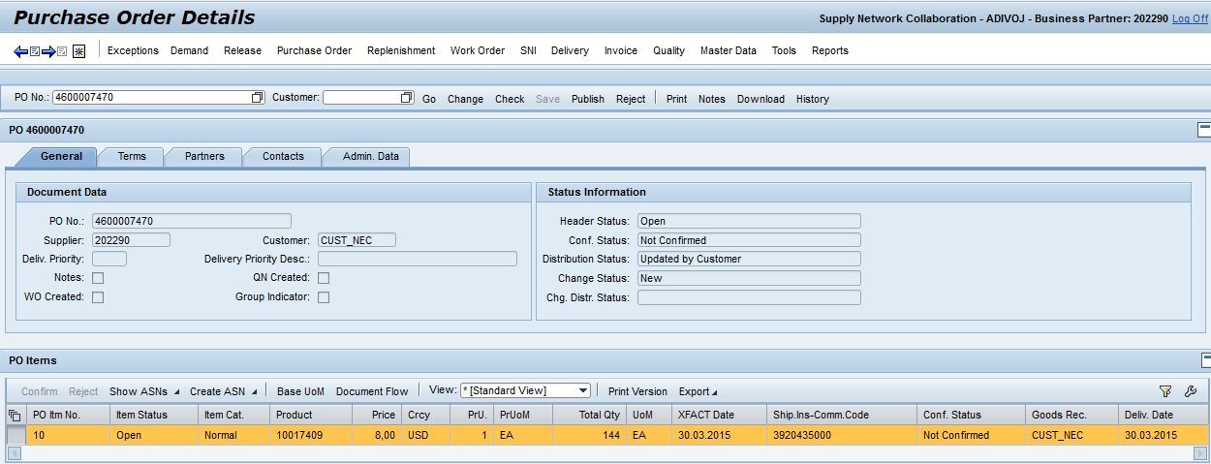

1. Change the Quantities in the Purchase Order # 4600007470, for Grid 718 Quantity is changed from 72 to 12 and for Grid 714 Quantity is changed from 72 to 24 by ME22N.

A Message is generated with output type ZSNC which is not processed as shown in below screen shot:

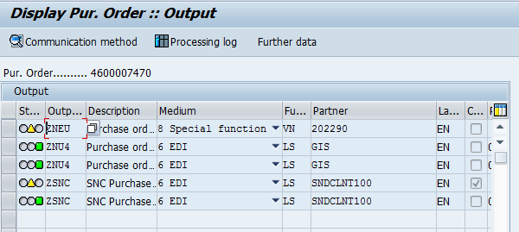

1. Change the Ex Factory date from 03/30/2015 to 02/10/2015 and Delivery date form 03/30/2015 to 02/10/2015 using ZPO_DATECHG.

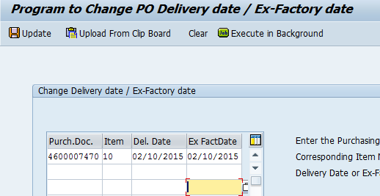

1. Change the Delivery date from 02/10/2015 to 02/11/2015 using ZPO_DATECHG.

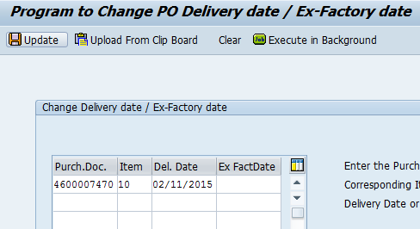

***Process the Out Put Message using ME9F:***

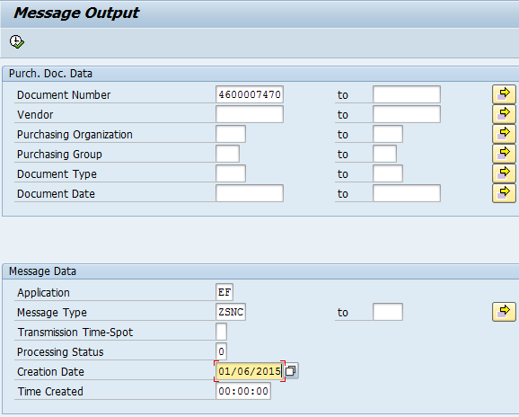

The Output Message is processed as shown in the below screen shot:

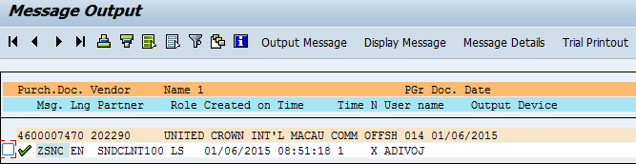

Here we seen in the below screen shot that the Message is processed.

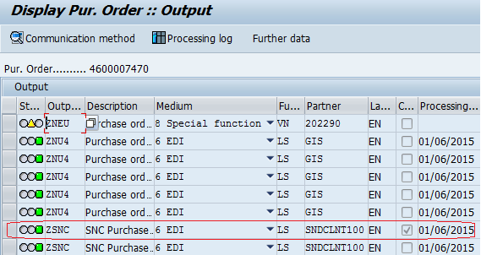

When we process the ZSNC Output Message (ORDCHG IDOC) the most recent changes are carried in the IDOC and are sent to SNC. IDOC 355714 is generated:

If we look in to the IDOC the most recent changes in the PO are carried into the IDOC.

* Ex Factory date in the IDOC is “02/10/2015” which is the most recent changes before the Message is processed.
* Delivery date in the IDOC is 02/11/2015 which is the most recent changes before the Message is processed.
* Quantities in the IDOC are 24 EA for grid 718 and 12 EA for grid 714, which are the most recent changes done before the Message is processed.

The Most recent changes are moved to SNC and below is the Screen shot form SNC system.

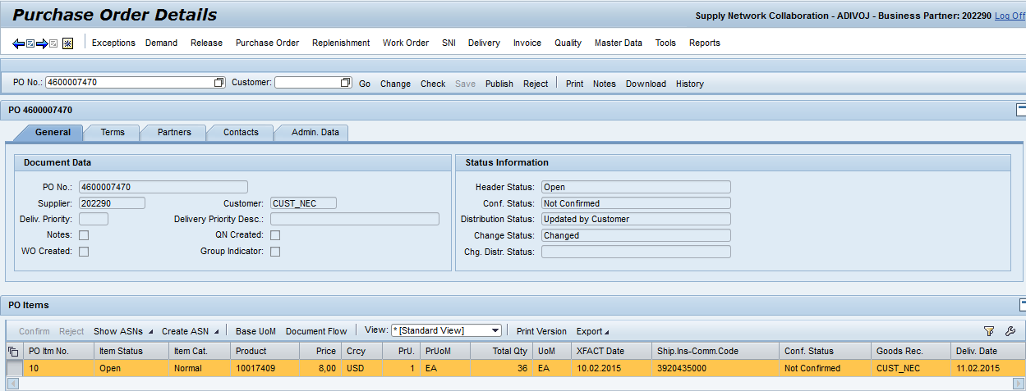

When there is a situation when the ME9F and the Change in PO (Using ZPO_DATECHG) or manually is happening simultaneously:

Updating Ex Fac and Delivery Date for POs

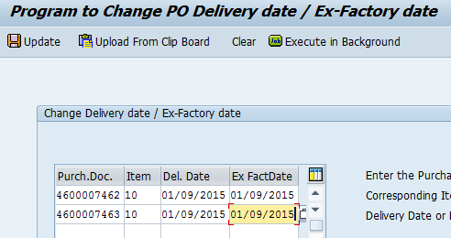

Processing Output for those POs at same time

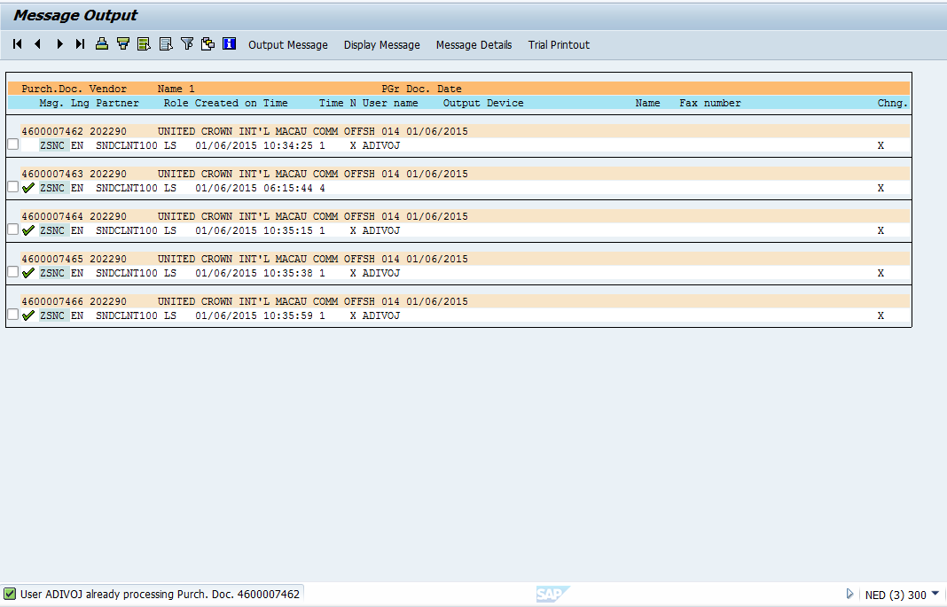

Here we can see a message that the PO # 4600007462 is already processing and the Output is not processed, and another Output Message is generated for the PO # 4600007463 due to the changes done using ZPO_DATECHG which shall be processed later.

**THE END**