## Issue

When the Item Category is changed in the sales order line item from TAB to TAS using **MASS** Transaction incomplete Purchase requisition is generated.

## Analysis

Usually if Item Category is changed in the sales order from TAB to TAS a new line item shall be generated in purchase requisition deleting the existing one which is not happening when there are multiple grids (schedule lines) in the sales order item:

When Changing Item Category from TAB t o TAS using MASS:

1. If the line item in the sales order is having a single schedule line (Grid) the new Purchase requisition line item is generated, deleting the existing one.

**Example in DEV 300:**

Sales Order: 69212

Purchase Requisition: 13404242.

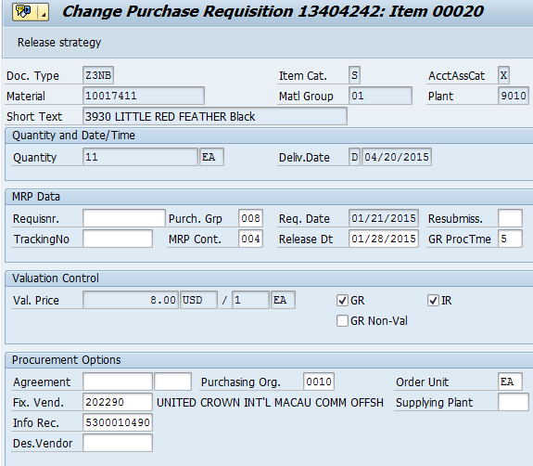

In above screen shot we see that a new item (20) is generated and data in purchase requisition is complete

1. If the line item in the sales order is having multiple schedule lines (Grids) the new Purchase requisition line item is not generated data (purchase group, release date, valuation price and GR/IR) is missing in the purchase requisition which is an incomplete requisition.

**Example in DEV 300:**

Sales Order: 69211

Purchase Requisition: 13404241.

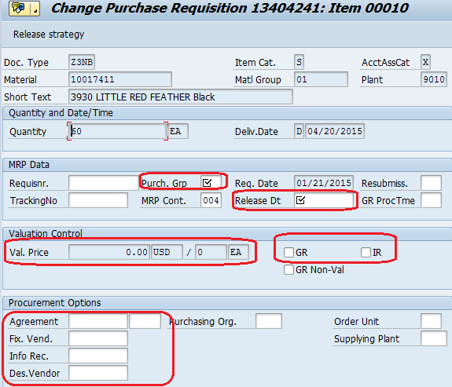

In above screen shot we see that no new item is generated and data in purchase requisition is incomplete.