**ISSUE WITH MASS CHANGE OF ITEM CATEGORY IN THE SALES ORDER**

**Step 01: Create sales orders**

Create two sales orders using same material and plant as shown below.

Materials: 10776057 & 10776054

Plant: 9010

Sales order type: ZPTO

Customer: 1007331

Sales org Data: sales organization: 1000, Distribution channel: 10 and Division: 00

Sales orders: 1336723 & 1336724

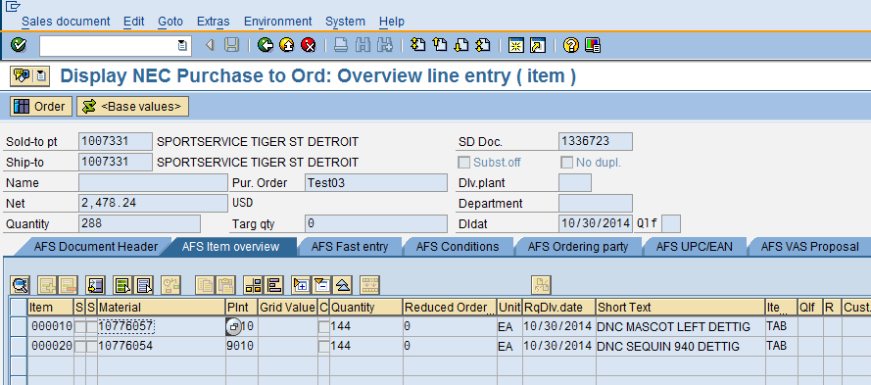

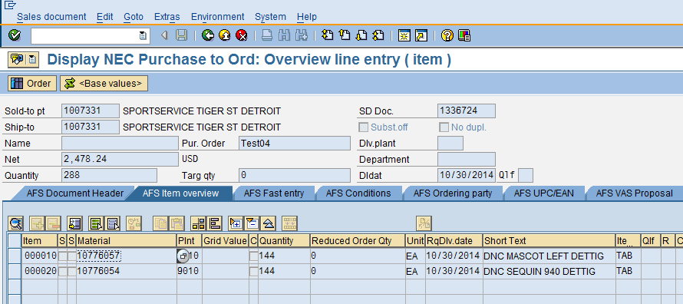

**Step 02: Change the item category manually in the sales order 1336723**

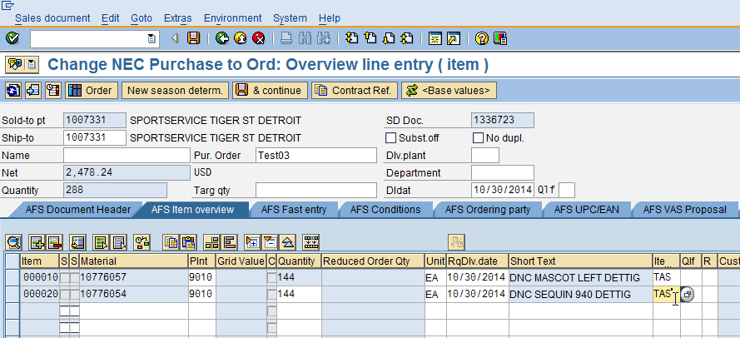

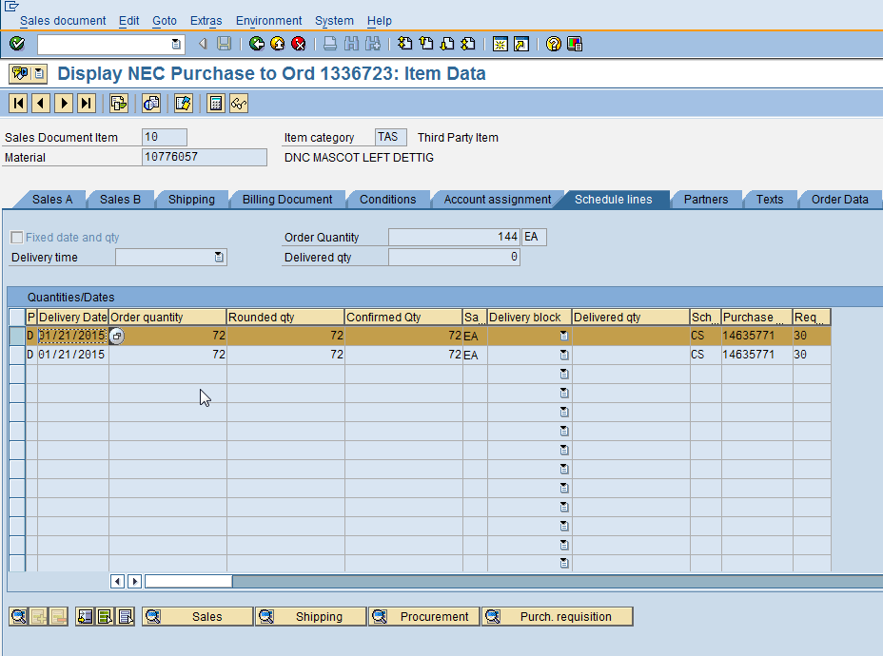

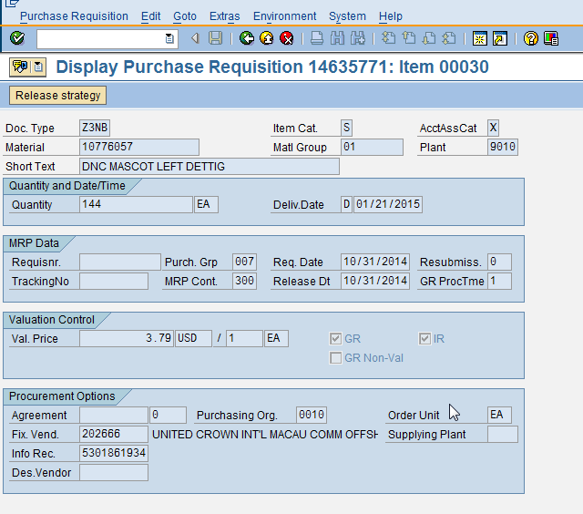

From the above we can understand that after changing the item category from TAB to TAS new purchase requisition items are created with correct data.

**Step 03: Change the item category in the sales order 1336724 in MASS**

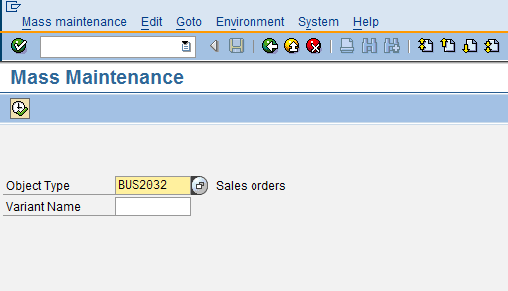

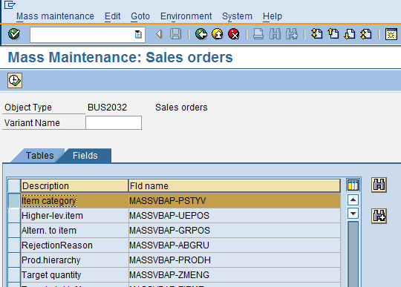

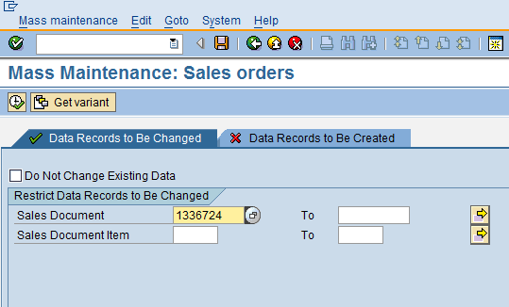

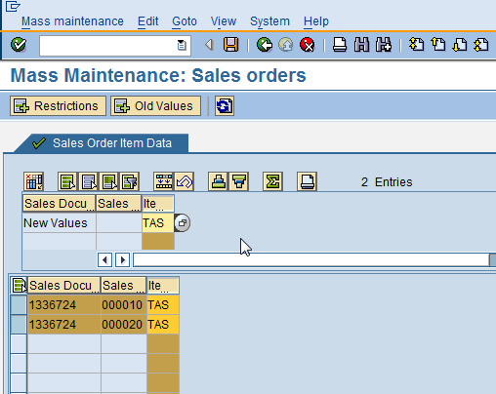

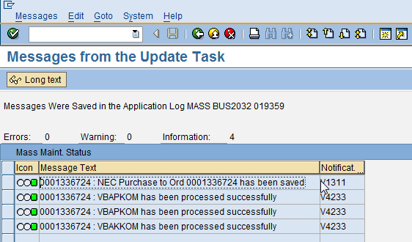

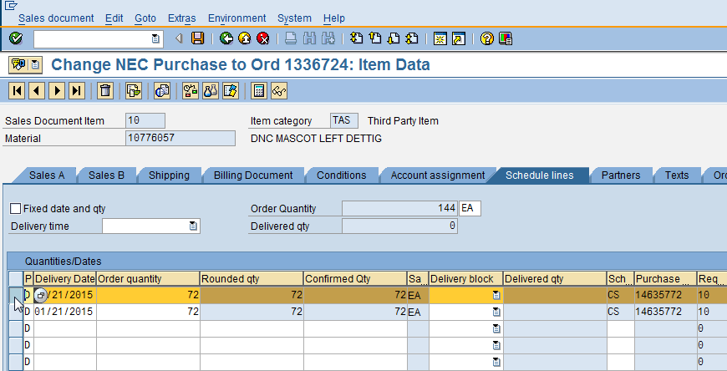

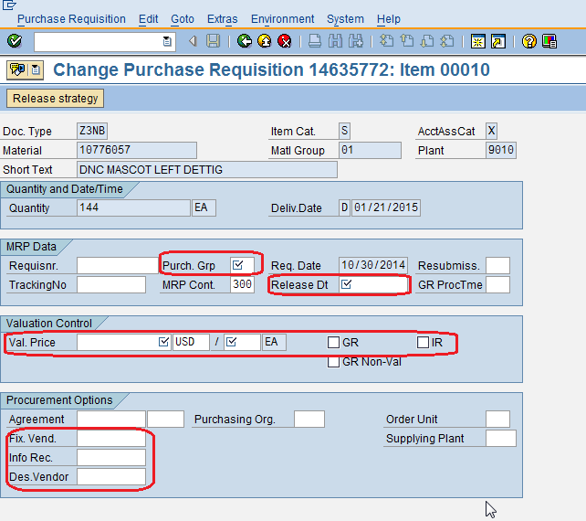

From the above we can understand that after changing the item category from TAB to TAS no new purchase requisition items are generated and data (purchase group, release date, valuation price and GR/IR ) is missing in the existing item.