**STEPS TO LOAD 0CUSTOMER**

We have loaded the customer master data into 0CUSTOMER info object in BPD, BPQ & BPP systems using the steps below:

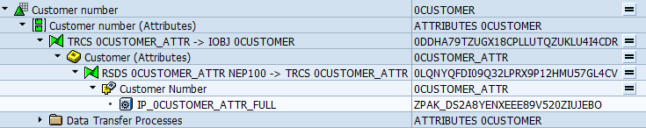

1. Executed info package for 0CUSTOMER in Full load mode to get the data into PSA table from ECC as seen here:

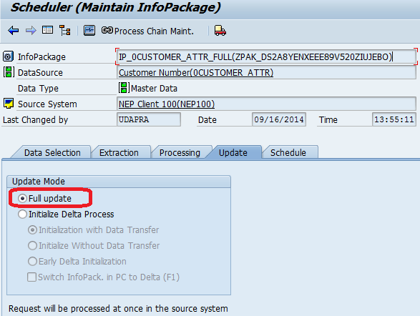

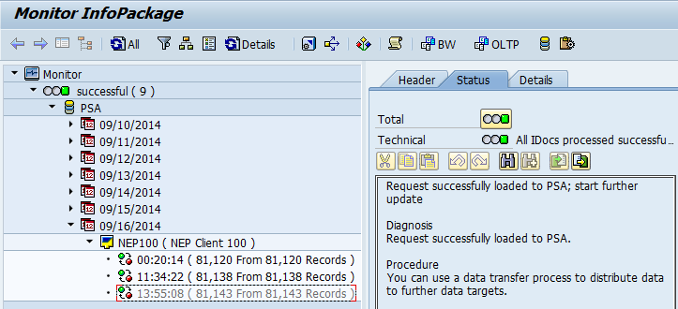

2. Once the Info package is completed successfully, we executed the Data Transfer process for 0CUSTOMER in Delta mode to load the data from PSA table to info object 0CUSTOMER, as shown:

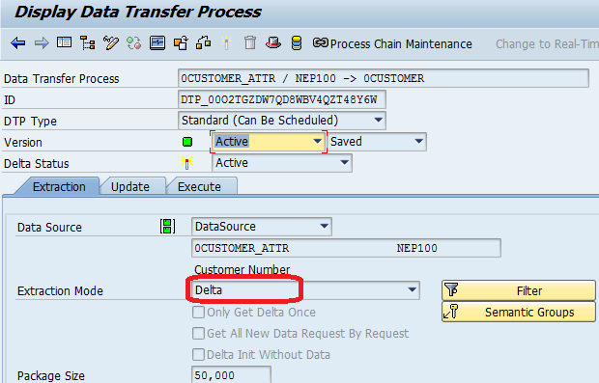

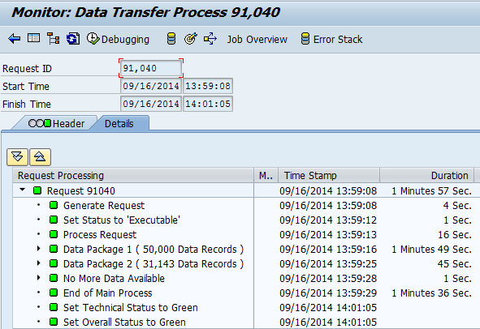

3. Once the DTP completes successfully, we activated the master data using attribute change run option in Tools menu under data warehousing workbench as shown here:

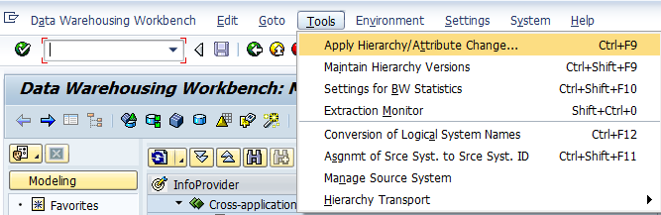

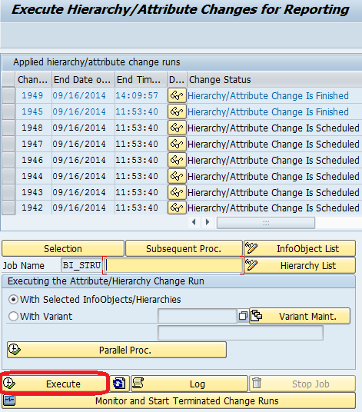

4. When we run the 0CUSTOMER_ATTR extractor in RSA3 transaction in NEP, it shows the Japanese characters correctly. But once it is loaded to BW, it does not identify the characters and replaces # values for Japanese characters in PSA:

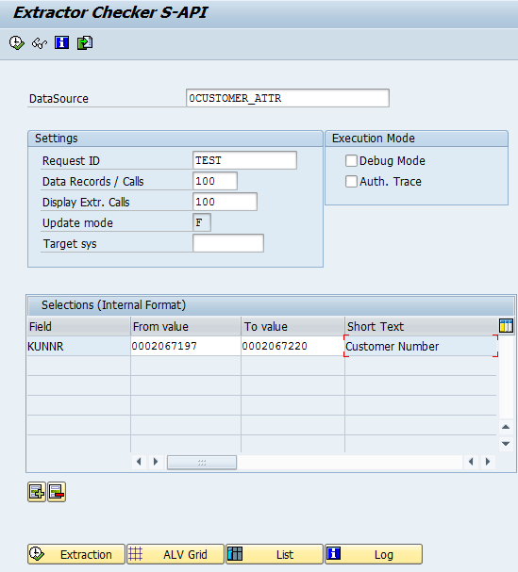

RSA3 Output in ECC:

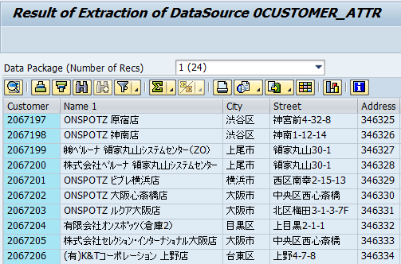

PSA Output in BW:

