1. **Max char for stock category field - 16**

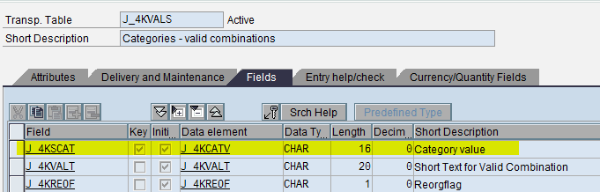

1. **Options to maintain different category structures:**

There are various options to set up cat structures and not limited to contract #, country of origin, quality, and industry segment-

It would be easier to check the feasibility of creating a new structure to suit the business rather than going by the available options. However, the following are a few examples-

* Sales org
* Dist channel
* Division
* Season
* Collection
* Theme
* Customer Group
* Product Hierarchy
* Material Group
* Material Type
* Sales Office

1. **Stock category enhancements:**

**In AFS6.4 (EHP 4)**, Batch Determination can be done using condition technique and AFS fields Grid Value, Stock category, Season, Collection and Theme have been included. This functionality can be used to display the AFS fields (Grid Value, Stock category, Season, Collection, and Theme) per batch.

**In AFS6.5 (EHP 5)**, Vendor capacity planning is the new functionality.

In reference to stock category, the AFS fields including stock category has been enhanced in Sub-contracting process wherein the component selection can be done based on AFS fields (Grid Value, Stock category, Season, Collection, and Theme).

PP order report (MD4C) has been enhanced with AFS fields. BOM levels and the status of the production order can be viewed based on AFS fields (Grid Value, Stock category, Season, Collection, and Theme).

1. **Areas of Impact in production:**

Apart from the areas mentioned like order entry, new materials etc, the other areas that could have impact is ARUN, MRP and ATP set up as we have not completely evaluated the process with thorough test data.

As for impact on STO’s we need to evaluate this area, but for now we are not sure if it would have any impact. Please let us know the area of concern you have w.r.t STO’s so that we could address the same.

1. **How to set up category structure and coverage strategy?**

**Please note: This is illustrative example and each aspect of AFS stock category need to be studied thoroughly as there’s not much info available on stock categories.**

Path: SPRO>Logistics General>AFS Categories>Define Category Structures

Step 1: Define category structure (4 Char) and maintain description

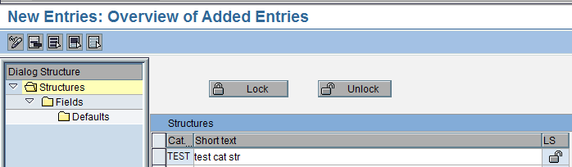

Step 2: Define characteristics in CT01 and assign the fields.

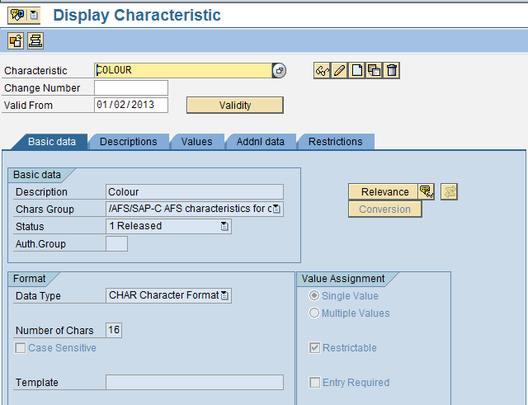

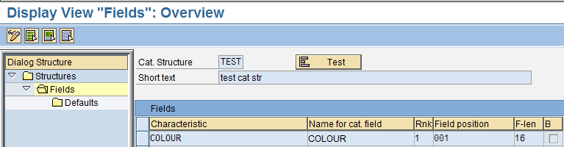

Step 3: Define coverage strategy.

Step 3.1: Select the defined structure and lock it and save.

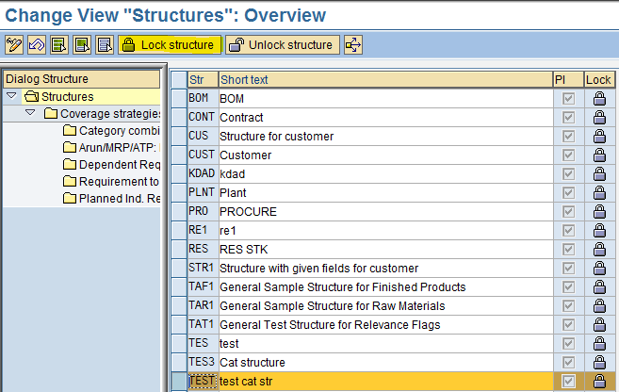

Step 3.2: Define coverage strategy

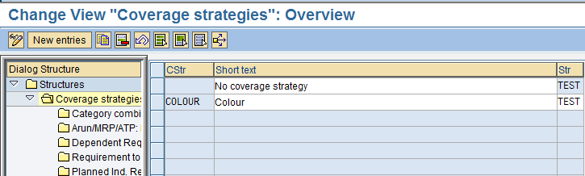

Step 4: Define category combination (select from the available values)

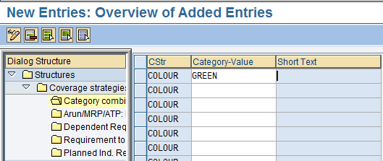

Step 5: Set up ARUN/MRP/ATP

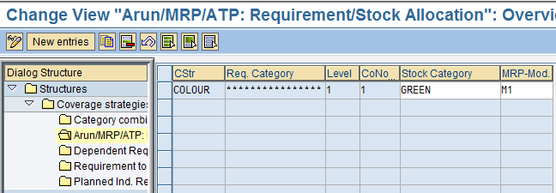

Step 6: Set up dependant requirements

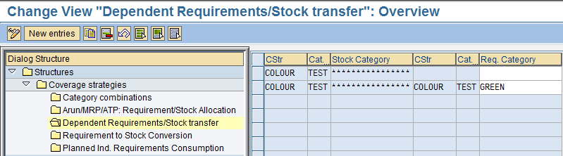

Step 7: Set up requirement to stock conversion

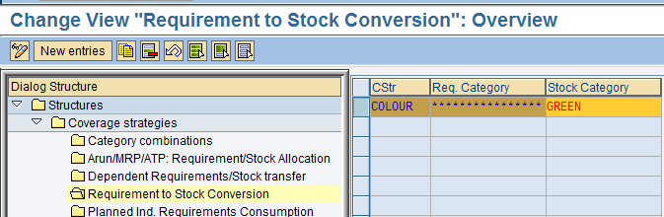

Step 8: Set up planned requirements

