1. Create a variant to the program ‘ZSD_CHAINLINK_JOB’.

Variant - CHAIN LINK (With the Application file path, which is using by the Background job ‘ZCHAINLINK_DEL_UPD’)

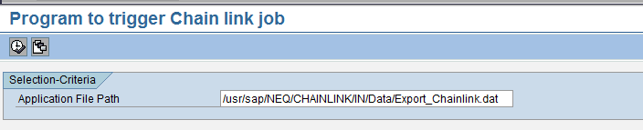

1. Delete the Existing Chain Link Job ‘ZCHAINLINK_DEL_UPD’ and create a new job ‘ZCHAINLINK_DEL_UPD’ with the same existing variant and below highlighted changes:

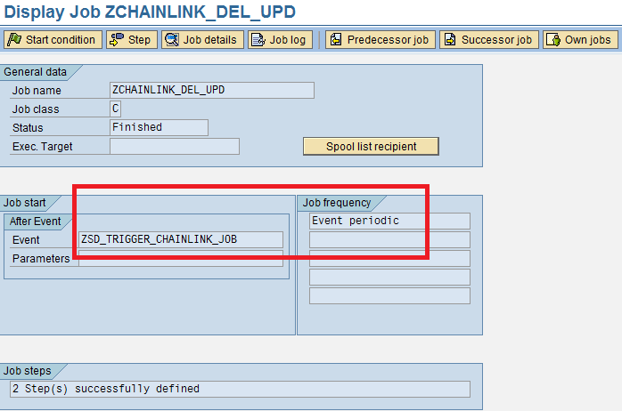

1. Create a new job ‘ZSD_CHAINLINK_JOB’ using the program ‘ZSD_CHAINLINK_JOB’ and variant ‘CHAIN LINK’ (From Step 1) as below:

