MD04 screen after running MRP for the stand alone SO (55226) and Contract-Call off (40000439-55224/5):

Stock was posted for SO 55226 (S=1000 EA)

Planned orders are created for contract-call off (T-Tab).

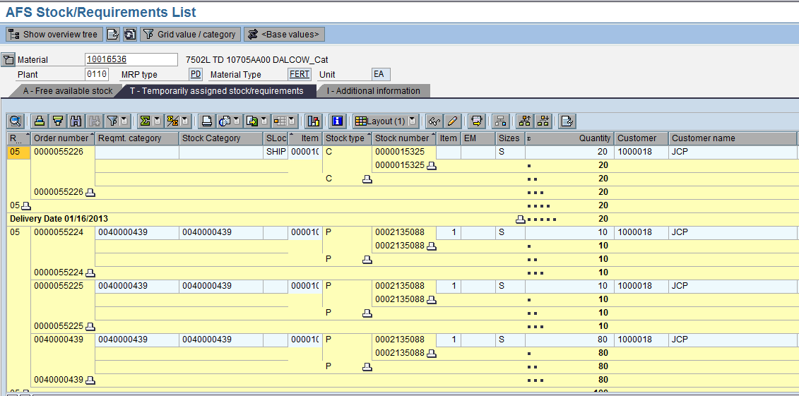

Stock posted for S=1000

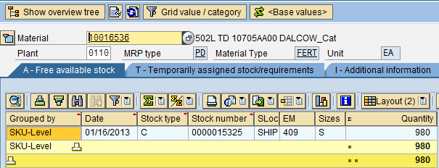

MD04 after MRP

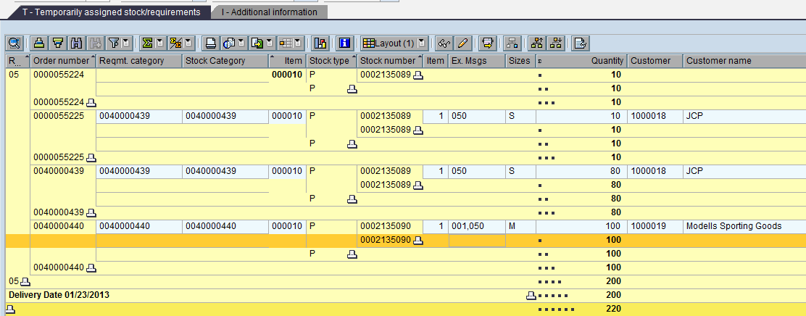

MD04 after confirmation of production orders

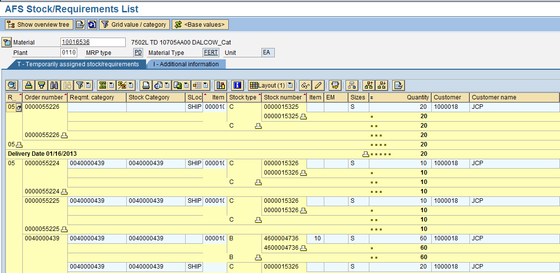

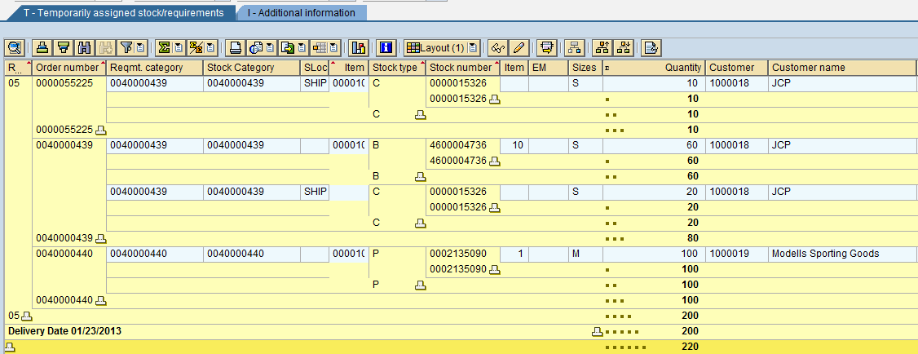

MD04 after ARUN (F-Tab) SO’s

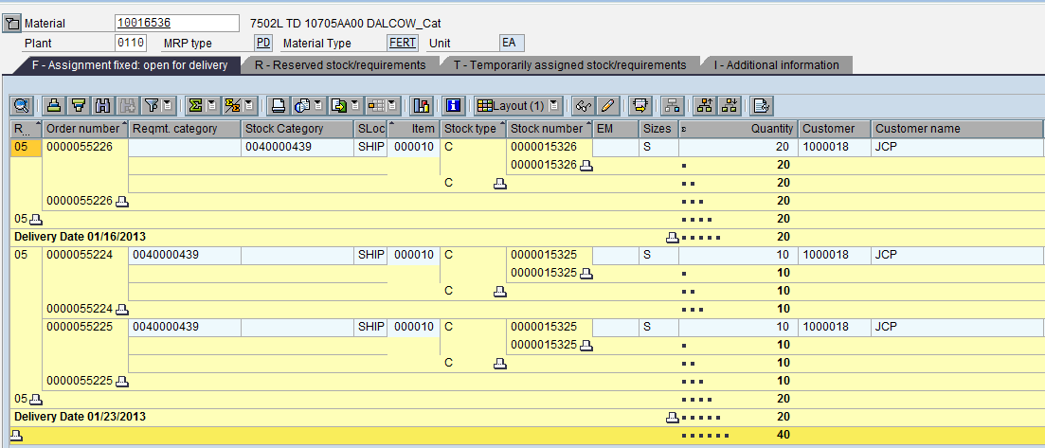

MD04 after ARUN (R-Tab) Unconfirmed Contract

