Summarization of Tax Items in OBCY does not occur because of the following reason:

Countries like US Canada calculates tax line by line by percentages .We can determine pricing percentage for each material for the customers. The statutory regulations in some countries (such as USA, Canada, India, Brazil) can be so detailed and differentiated that the tax calculation not only depends on date and place but also, for example, on material, amount, special vendor or customer and so on.

Summarization of Tax in FI document can be done as below.

- The following only applies to FI documents posted from FI (for example, using Transaction FB01, FB60, and so on) or from logistics (Transactions MIRO, MRKO and so on...).

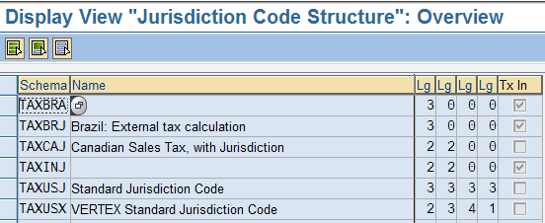

- The above config change to disable tax line by line does not apply to FI documents originating from SD or similar applications. In SD, tax determination can be carried out at document level or line by line, independently of the FI setting in Transaction OBCO. If this setting is not activated, tax is NOT determined line by line, just like in countries without tax jurisdiction codes. In this case, tax is determined from an aggregated value, that is, the amounts of all line items with identical tax code and tax jurisdiction code are cumulated and the tax amount is only then determined from this total amount.

Solutions suggestions:

- In SD, tax determination can be carried out at document level instead of line by line. So configure SD document accordingly.
- Find the user exit for SD billing and apply the change to condense the tax lines.

