1. REQUIREMENT: 2

2. TRANSACTION FLOW: 2

2.1 Reduce the quantity using rejection code 2
3. CUSTOMIZATION SETTINGS: 5

3.1 Define rejection code 5

1. REQUIREMENT:

Close partially invoiced third party (TAS) sales orders

2. TRANSACTION FLOW:

2.1 Reduce the quantity using rejection code

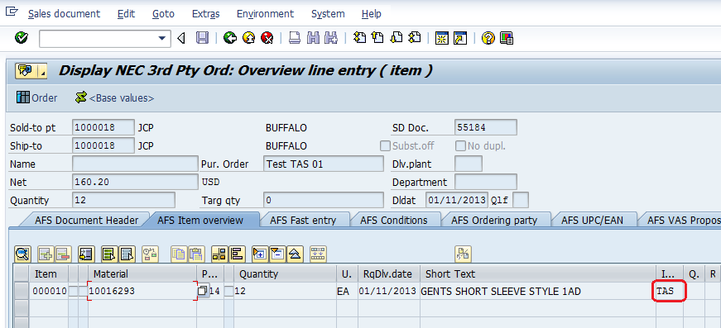

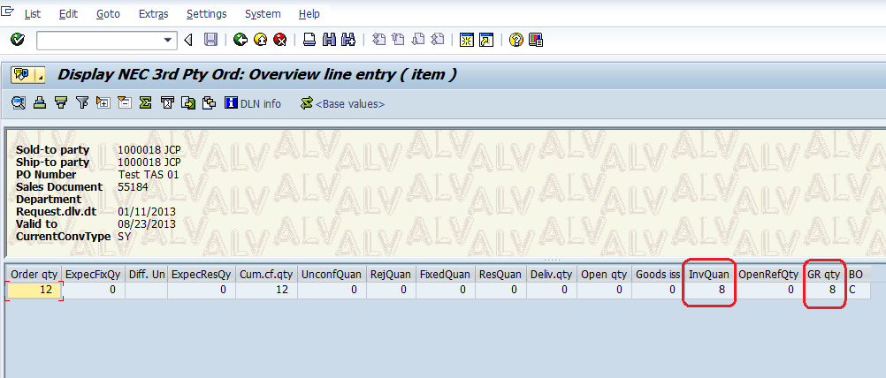
From the above we can confirm that against third party sales order partial quantity is goods receipted and invoiced (Out of 12 only 8 qty is invoiced).
Sales order number: 55184
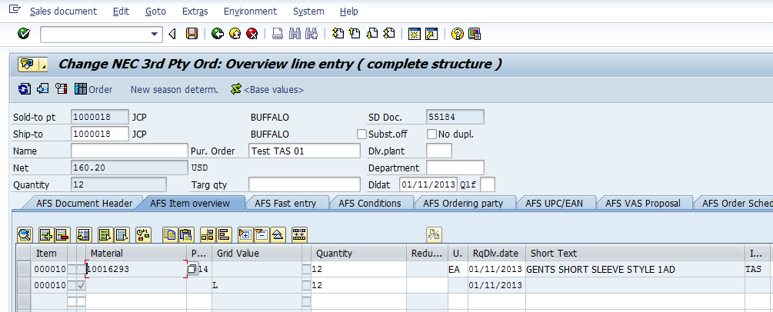

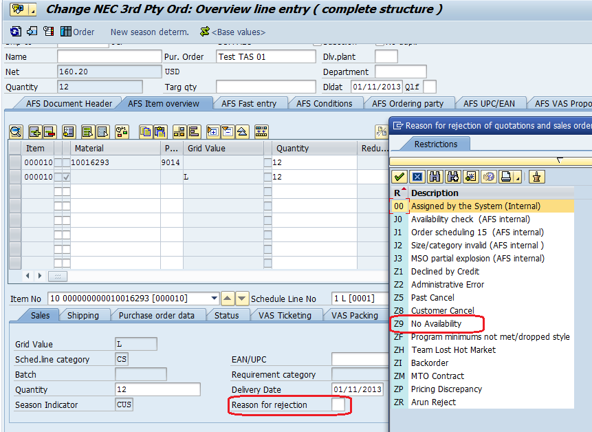
Since the order quantity is 12 and invoiced quantity is only 8 sales order will show open. So in this case we need to reduce the quantity from 12 to 8 by using rejection code. For this we need to select the schedule line and assign the rejection code Z9 (Which is used to reduce the qty) then input the invoice quantity so that balance qty will be rejected.
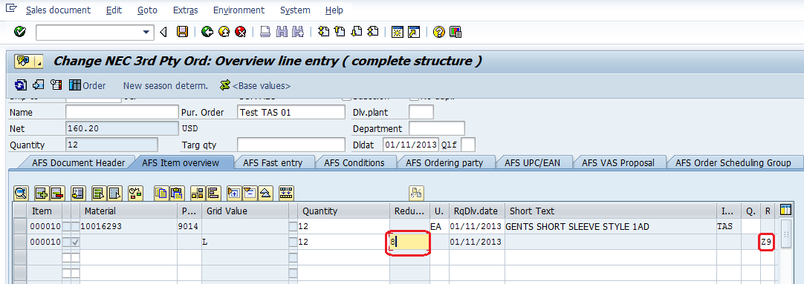

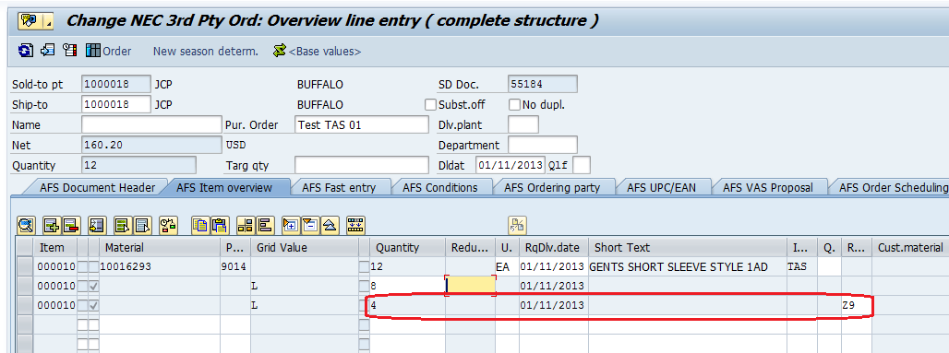

3. CUSTOMIZATION SETTINGS:

3.1 Define rejection code

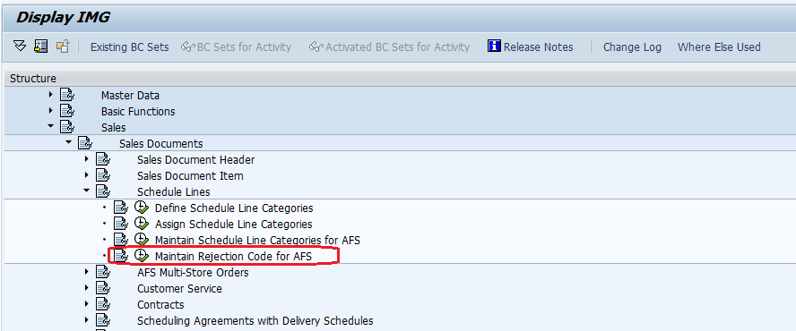

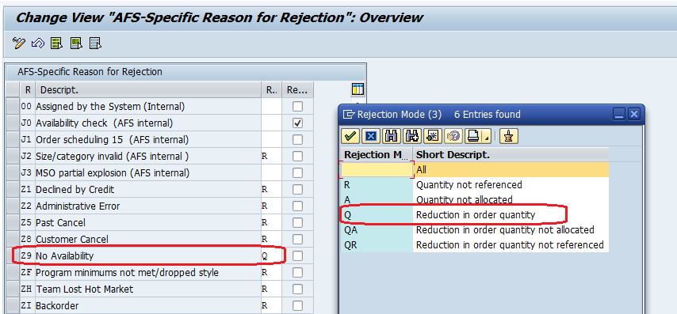

In the third party sales order straight away not possible to reject the balance qty. So for this we need to define the rejection code for reducing the quantity as shown above.

*End of Document*

