**Counter Limitation on TVARVC Table**

Description of the Issue

There’s a limitation on the counter of TVARVC (Table of Variant Variables) table on the field NUMB with data type NUMC of LENGTH 4.

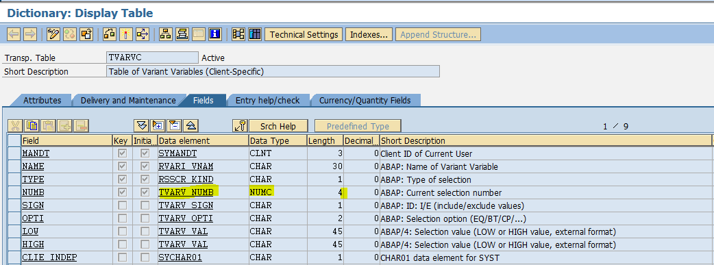

The table is being used in the Rescheduling Job (NA_WKLY_NON_STOCK_RESCHD) that runs weekly on Saturdays.

Issue

Because of the limitation that table can’t hold more than 9999 materials on a given variable (e.g. ZRSD_RESCHEDULING_PO_0116) while we have a ton of materials that can’t be loaded into the variable.

Enhancement

Enhancement was provided with manual steps for table J_3ASUCAL (AFS supplier capacity node data) with the incident # **Vendor capacity ( 216517 / 2016 ) and OSS note 2308383 - Vendor capacity : Number Range was created as a resolution.**

This was done for VCP (Vendor Capacity Planning) when a similar issue was faced.

Resolution?

Provide enhancement for table TVARVC to avoid materials not run through Rescheduling for the counter limitation.

Alternatively, please provide a workaround.