**Purpose :**

Performance Testing of Production Order release, after adding a parameter as per the note 1071025.

**Foreground Testing**

**Test 1:** Below are the list of Orders 19 in number for which Release is carried out.

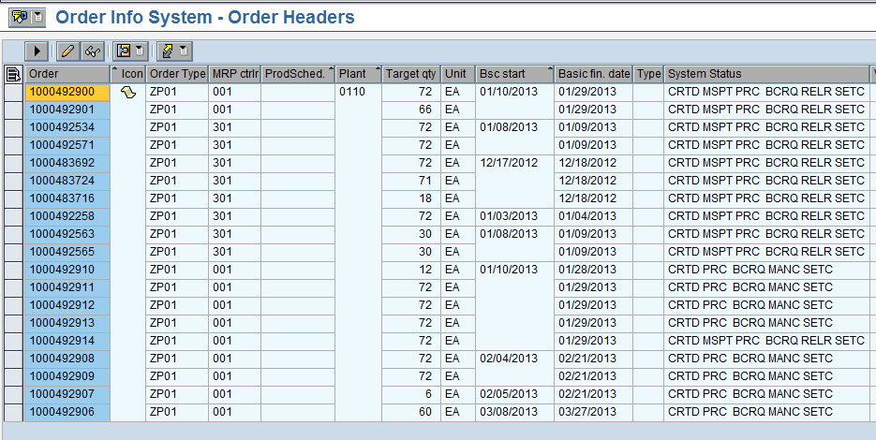

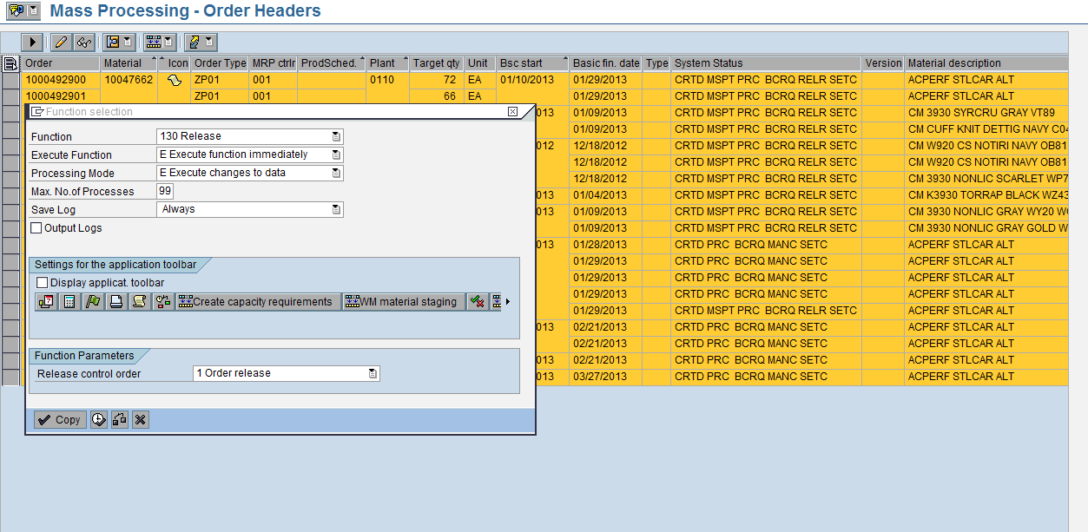

It ran for almost half an hour and got dumped.

Start Time approx: 07:10 and it got dumped at 07:50

**Test2:** Production order release Test is carried out for 10 Orders as listed below.

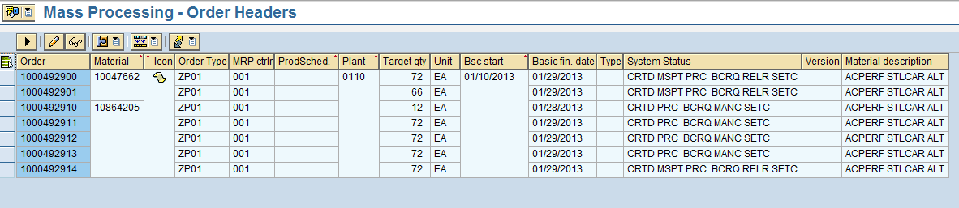

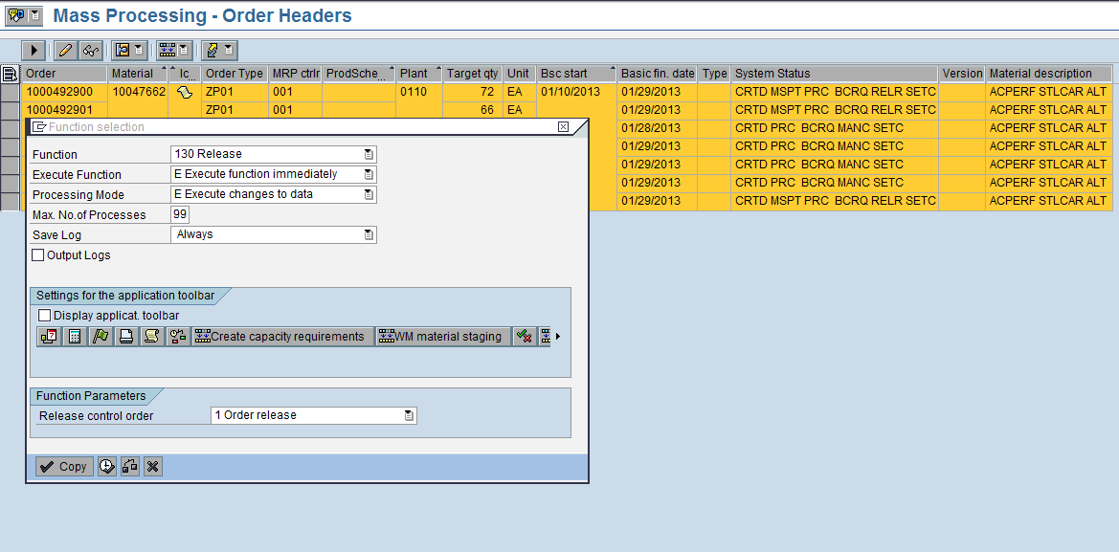

It ran for almost half an hour and got dumped.

Start time approx: 09:10 and it was dumped at 09:43

**Test 3:** Production order release Test is carried out for 2 Orders as listed below.

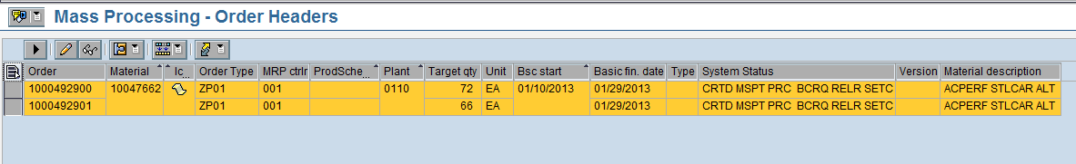

It ran for almost half an hour and got dumped.

Start time approx: 09:50 and it was dumped at 10:20.

**Background Testing**

**Test 1:** Production order release Test is carried out for 2 Orders as listed below.



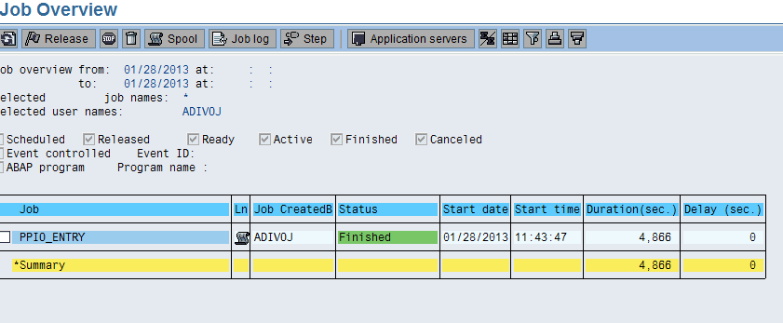

Job started at 11:43 and completed at 13:04.

It took almost 80 minutes for release of 2 Production Orders.

It was observed that the performance was not improved but it has decreased.