|  |  |
| --- | --- |
| *Recap Ticket#* | 5824 |
| *Transport#* | n/a |
|  | Re-process failed IDOCs using BD87 |

**UNIT TEST RESULTS**

|  |  |
| --- | --- |
| *Expected Results* | After reprocessing the IDOC, Intercompany AP document gets generated properly. |
| *Actual Results* | After reprocessing the IDOC, Intercompany AP document gets generated properly. |
| *Pass / Fail* | *pass* |
| *SAP Client where tested* | *NEQ100* |
| *Date Test was Performed* | *05/02/2013* |
| *Tester Name* | *Jingsha Brennan* |

Before re-processing the IDOC. IDOC failed to post to accounting. No ICO AP document is created

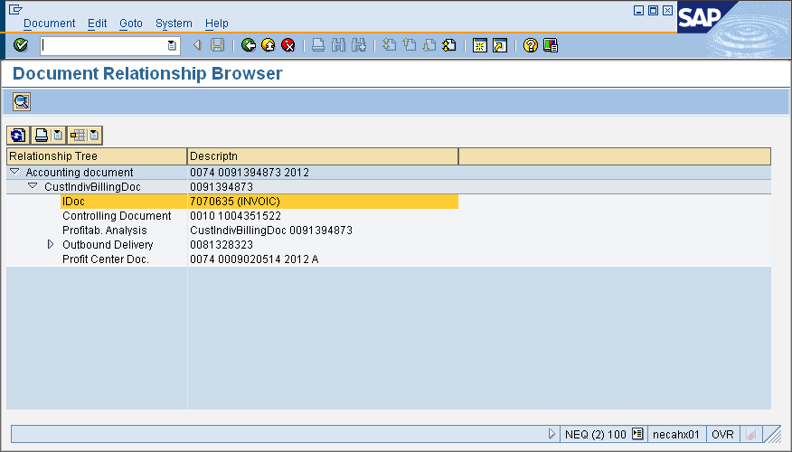

After re-processing the IDOC, a new IDOC was generated as a child IDOC for the original failed IDOC. An ICO AP document was created properly

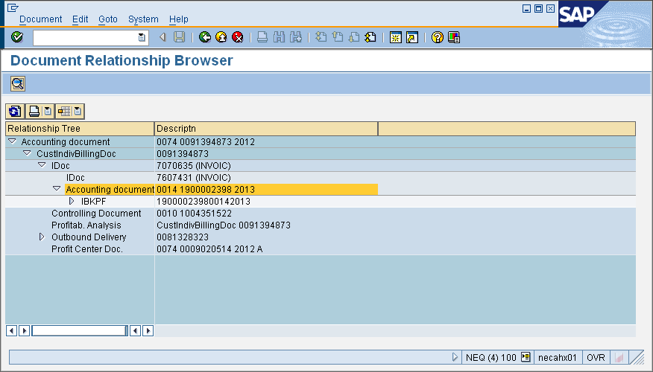

Step by step testing as below:

IDOC failed to post:

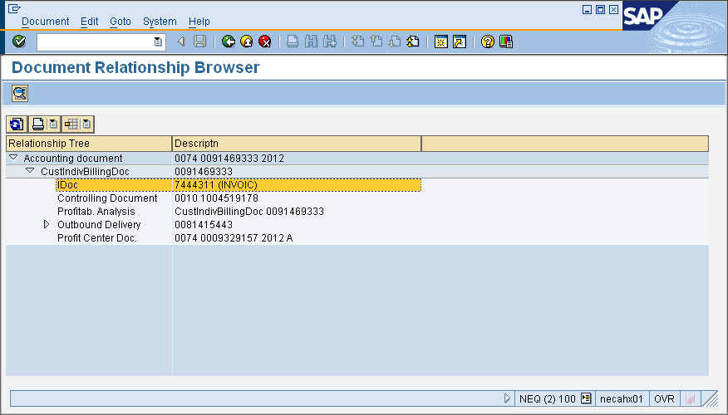

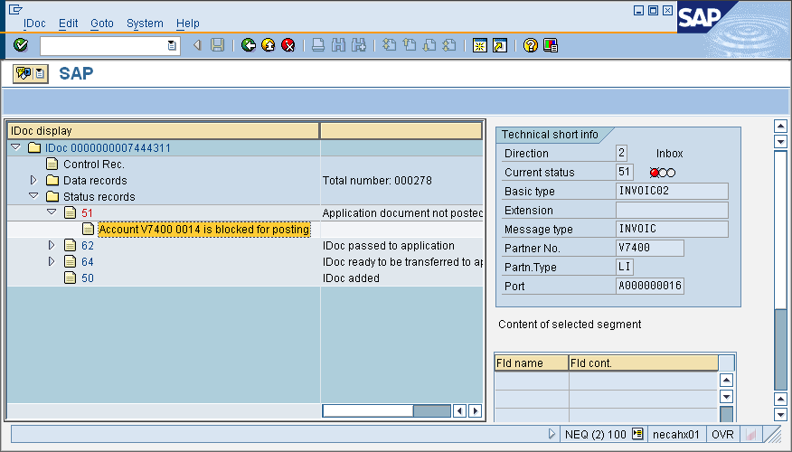

Use Tcode BD87 to process the IDOC:

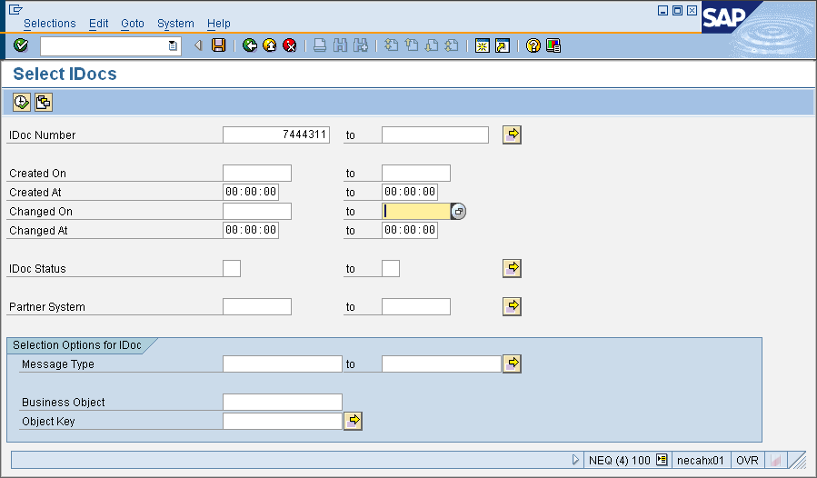

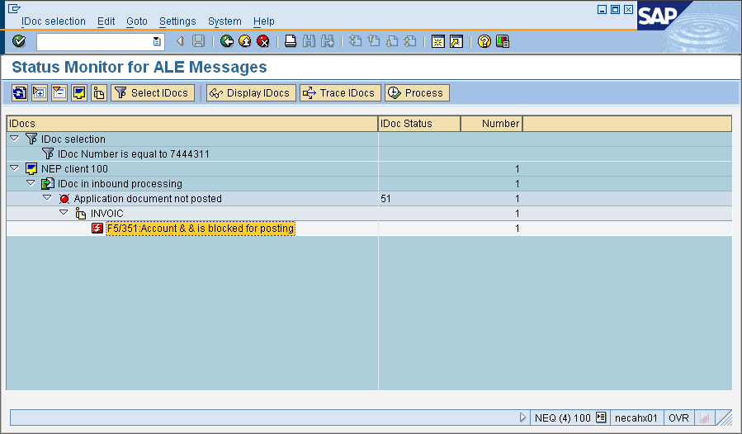

Double click into the failed IDOC

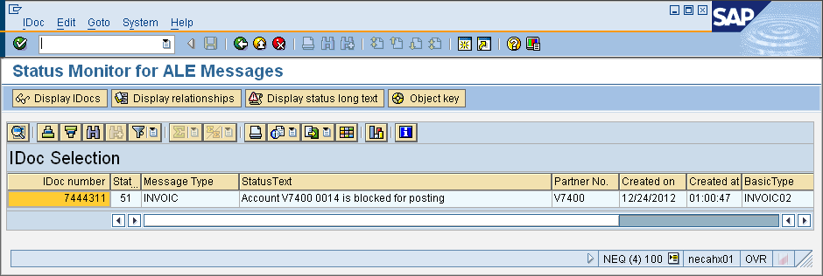

and double click on the IDOC number

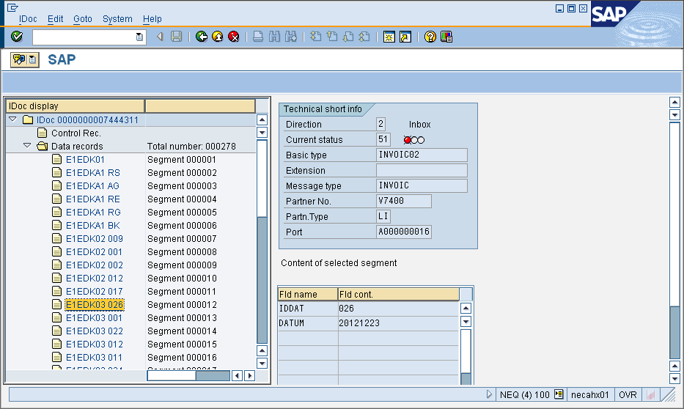

Segment E1EDK03 026 - Posting date

Segment E1EDK03 012 - Document date

Double click on the  button in front of the segment that needs to be edited. In this case, we are going to change the posting date.

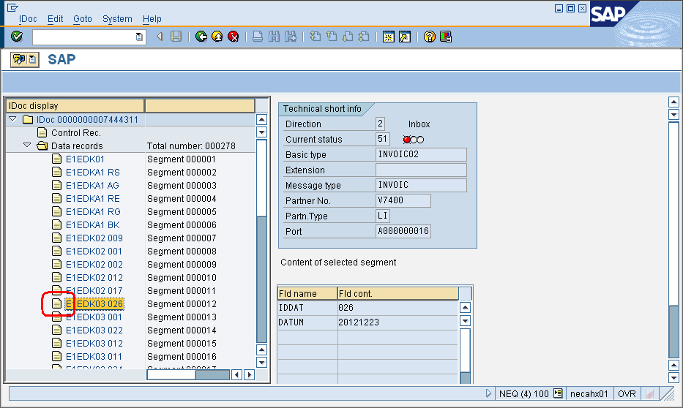

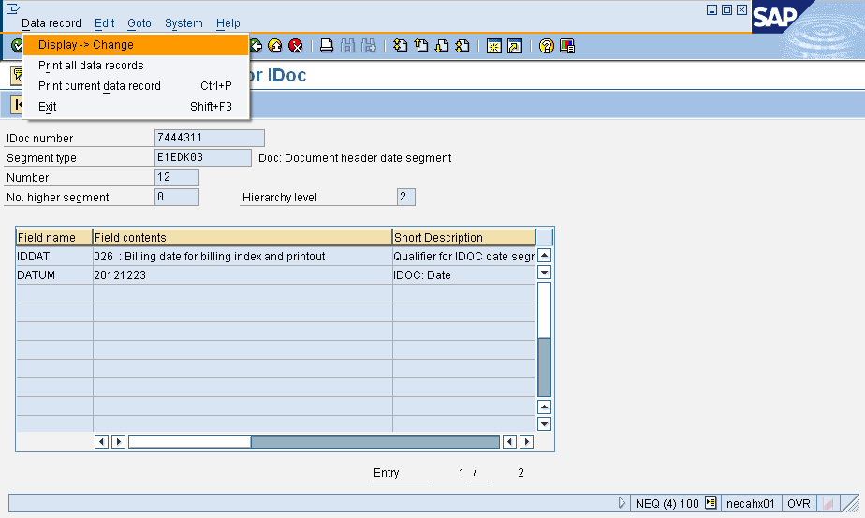

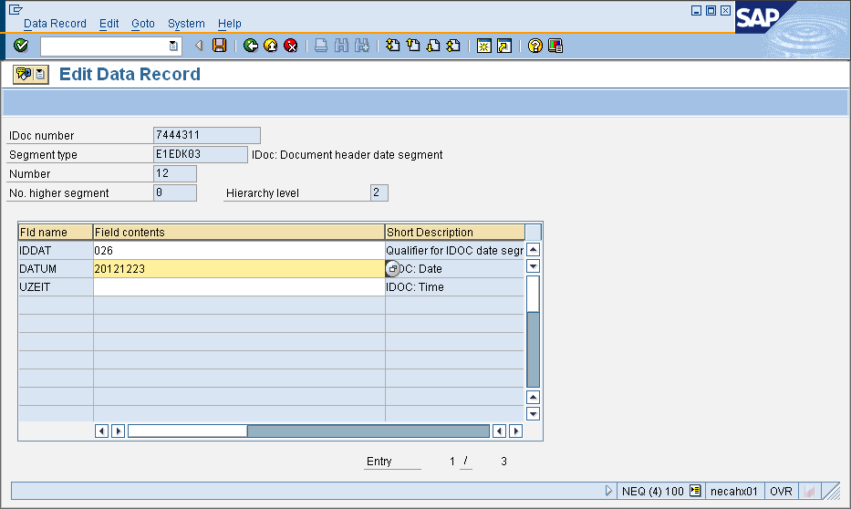

Change the date to 20130415

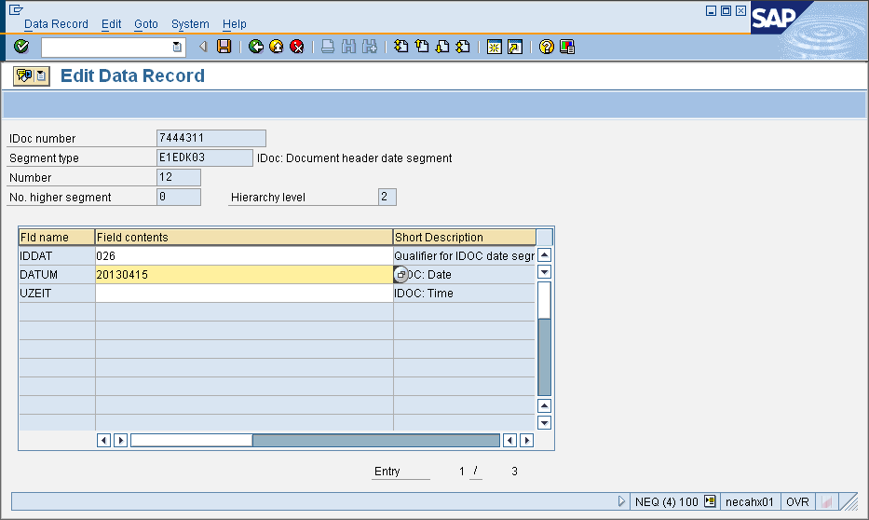

Then save the document. Go all the way back and click on “Process”

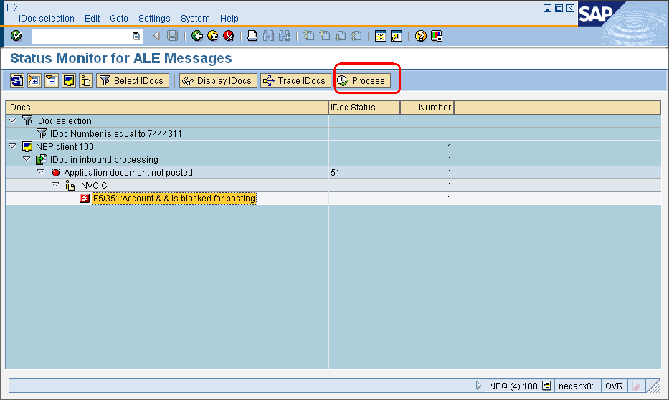

IDOC is being processed

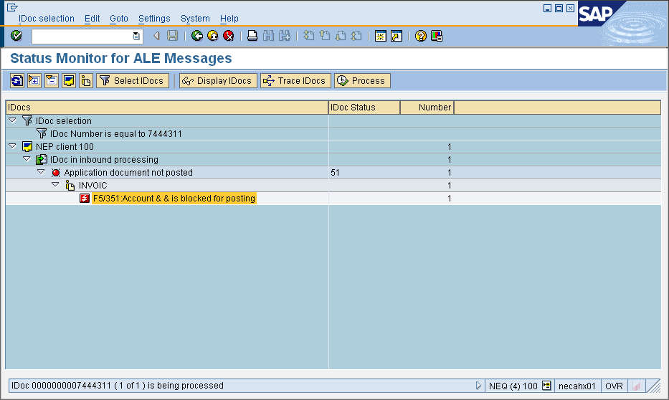

IDOC is process successfully

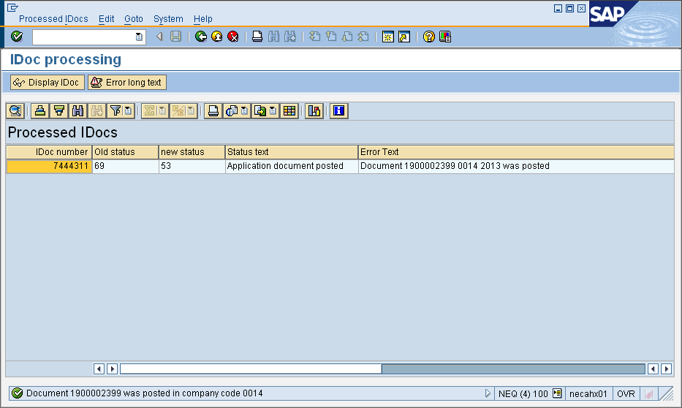

Now go back and check the document relationship and it shows that the IDOC was reprocessed successfully, and the posting date is 04/15/2013.

