1. REQUIREMENTS: 2

2. MASTER DATA: 2

2.1 Create standard finished material 2
2.2 Create standard raw material (Fabric) 4
2.3 Create BOM 5
2.4 Create Planning scenario 6
3. TRANSACTION FLOW: 9

3.1 Create planned independent requirements 9
3.2 Run long term planning 10
3.3 View MRP list for long term planning 12
3.4 View Stock/ Requirements list for long term planning 13
3.5 View Stock/ Requirements list for long term planning 14

1. REQUIREMENTS:

5614.200 - Fabric Requirements

2. MASTER DATA:

2.1 Create standard finished material

Created a standard material(NON AFS material) for finished product.
Material number 10016553

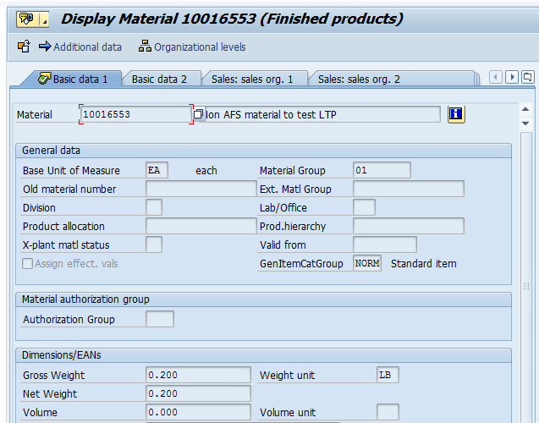

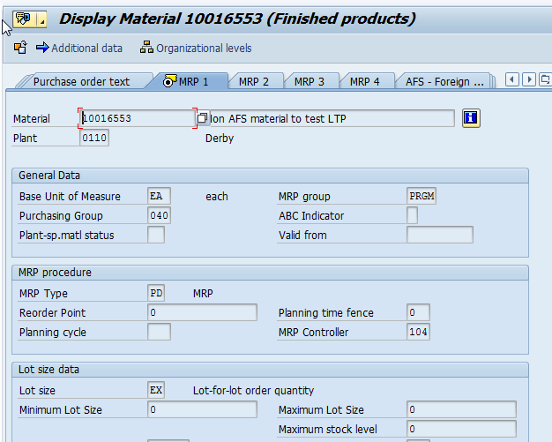

2.2 Create standard raw material (Fabric)

Created a standard material(NON AFS material) for raw material (Fabric).
Material number 90001442

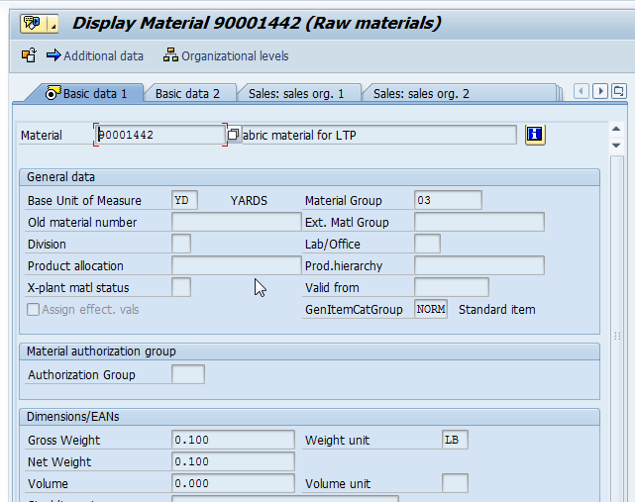

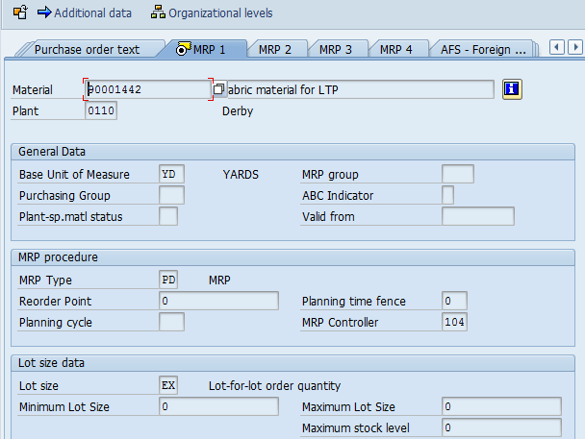

2.3 Create BOM

Created BOM for finished product, which contains component as fabric.

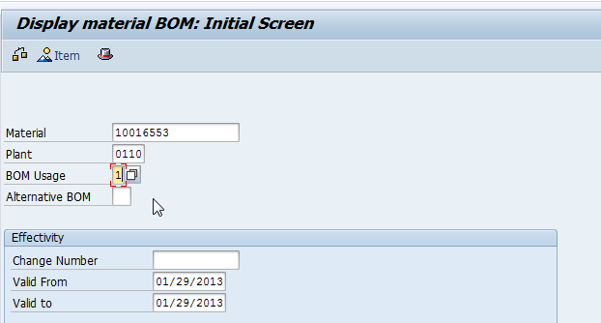

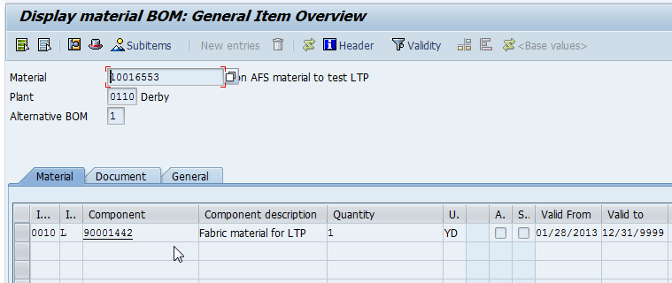

2.4 Create Planning scenario

Created the planning scenario 002 as shown below. Planning period for planned independent requirements is defined as six months and plant assigned is 0110. Planned independent version assigned to this scenario 02 (simulation 2).

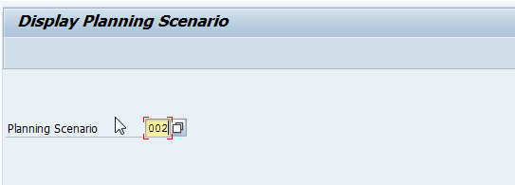

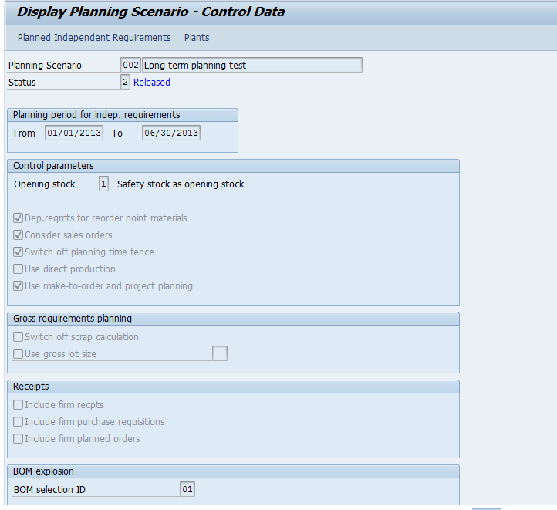

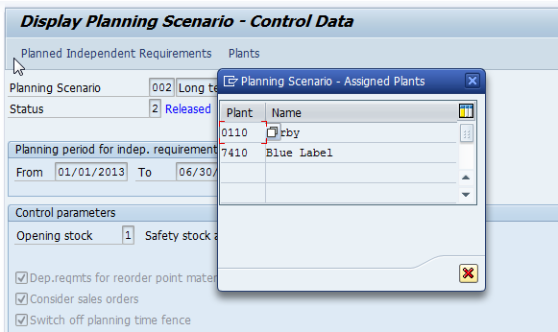

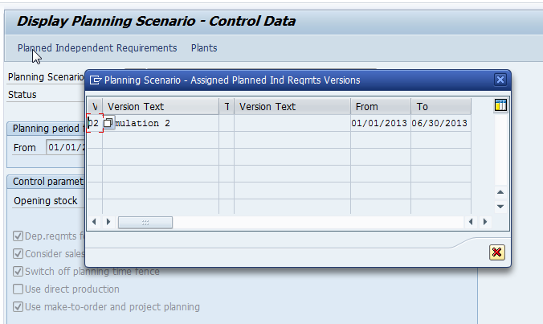

3. TRANSACTION FLOW:

3.1 Create planned independent requirements

Created the planned independent requirements using version 02. As we know that to run long term planning PIRs should be inactive.

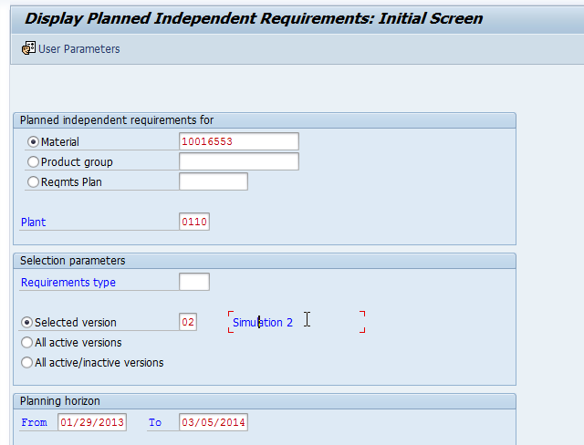

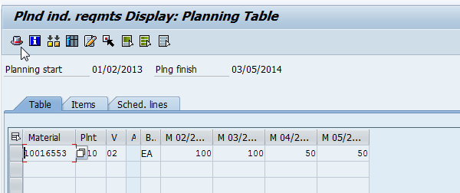

3.2 Run long term planning

Run the long term planning as shown below. The major difference when compare to general MRP is needed to specify the planning scenario to run long term planning.

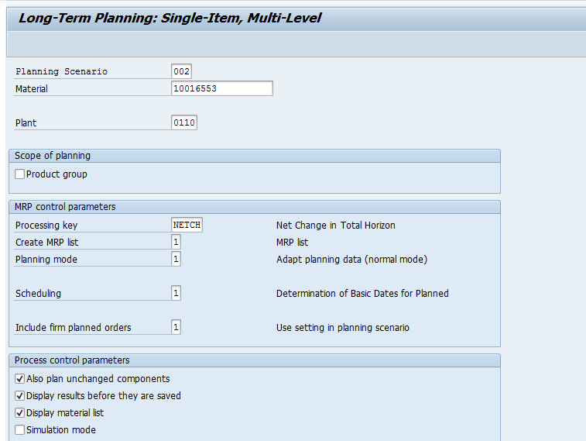

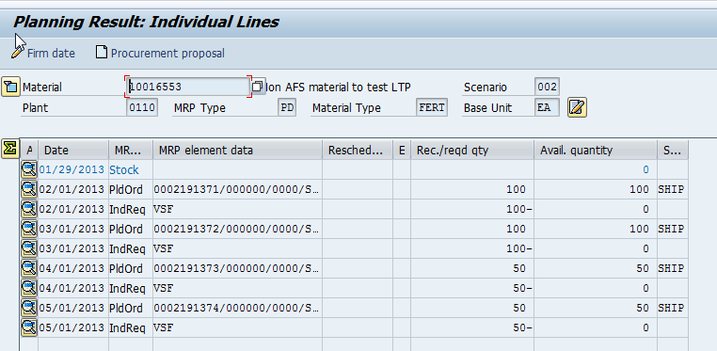

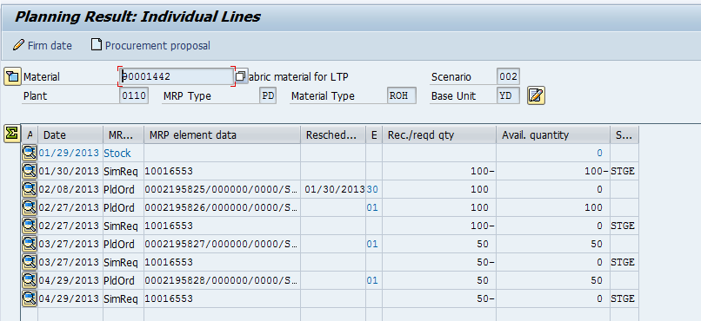

In the long term planning planned orders will be generated to view the requirements. These planned orders will not be convertible because this is a simulative planning.

3.3 View MRP list for long term planning

As shown below we can view the list materials ran for long term planning

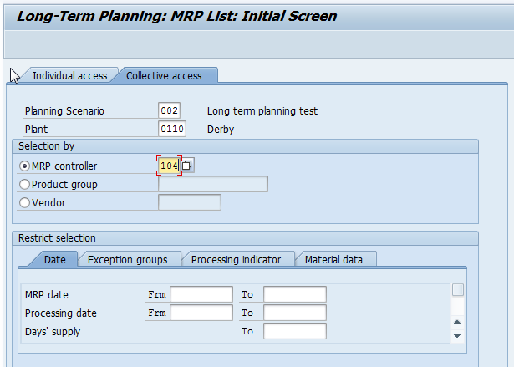

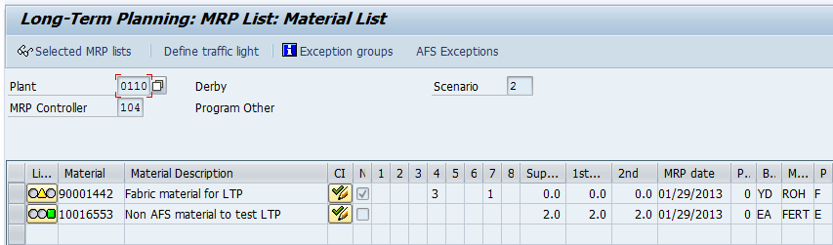

3.4 View Stock/ Requirements list for long term planning

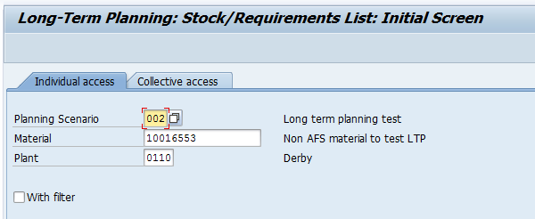

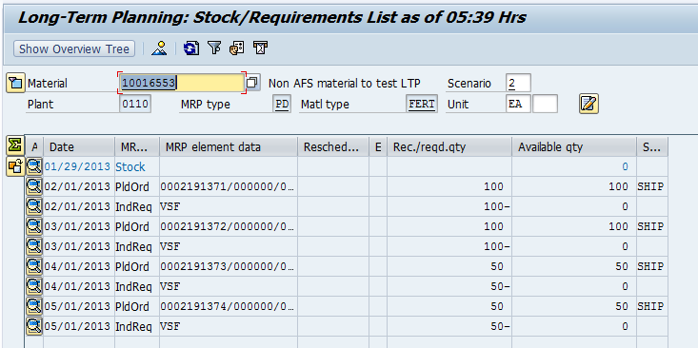

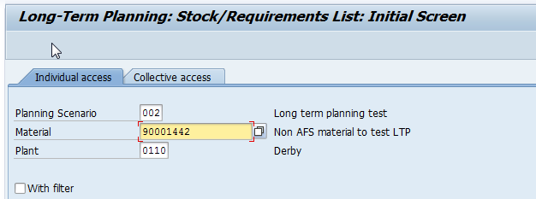

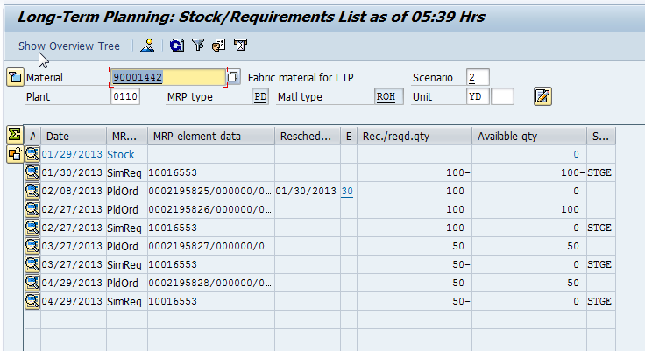

3.5 View Stock/ Requirements list for long term planning

From the below we can understand that there is no requirements generated in the normal MRP after running the long term planning.

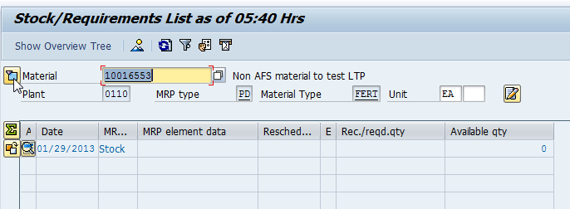

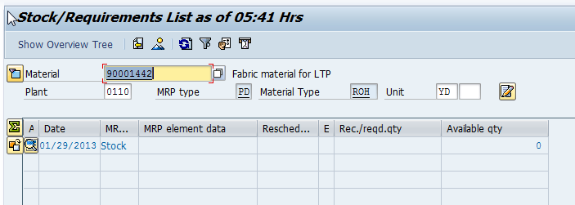

*End of Document*

