Object Name | : SDE003-01 UPC Label Printing Program
ReCAP Number | : 6020
Functionality | : US UPC Label Printing Program
Functional Area | : Sales & Distribution
Created By | : Thi Tran
Created Date | :

Revision History:
Revision Number | Date | Summary of Change
1.0 | 03-Apr-2013 | Initial Revision – Bug Fix on printing of customer specific labels

Related Documents (Document, URL, Email, etc.):
Document Name | Date | Author | Description

Business Requirement:
Business is trying to print Customer Specific Labels and they are getting a “Collection not Found” error.

Functional Specification:
Using the printing programs, when user enters data to the US or China program to print customer specific labels:
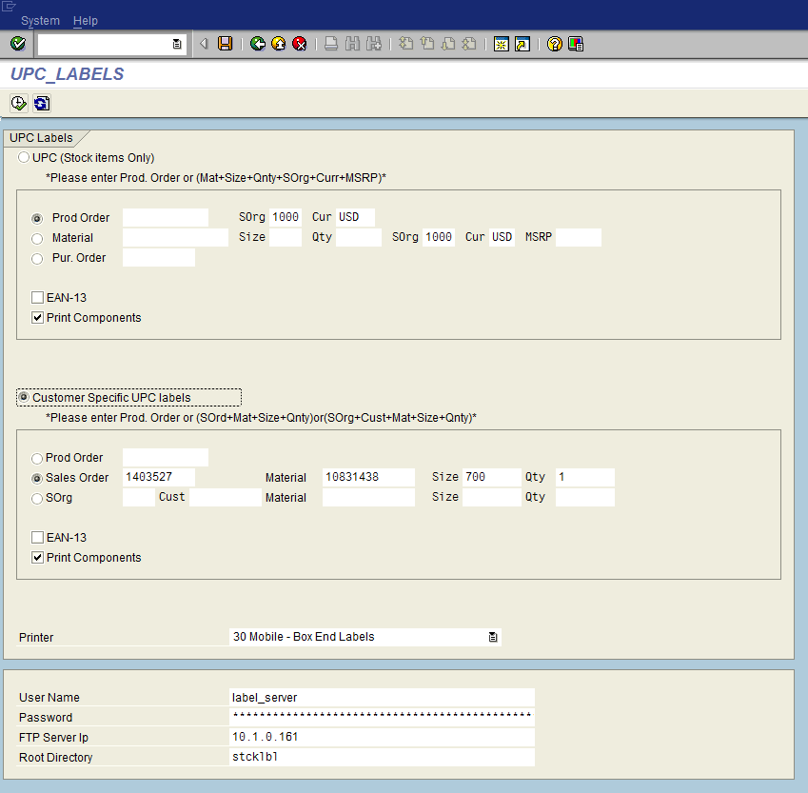
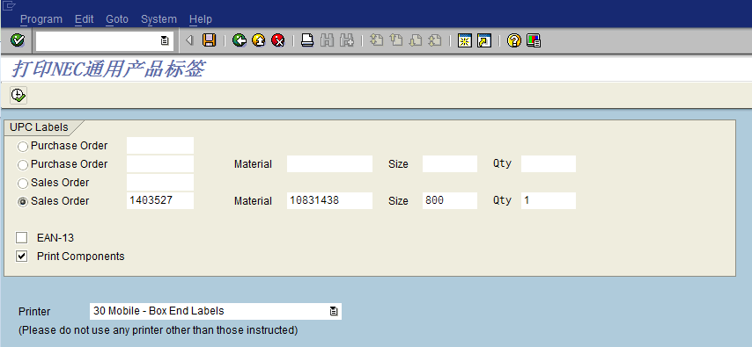
The following error message is displayed:
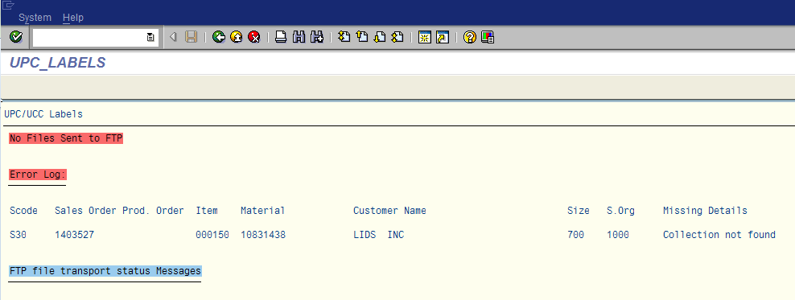

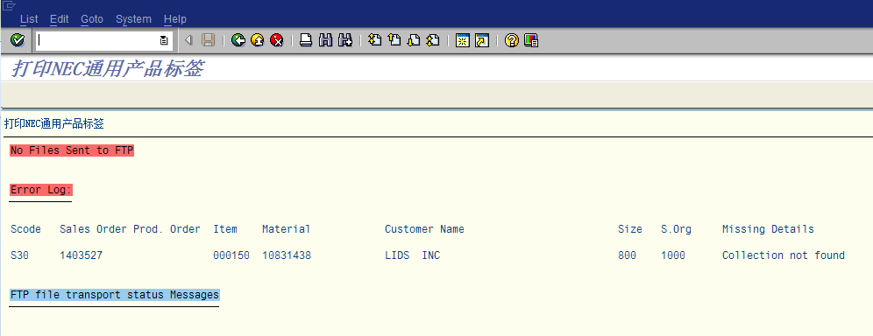
The reason, as BMS stated, is because the material has two different seasons and when that occurs, the current date needs to be in the season delivery window in order print labels. This is not valid code for the business requirements.
What we should be doing, when printing by Sales Order:
- Take the season and collection from the sales order, regardless of how many seasons are assigned to the material in the material master.
- Use the collection from the sales order to find the correct collection text to print on the label, if needed.
- Use the corresponding line item ZCRS price as the price to be printed on the label.
So for this example, the collection should be 5899:
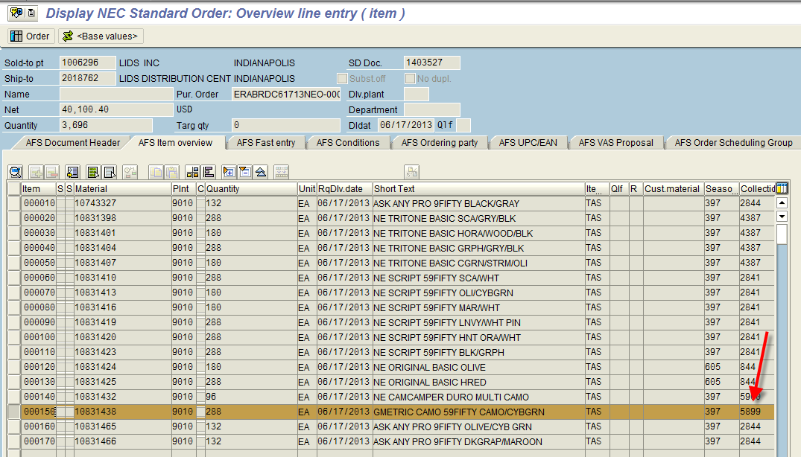
So the collection text should be “GMETRIC CAMO”.
The price should be $35.99:
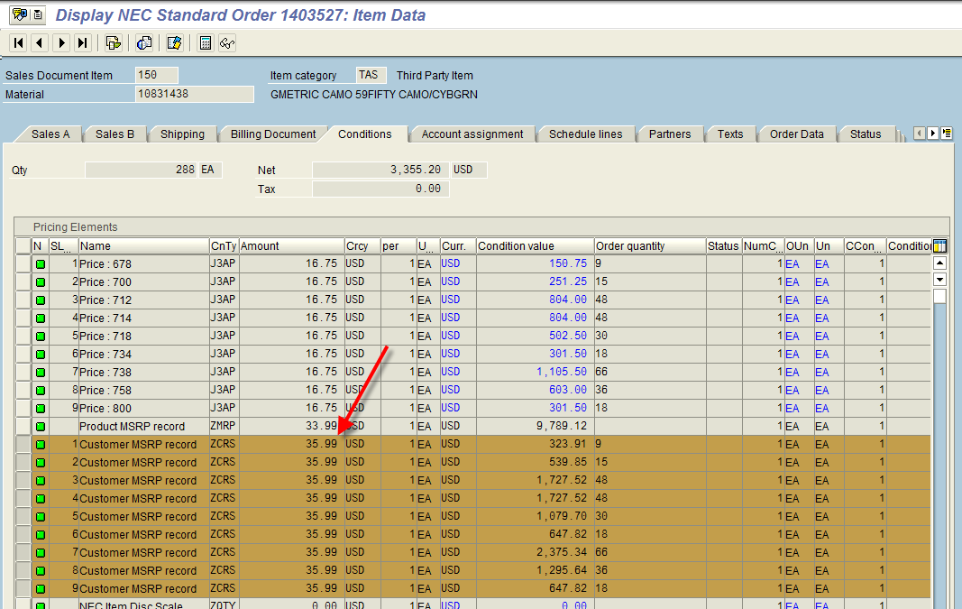
Assumptions:
- Materials may have more than one season, but collection should always be the same.

Known Issues:
N/A

Technical Specification:
Object | Type | Description
ZRSD_UPC_LABELS | Program | US UPC Label Printing Program
ZSD_UPCLBL | Transaction | US UPC Label Printing Program
ZRSD_UPC_LABELS_CHINA | Program | China UPC Label Printing Program
ZCH_UPC | Transaction | China UPC Label Printing Program

Transports:
Transport | Developer | Description

Test Scenarios:
No. | Test Scenario | Expected Results | Actual Results | Tester | Date | P/F
1 | Test US label printing program with a sales order for a customer with a customer specific label, where the material has more than one season | Ensure price comes from Sales Order and collection error not displayed
2 | Test China label printing program with a sales order for a customer with a customer specific label, where the material has more than one season | Ensure price comes from Sales Order and collection error not displayed

Panaya Scripts:
Panaya Script | Tester | Description

TDMS Requirements:
Is a new TDMS client required? NO

uPerform / RWD:
Are uPerforms required? NO

