WIP: At present WIP is not calculating for the plant 1410 plant and the below accounts are set to calculate the WIP.

Below is the WIP configuration for 1410 and 7410

OKG8
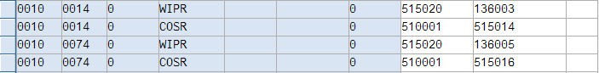
P&L accounts for WIP 515020 should be created with out cost element.

OKG9
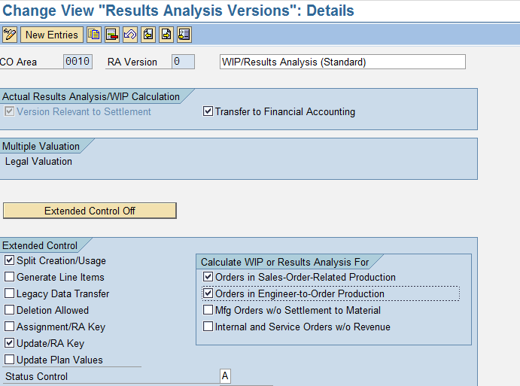
This need to be unchecked before we do the WIP configuration and put it back

Two scenario’s are tested:
- Internal procurement in plant 1410.
- Procurement of Finished goods in the plant 1410 and the SFG procurement in the plant 7410.

WIP calculation KKAX:
WIP need to be calculated before we do settlement for the partially settled orders.
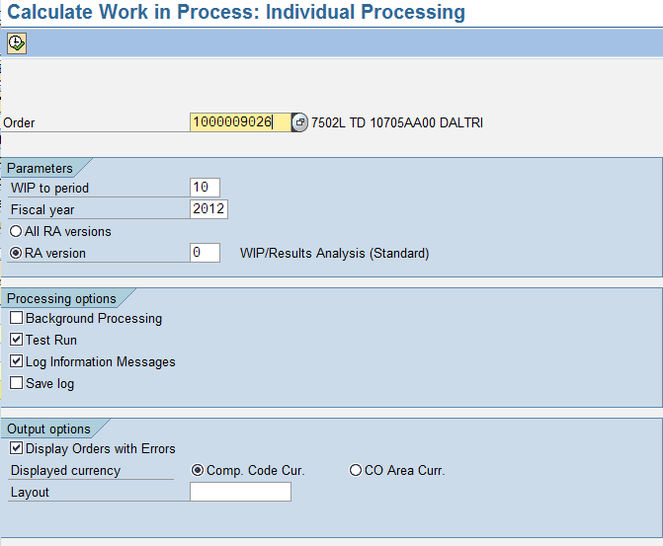

Sales Order: 54079
FG Material: 10016309
Plant:1410
Production Order: 1000009024

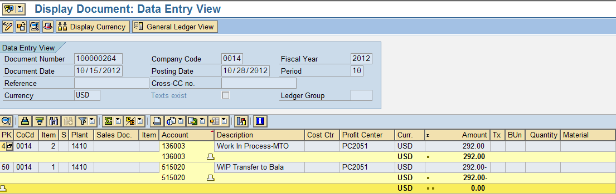

Cost Analasis:

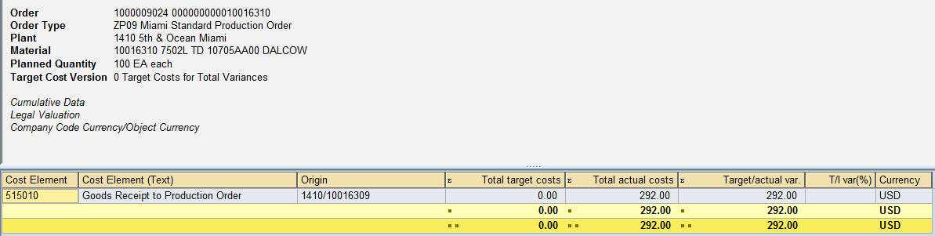

Scenario 2:
Final product make in plant 1410 semifinished goods are produced in plant 7410.
Both plants can calculate the WIP.
Sales Order: 54088
Material in 1410 plant: 10016310
Material in 7410 plant: 10016309
Production order in plant 1410: 10000009026
Production order in plant 7410: 10000009025

WIP calculatuion in 7410 plant
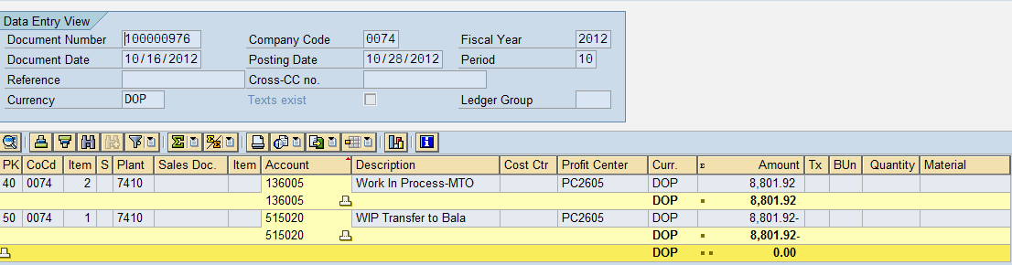

WIP postings in 1410 plant
