TEST 1:

SNC NB TAB PO WITH INB DELIVERY:

UPDATED DELIVERY DATE AND EX FACTORY DATE WITH DELIVERY DATE NOT A WORKING DAY:

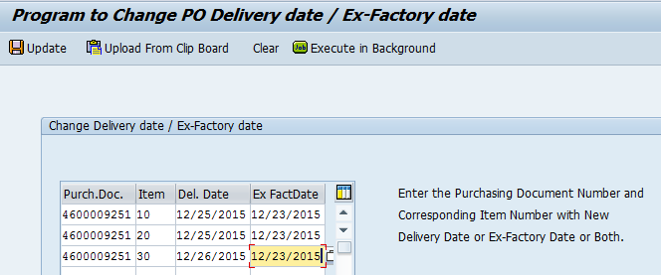

DELIVERY DATE AND EX FACTORY DATE ARE UPDATED IN PO AND DELIVERY DATE IS UPDATED INB DELIVERY:

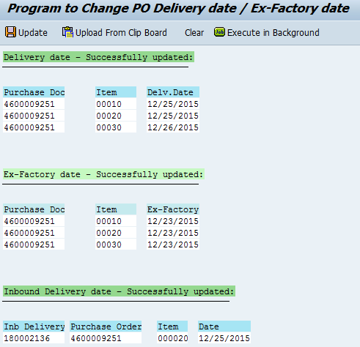

TEST 2:

SNC NB TAB PO WITH INB DELIVERY:

UPDATED DELIVERY DATE AND EX FACTORY DATE WHICH ARE NOT A WORKING DAYS (RAN IN BACKGROUND)

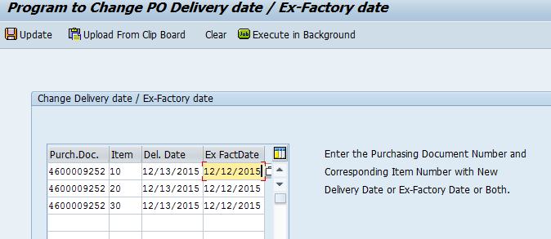

DELIVERY DATE AND EX FACTORY DATE ARE UPDATED IN PO AND DELIVERY DATE IS UPDATED IN INB DELIVERY

