--------------------------------------------------------------------------------------------------------------------------------------

TEST 1:

NON SNC NB PO W/O INB DELIVERY

4500076029 DELIVERY DATE IS UPDATED IN PO

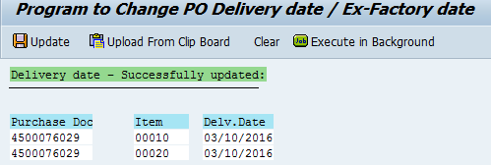

--------------------------------------------------------------------------------------------------------------------------------------

TEST 2:

SNC NB PO WITH INB DELIVERY

4500076022 & 4500076028 DELIVERY DATE IS UPDATED IN PO AND INB DELIVERY

1. 4500076022: THIS PO IS HAVING 4 PO LINE ITEMS ABD DELIVERY DATE IS UPDATED FOR 3 LINES OF THE PO AND ALSO IN THE INB DELIVERY.

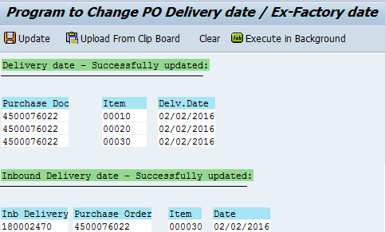

1. 4500076028 ***IN THIS CASE THE DATE WHICH IS NOT WORKING DAY IS UPDATED IN PO BUT NOT IN INB DELIVERY***

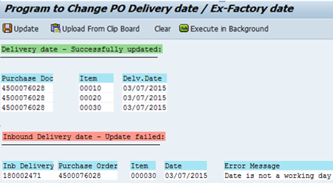

1. 4500076028 UPDATED THE DELIVERY DATE IN PO AND INB DELIVERY WITH WORKING DATE AND IT GOT UPDATED, THIS PO IS ALSO HAVING 4 LINES.

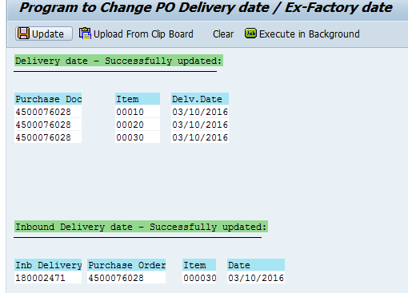

--------------------------------------------------------------------------------------------------------------------------------------

TEST 3:

NON SNC NB PO WITH OUT INB DELIVERY

UPDATED DELIVERY DATE IN PO:

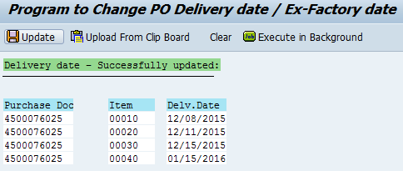

THEN AGAIN UPDATED DELIVERY DATE IN PO WITH SOME OTHER DATES IN BACKGROUND:

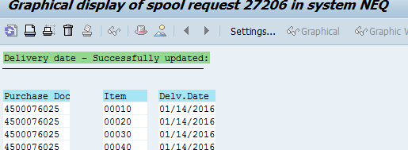

--------------------------------------------------------------------------------------------------------------------------------------

TEST 4:

TWO SNC Z3NB POS WITH 2 LINES OF ONE SALES ORDERS IN ONE PO AND ANOTHER TWO LINES OF THE SALES ORDER IN ANOTHER PO, WITH INB DELIVERY

UPDATED DELIVERY DATE IN PO AND INB DELIVERY (RAN IN BACKGROUND)

LINE 10, 20 OF PO **4500076020** IS FOR SALES ORDER **1339203** WHICH HAS INB DELIVERY **180002461**

WHICH IS UPDATED WITH DELIVERY DATE 01/11/2016

LINE 30, 40 OF PO **4500076020** IS FOR SALES ORDER **1339204** WHICH HAS INB DELIVERY **180002463**

WHICH IS UPDATED WITH DELIVERY DATE 01/12/2016

LINE 10, 20 OF PO **4500076021** IS FOR SALES ORDER **1339203** WHICH HAS INB DELIVERY **180002462**

WHICH IS UPDATED WITH DELIVERY DATE 01/11/2016

LINE 30, 40 OF PO **4500076021** IS FOR SALES ORDER **1339204** WHICH HAS INB DELIVERY **180002464**

WHICH IS UPDATED WITH DELIVERY DATE 12/08/2015

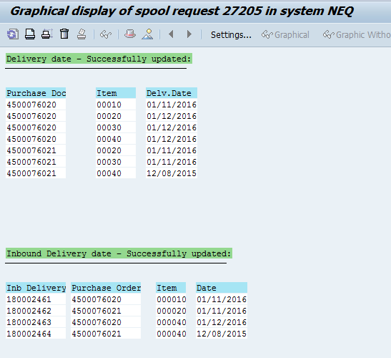

--------------------------------------------------------------------------------------------------------------------------------------

TEST 5:

SNC NB TAB PO WITH INB DELIVERY

UPDATED DELIVERY DATE IN PO AND INB DELIVERY 4500076023

THE PO IS HAVING 4 LINE ITEMS AND DELIVERY DATE IS UPDATED FOR THREE LINE ITEMS AND ALSO IN THE INB DELIVERY

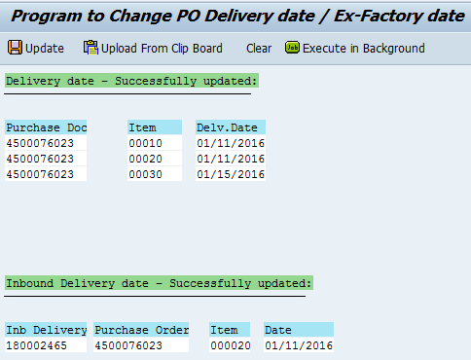

--------------------------------------------------------------------------------------------------------------------------------------

TEST 6:

Non SNC NB TAB PO 4500076030

UDATED DELIVERY DATE FOR 4 LINES WITH 02/10/2016 AND 2 LINES (50,60) WITH THE SAME DELIVERY DATE THE PO IS HAVING

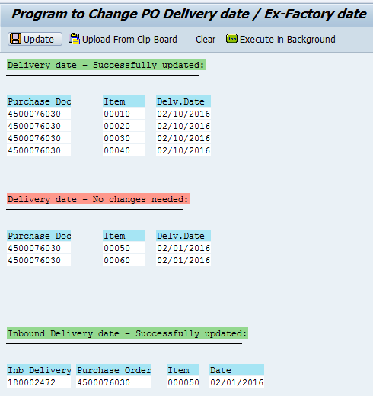

AGAIN UPDATED DELIVERY DATE WITH THE BELOW GIVEN DATES IN BACKGROUND AND THE LATEST DELIVERY DATE IS UPDATED IN THE INB DELIVERY

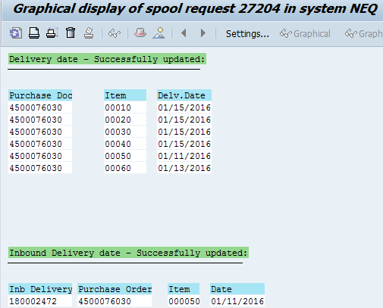

--------------------------------------------------------------------------------------------------------------------------------------

TEST 7:

NON SNC NB PO WITH OUT INB DELIVERY

UPDATED DELIVERY DATE AND EX FACTORY DATE:

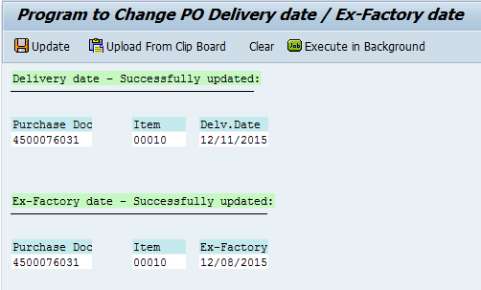

--------------------------------------------------------------------------------------------------------------------------------------

TEST 8:

SNC NB PO WITH INB DELIVERY

UPDATED DELIVERY DATE IN PO AND INB DELIVERY AND EX FACTORY DATE (RAN IN BACKGROUND)

