**Rush Orders not allocated and delivered**

1. **Client – NEP100**
2. **Order type - ZQR**
3. **Sales area – 1000/10/00**
4. **The rush orders with order type ZQR are created through batch job that is scheduled every 1 hour.**

**Job name - NA_SD_EDI_ORDERS_INBOUND**

**Program - RBDAPP01**

**Variant - INBOUND_ORDERS**

1. **If sufficient stock exists then the ZQR orders would be auto allocated and delivered. If sufficient stock doesn’t exists for the materials then the J0 rejection reason would be changed to Z9. (As per the custom logic in the exit MV45AFZZ)**
2. **The ZQR orders that are created on 09/25/2016 (21:50:21) through the batch job, some of the materials didn’t auto allocate and the corresponding deliveries are not created automatically though there is enough stock for these materials.**

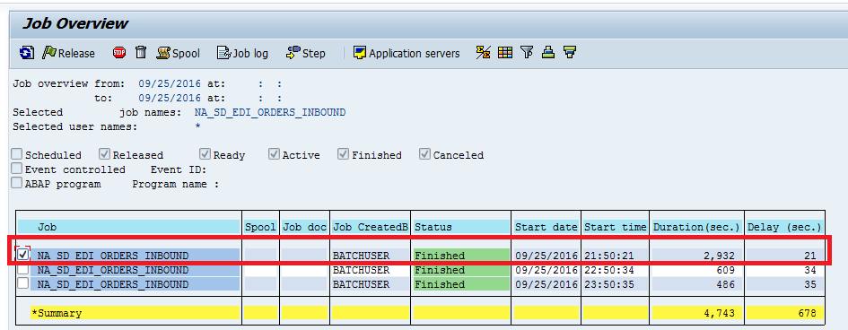

1. **An information log is seen in the job log for all the materials that didn’t allocate and deliveries are not created as below.**

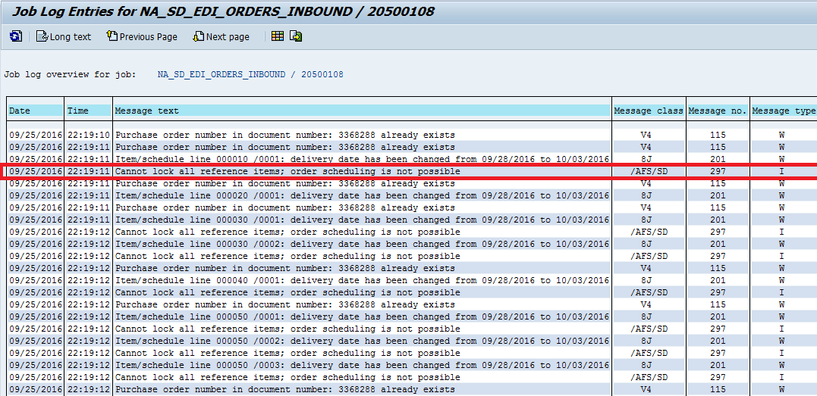

**Analysis:**

**For the same materials, some ZQR orders are auto allocated and delivered and while some of the orders didn’t .The job for some reason was unable to lock the materials for auto allocation and auto delivery creation.**

**For example Mat ID 10047290, some ZQR orders are auto allocated and delivered. While some ZQR orders the auto allocation didn’t happen and the above log is shown up in the job.**