SALES ORG 4000 ZRDO OUTPUT
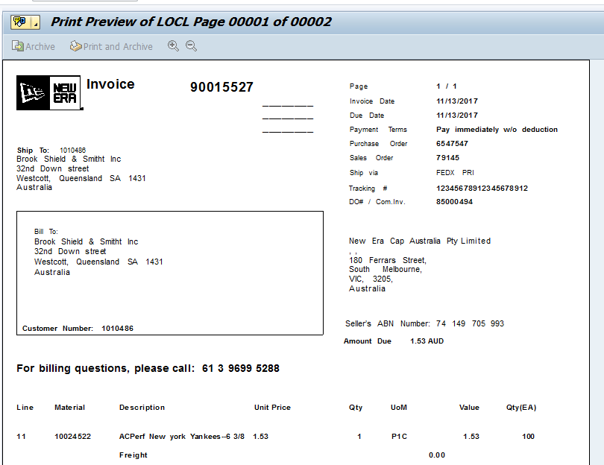

SALES ORG 4100 ZRDO OUTPUT

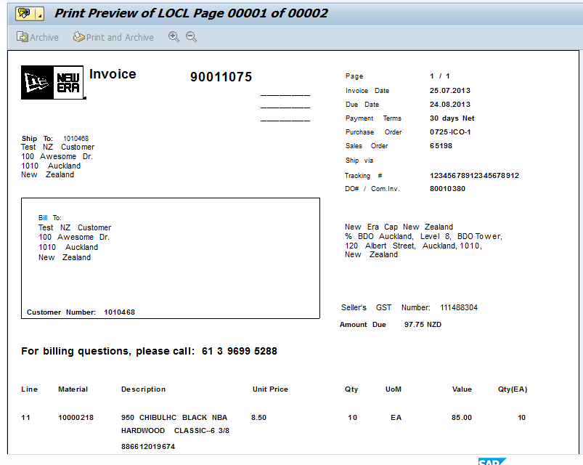
SALES ORG 1000 ZRD0 OUTPUT 