**Business Requirement:**

The orders are coming through EDI in to SAP. Some of the orders contains department ID number. The system should be able to print the Dept. ID numbers on the packing slip.

**Functional Specification:**

The dept. ID is stored at the item level text of the sales order in the Customer Department text type. The Packing slip form will have to extract the data from the Sales order item level text and display on the output.

|  |  |  |  |
| --- | --- | --- | --- |
| Object | VA01 | Text Type | Call Function |
| Description | Item Level | Customer Department (Z009) | READ_TEXT |

Call Function “READ_TEXT”

EXPORTING

CLIENT =sy-mandt

ID =it_stxl-z009

Language =it_stxl_tdspras

Name =it_stxl_tdname

Object =it_stxl_VBBP

TABLE

STXL =it_stxl

** Example format displaying below.

**With Dept. ID**



**Without Dept. ID**

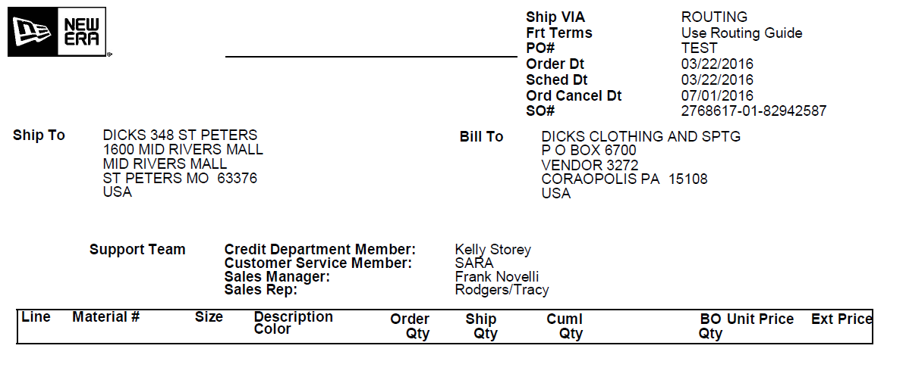

**DEPT. ID**

Production example is order # 211077.

**Assumptions:**

* If the Order item level text doesn’t contain any Dept. ID the Dept. ID field should still be printed on the packing slip but blank.

**Known Issues:**

**Technical Specification:**

| Technical Object | Type | Description |
| --- | --- | --- |
| Read_Text | FM | Text FM |

**Source Control:**

| Change Object | Application | Developer | Description |
| --- | --- | --- | --- |
|  |  |  |  |
|  |  |  |  |

**TDMS Requirements:**

**Test Scenarios:**

| No. | Test Scenario | Expected Results | | Actual Results | Application / Environment | Tester | Creation  Date | P/F | Panaya |
| --- | --- | --- | --- | --- | --- | --- | --- | --- | --- |
|  |  |  | |  |  |  |  |  |  |
| 1 | All data available | The Dept. ID should be printed on the packing slip | The Dept. ID should be printed on the packing slip if available in the item level text. | | NECNED-300 | Rizwan Shah |  |  | ☐ |
| 2 | All data available | The Dept. ID number should not be printed on the packing slip if sales order item text is blank | The Dept. ID should not be printed on the packing slip if item level text is blank. | | NECNED-300 | R Rizwan Shah |  |  |  |

**Panaya Scripts:**

| No. | Panaya Script | Test No. | Tester | Description |
| --- | --- | --- | --- | --- |
|  |  |  |  |  |
|  |  |  |  |  |
|  |  |  |  |  |

**uPerform / Camtasia:**

| No. | uPerform Script | Creation Date | Language | Description |
| --- | --- | --- | --- | --- |
|  |  |  |  |  |
|  |  |  |  |  |
|  |  |  |  |  |