Steps:

Step1: check the negative values in S066.

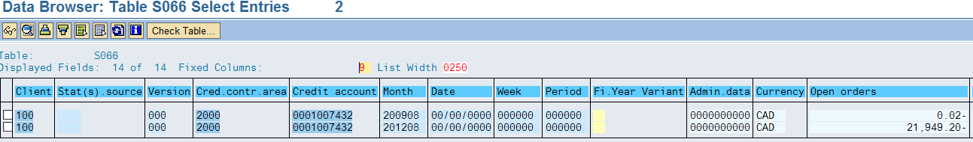
Check the Customer Credit FD32:
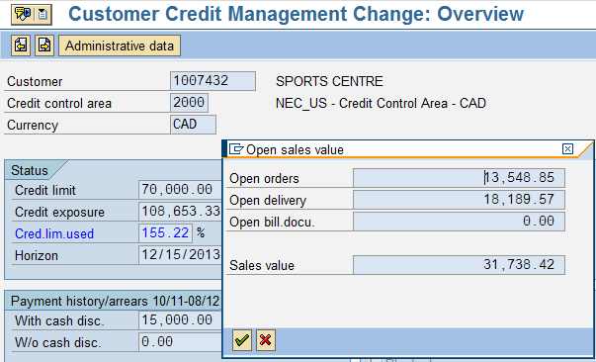
Execute simulation report: RVKRED88
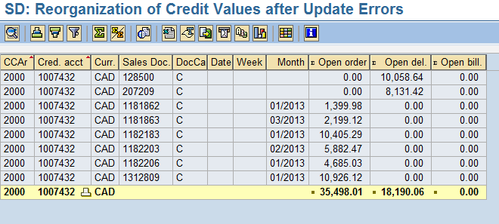
Execute the credit correction report: RVKRED88

